###### Management of change for balloon transport AOC holders - Process template

Introduction

How to use this template

This template is designed to assist operators in developing an exposition section/supplement for compliance with paragraph 131.195(1)(m) of the Civil Aviation Safety Regulations 1998 (CASR).

The template was prepared assuming that the operator does not have a Safety Management System (SMS) in place. Even without an SMS, sometimes operators designate a person as the Safety Manager (SM). The template refers to the person managing and maintaining the change management process as the SM however operators can designate the person responsible for this duty at their discretion. Especially for small operators, it is common practice for either the HOFO or a senior line pilot to be designated as having the responsibility for maintaining and managing the change management process. Note that the person responsible for managing and maintaining the process is not necessarily the person responsible for approving changes.

Section 3 of this Appendix includes the template for a change register. The template may be used as the basis for a document to be added to an operator's suite of forms and registers. Each section of the table is intended to align with steps in the process discussed below.

Tables and forms may need to be labelled to suit your exposition, with relevant references in the text amended as a result. Relevant acronyms are provided which an operator may choose to insert into existing reference sections of their exposition.

The numbering used in the template may need to be amended to align with the numbering system of your exposition.

This template will enable an operator to meet the requirements of Part 131 for a management of change process. However, operators may need to adjust the language of the template to be consistent with their operation. Where <XXXX> or similar is shown in the text, the text will need to be replaced to reflect the relevant matter e.g., AOC holder’s name; CEO’s name; role in operator structure; name of the system used; or other specific information particular to your operation.

Additional guidance in the footnotes of the document may be deleted as part of the updates to relevant text.

The template is designed for a fictional 'Sample Ballooning', which is an entity with six full time staff members comprising:

* the individual who holds both the key person positions of CEO and HOFO
* two line pilots, one of whom is also the individual responsible for managing the management of change process
* office coordinator (all support duties from rostering to admin/pay etc)
* two ground support staff members.

Sample Ballooning uses a single group of publications defined as an exposition for the compliance requirements of Part 131. This set of documents incorporates the flying training manual.

# Reference material[1]

Acronyms

|  |  |
| --- | --- |
| Acronym | Description |
| CASA | Civil Aviation Safety Authority |
| CASR | Civil Aviation Safety Regulations 1998 |
| CEO | Chief Executive Officer |
| HOFO | Head of Flying Operations |
| SM | Safety Manager |
| SMS | safety management system |

Definitions

|  |  |
| --- | --- |
| Term | Definition |
| key personnel[2]: | means the following positions:   * + 1. Chief Executive Officer     2. <Head of Flying Operations><Chief Flying Instructor>[3] |
| non-significant change | a change that is not a significant change |
| significant change | From regulation 131.030 of CASR:  a. a change in relation to any of the following:   * + - 1. the location and operation of the operator’s main operating bases, including the opening or closing of main operating bases;       2. the operator’s key personnel;       3. a person authorised to carry out the responsibilities of any of the key personnel if the position holder is absent from the position or cannot carry out the responsibilities of the position;       4. the formal reporting lines for a managerial or operational position with safety functions and responsibilities that reports directly to any of the key personnel;       5. the operator’s process for making changes that relate to the safe conduct and management of the operator’s balloon transport operations;       6. the kinds of balloon transport operations the operator is authorised to conduct under the operator’s balloon transport AOC;       7. the operator’s areas of operation, including beginning to operate in a new area;       8. the classes of Part 131 aircraft used in the operator’s balloon transport operations, including the addition of a new class; or   b. a change in relation to any of the following that does not maintain or improve, or is not likely to maintain or improve, aviation safety:   * + - 1. the plans, processes, procedures, programs and systems for the safe conduct and management of the operator’s balloon transport operations;       2. the qualifications, experience and responsibilities required by the operator for any of the operator’s key personnel;       3. any other aeronautical or aviation safety related services provided to the operator by third parties;       4. any change to the registration of a Part 131 aircraft used in the operator’s balloon transport operations;       5. any leasing or other arrangements for the supply of a Part 131 aircraft used in the operator’s balloon transport operations; or   c. a change required to be approved by CASA under the Regulations, other than a change that results in the reissue or replacement of an instrument previously issued by CASA in which the conditions or other substantive content of the instrument are unchanged. |

# <Sample Ballooning> Management of Change Process

## Process overview

Figure 1 shows an overview of the process workflow for the <Sample Ballooning> management of change process:

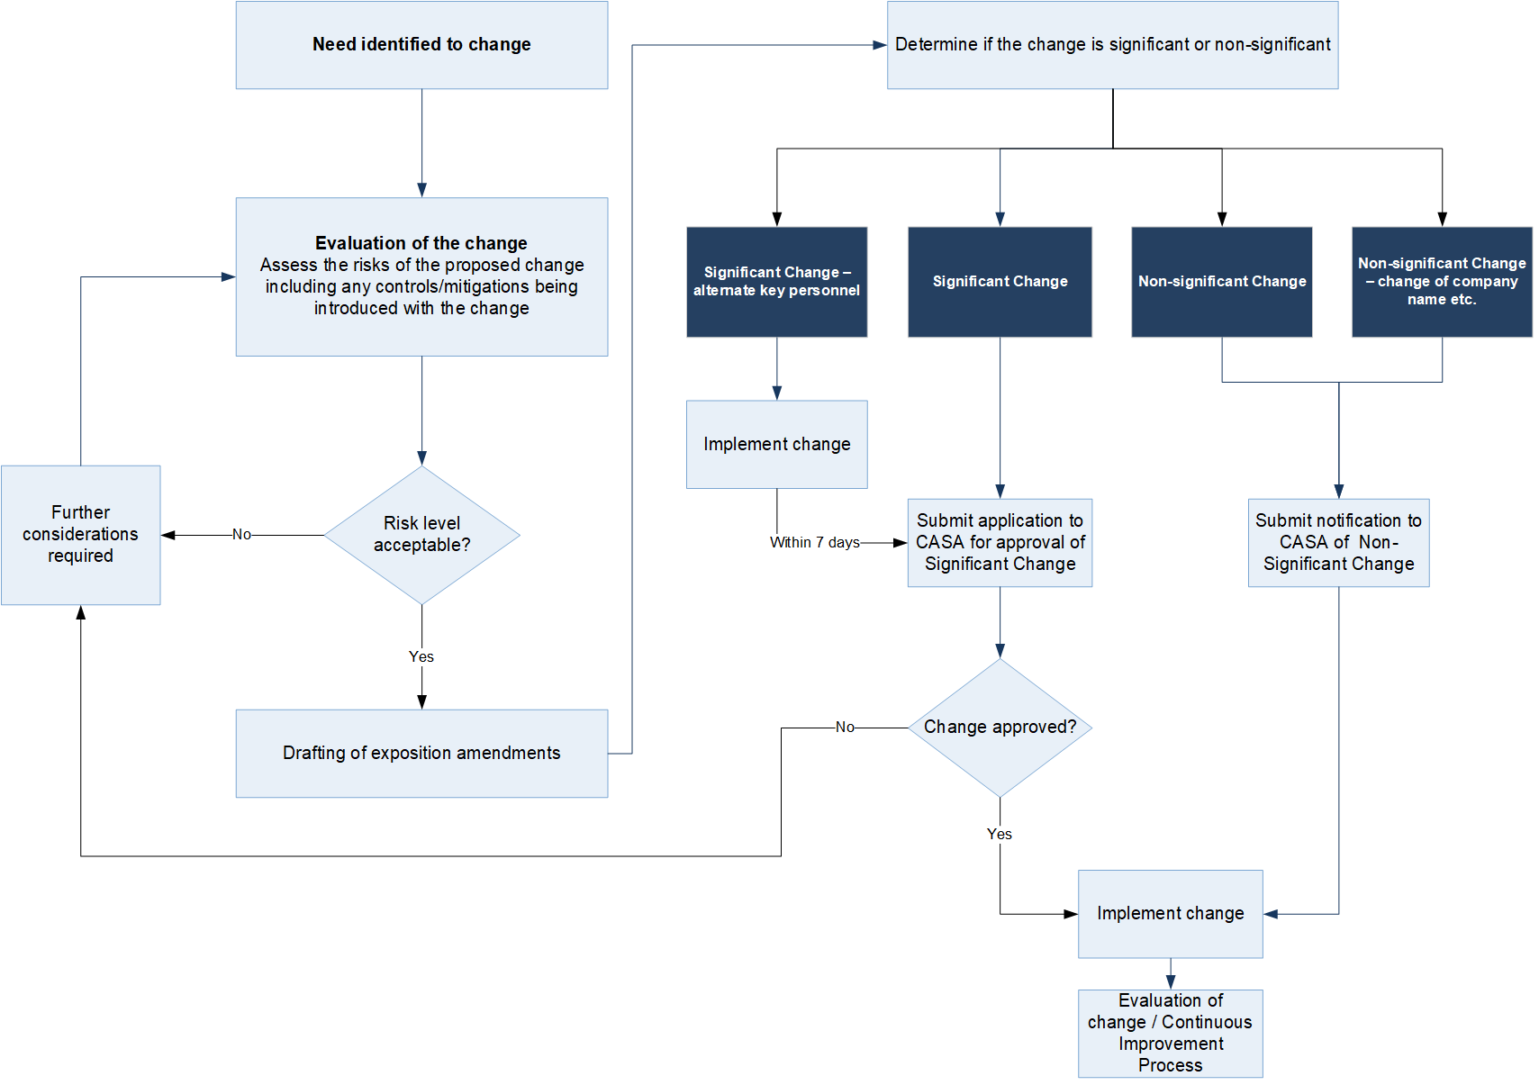

Figure 1: Management of change process workflow

## Governance

Compliance

When actioning a proposed change, the management of change process workflow in Figure 1 must be followed. Additional information on the associated course of action is outlined below.

All changes to systems, processes, or procedures are to be made in accordance with this process.

The change process will be implemented, maintained, reviewed and revised by the <Safety Manager> stated in the operator's organisation structure, as shown in <section> of this exposition.

Approval and administration

<change meetings> will be held by the <SM> <monthly[4]>. The purpose of the <change meeting> is to:

* provide options for progressing new changes
* provide updates on changes in progress.

Meetings will be attended by the <SM>, CEO, HOFO and available line pilots/ground support staff office coordinator and may be combined with other meetings.

The <CEO> is the Change Approver[5] for all <Sample Ballooning> change proposals. This approval must be given prior to the implementation of any change proposal.

Safety risk management

As part of considering the change it will be necessary to assess the risks of the proposed change by considering the following matters as a minimum:

* resource requirements
* compliance considerations
* urgency of change
* implementation implications and strategy
* impact on safety.

Any safety risk analysis will be conducted in accordance with the safety risk management <policy or system> in <section>.

## Change process

### Need to change identified

Change can be initiated for many reasons including but not limited to:

* new regulatory requirements
* audit report findings
* safety report findings
* continuous improvement process
* new business opportunities or new or different kinds of aircraft
* change of key personnel
* issues identified in daily operations.

Where a change is suggested the CEO and <SM> will verify if this is a change that the operator wishes to action.

In carrying out their duties, all staff must be conscious of areas in which efficiencies, improvements and increases in safety standards are possible.

Upon noticing an opportunity for change, or a need for change, staff are to contact the <SM> to discuss the idea.

When receiving suggestions for change, the <SM> will enter a new line item in the change register.

### Evaluation of the change

If the change is considered urgent, the <SM> and CEO will discuss the identified change opportunity, requesting input from others in the operation as necessary. Non-urgent change opportunities will be discussed at the next <change meeting>.

Following discussion between the <SM> and CEO (urgent changes) and/or at the next <change meeting>, a safety risk analysis must be conducted in accordance with the safety risk management <policy or system> in <section>.

The assessment should consider all the respective factors, including (but not limited to):

* major components or activities of the change
* regulatory requirements
* number and types of affected stakeholders
* complexity of the proposal
* training requirements
* impact on processes and procedures
* impact on safety culture
* hazard and consequence identification.

Consideration should be given to external contracts that may be needed or require amendment and purchasing that may be necessary.

A plan for implementing the change must be developed by the CEO and <SM/other staff>.

For changes of an editorial nature (such as a spelling, format, incorrect word or number), a safety risk analysis may be omitted where it is determined that there is no safety impact that would affect the current organisation risk treatments.

### Consideration of risk level

The level of risk determined through a safety risk analysis will be discussed by the <SM> and CEO.

The output of the safety risk analysis conducted during the evaluation of the change will be an indication of whether the risks associated with the change are acceptable. The output of the safety risk analysis will be managed according to the following:

* risk acceptable
  + proceed to 2.3.4 Drafting of exposition amendments
* risk not acceptable
  + further evaluation of the change is required - repeat section 2.3.2 (Evaluation of the change).

To assist in the determination of whether the change is a significant change, consideration will be given to whether the change will maintain, improve or have an adverse effect on aviation safety.

### Drafting of exposition amendments

Development of exposition amendments will be conducted in accordance with <section>.

### Determine if the change is a significant change

The CEO and <SM> will determine whether the change is a significant change or a non-significant change. Determination of whether a change is significant or non-significant will be made by referring to regulation 131.030.

* for significant changes, proceed to 2.3.6 (Application for approval of a significant change)
* for permanent or acting appointment of alternate key personnel, proceed to 2.3.7 (Significant change — alternate key personnel (regulations 131.100 and 131.125))
* for non-significant changes, proceed to 2.3.8 (Notification of a non-significant change)
* for changes in the operator's name or contact details, or to the operational headquarters, proceed to 2.3.9 (Non-significant change — Changes of name etc. (regulation 131.095)).

### Application for approval of a significant change (regulation 131.100)

Except in some circumstances (see section 2.3.7), a significant change must be approved by CASA prior to implementation.

An application for approval of the significant change must be submitted to CASA using form [Air Operator’s Certificate (balloon operations) / Associated Approvals](C://Users/goosen_e/Downloads/air-operators-certificate-balloon-operations-associated-approvals-application%20(2).pdf) on the CASA website. Prior to submitting an application to CASA, the following will be conducted:

* + preparation of a draft copy of the amended exposition, including a summary of changes.
  + a review of all draft documentation, to confirm all risk actions/treatments have been actioned in preparation for the change.
  + The CEO, in consultation with the <SM>, will prepare and submit to CASA an application for the approval of a significant change, including the following:
    - a summary of the change
    - the amended sections/pages of the exposition.

CASA will use the contact details they currently hold to discuss any queries that may arise from the application. To avoid the risk of unnecessary delays, prior to submitting the application the <CEO> will confirm those details are correct using the [myCASA portal](https://my.casa.gov.au/).

When submitting the application for the approval of a significant change of key personnel for the purpose of section 2.3.7, the application form must be accompanied by a copy of the amended part of the exposition. A copy of the change register must not be submitted as part of this application (regulation 131.100).

Once a letter of approval of a significant change has been received from CASA, proceed to 2.3.10 (Implement change).

### Significant change — alternate key personnel (regulations 131.100 and 131.125)

This section applies if the operator makes a significant change that is the permanent appointment or acting appointment (for a period of greater than 35 days), to any key personnel position, only of a person stated as an alternate in <section> (previously authorised to carry out the responsibilities of the position in a circumstance mentioned in subparagraph 131.195(1)(e)(iv)).

In such cases:

* an application for the approval of a significant change must be submitted to CASA within 7 days of the appointment
* f there is another person authorised to carry out the responsibilities for all or part of a period longer than 35 days, the operator must inform CASA within 3 days of becoming aware of the matter
* if there is not another person authorised to carry out the responsibilities for all or part of a period longer than 35 days, the operator must inform CASA within 24 hours of becoming aware of the matter.

### Notification of a non-significant change (regulation 131.195)

Although CASA approval of a non-significant change is not required, a notification of the change must be submitted to CASA and an acknowledgement received.

A notification of a non-significant change must be submitted to CASA using form [Air Operator’s Certificate (balloon operations)/Associated Approvals](C://Users/goosen_e/Downloads/air-operators-certificate-balloon-operations-associated-approvals-application%20(2).pdf) on the CASA website.

Prior to submitting an application to CASA, the following will be conducted:

* preparation of a draft copy of the amended exposition, including a summary of changes.
* a review of all draft documentation, to confirm all risk actions/treatments have been actioned in preparation for the change.
* The CEO, in consultation with the <SM>, will prepare and submit to CASA a notification of a non-significant change, including the following:
  + a summary of the change
  + the amended sections/pages of the exposition.

CASA will use the contact details they currently hold to discuss any queries that may arise from the application. To avoid the risk of unnecessary delays, prior to submitting the application the <CEO> will confirm those details are correct using the [myCASA portal](https://my.casa.gov.au/).

Once an acknowledge letter of approval of a significant change has been received from CASA, proceed to 2.3.10 (Implement change).

When submitting the notification of change of name etc for the purpose of section 2.3.9, the application form must be accompanied by a copy of the amended part of the exposition. A copy of the change register must not be submitted as part of this notification (regulation 131.095).

### Non-significant change — Changes of name etc. (regulation 131.095)

A change to the applicant’s name (including any operating or trading name), contact details and operational headquarters address (if different to the mailing address) must be notified to CASA prior to the change occurring. CASA will be notified by following the process for notification of a non-significant change (refer to section 2.3.8).

Note: A change in the address of a main operating base is a significant change (regulation 131.030).

### Implement change

Once approval for the significant change has been received from CASA, the CEO may authorise implementation of the change.

Implementation must be conducted by following the implementation plan developed in section 2.3.2 (Evaluation of the change).

A distribution of the revised exposition accompanied by an explanation of the changes must be provided to all staff members and other stakeholders in accordance with the document amendment process in <section>.

### Evaluation of change and continuous improvement

All changes must be monitored both during implementation and upon completion of the change to ensure that any issues are not outside the scope of those previously identified. The monitoring process is also to ensure that any identified risk treatment plans have been actioned along with the change implementation.

Following completion of the implementation, a review of the execution of the change process and implementation, and of the change itself will be conducted at the next <change meeting>.

Where issues are identified, a new change should be suggested in line with section 2.3.1 (Need to change identified).

# Change register

|  |  |  |  |  |  |  |  |  |  |  |  |  |  |  |
| --- | --- | --- | --- | --- | --- | --- | --- | --- | --- | --- | --- | --- | --- | --- |
| Identification | | Evaluation | | Assessment of risk | | Implementation | | | | | | | Continuous improvement | |
| Item number and date of entry | Change proposer | | Summary of need and evaluation of Change | | Safety risk acceptable? (Refer to safety risk management <policy or system>). | | Exposition reference and amendment/revision number | Change type (significant / not significant) | Internal change approver and date of internal approval | Date submitted to CASA | CASA response (non-significant change acknowledged / significant change approved) and date | Date amended documents re-issued | | Date for review |
|  |  | |  | |  | |  |  |  |  |  |  | |  |
|  |  | |  | |  | |  |  |  |  |  |  | |  |
|  |  | |  | |  | |  |  |  |  |  |  | |  |
|  |  | |  | |  | |  |  |  |  |  |  | |  |
|  |  | |  | |  | |  |  |  |  |  |  | |  |
|  |  | |  | |  | |  |  |  |  |  |  | |  |
|  |  | |  | |  | |  |  |  |  |  |  | |  |
|  |  | |  | |  | |  |  |  |  |  |  | |  |
|  |  | |  | |  | |  |  |  |  |  |  | |  |
|  |  | |  | |  | |  |  |  |  |  |  | |  |
|  |  | |  | |  | |  |  |  |  |  |  | |  |
|  |  | |  | |  | |  |  |  |  |  |  | |  |
|  |  | |  | |  | |  |  |  |  |  |  | |  |
|  |  | |  | |  | |  |  |  |  |  |  | |  |
|  |  | |  | |  | |  |  |  |  |  |  | |  |
|  |  | |  | |  | |  |  |  |  |  |  | |  |
|  |  | |  | |  | |  |  |  |  |  |  | |  |
|  |  | |  | |  | |  |  |  |  |  |  | |  |
|  |  | |  | |  | |  |  |  |  |  |  | |  |
|  |  | |  | |  | |  |  |  |  |  |  | |  |

1. Reference material is provided for operators who choose to insert into the relevant sections of their exposition.
2. Key personnel means the people (however described) that hold, or carry out the responsibilities of, these positions. The definition provided here provides an example of how an operator might choose to define their key personnel.
3. Chief Flying Instructor (CFI) is not a key personnel position. However, should the responsibilities of the CFI be combined with the responsibilities of a Head of Flying Operations (HOFO), the position must be considered a key personnel position (regardless of whether the position title is HOFO or CFI).
4. Smaller operators might elect to have less frequent meetings, perhaps quarterly.
5. There is no regulatory requirement prescribing that the CEO of an organisation must also be the change approver.