Civil Aviation Safety Authority

*Stakeholder Satisfaction Research 2018*

Twitter: ColmarBruntonAU

www.colmarbrunton.com

Issue Date: 1 August 2018

Project # CASA0003

Contents

1. Executive summary 7

1.1. Introduction 7

1.2. Methodology in brief 7

1.3. Key findings 7

1.4. Conclusions 14

2. Introduction 15

2.1. Background 15

2.2. Research objectives 16

3. Methodology in brief 17

3.1. Overview of research approach 17

3.2. Interpreting this report 21

4. Qualitative Findings 24

4.1. Targeted stakeholders 24

4.2. General industry stakeholders 24

4.3. Attitudes towards safety 25

4.4. Industry consultation approaches 26

4.5. Regulatory reform process 27

4.6. Need to drive culture change throughout CASA 27

4.7. Timeliness & responsiveness still a key concern 28

4.8. Drone operators 28

4.9. CASA communications 29

4.10. Key priorities over next 18-24 months 29

5. Quantitative findings 31

5.1. Sample profile 31

5.2. Overall satisfaction 33

5.3. Compliance with aviation safety regulations 42

5.4. Aviation safety best practice 47

5.5. CASA’s service delivery 51

5.6. Development and reform of aviation safety regulations 60

5.7. Consistency of decision making 68

5.8. Safety reporting 72

5.9. Dialogue with industry 78

5.10. CASA’s auditing roles and responsibilities 82

5.11. Areas to improve aviation safety 86

6. Appendix A: Qualitative Interview Guide 88

7. Appendix B: Quantitative Questionnaire 91

Index of tables

Table 1: Completed qualitative interviews by stakeholder groups 17

Table 2: Completed interviews by subgroups used for tests of statistical significance 19

Table 3: Definitions 21

Index of figures

Figure 1: Overview of key metrics 8

Figure 2: CASA Program Logic 16

Figure 3: Demographic profile of 2018 and 2015 survey respondents 32

Figure 4: Overall satisfaction with relationship with CASA 33

Figure 5: Reasons for scoring satisfaction with CASA as 0-3 35

Figure 6: Reasons for scoring satisfaction with CASA as a 4 - 6 36

Figure 7: Reasons for scoring satisfaction with relationship with CASA as a 7 - 10 37

Figure 8: Satisfaction with individual performance measures 39

Figure 9: Ease of complying with aviation safety regulations 42

Figure 10: Confidence in ability to comply with safety regulations 43

Figure 11: Agreement with compliance statements 45

Figure 12: How frequently are activities in line with best practice 47

Figure 13: Agreement with statements on aviation safety best practice 48

Figure 14: Satisfaction with CASA service delivery 51

Figure 15: Direct contact with CASA staff over past 12 months 52

Figure 16: Reason for most recent contact with CASA staff 54

Figure 17: Satisfaction with most recent contact with CASA 56

Figure 18: Acceptable timeframes for specific CASA interactions – Key tasks 58

Figure 19: Acceptable timeframes for specific CASA interactions - Applications 59

Figure 20: Satisfaction with CASA's development of aviation safety regulations 60

Figure 21: Agreement with CASA regulation performance statements 62

Figure 22: Participation in regulation reform or development consultation 64

Figure 23: Reasons for lack of participation in consultation 65

Figure 24: Importance of factors to encourage consultation participation 66

Figure 25: Satisfaction with consistency of CASA decision making 68

Figure 26: Agree with CASA decision consistency statements 70

Figure 27: Likelihood of reporting situations of material non-compliance to CASA 72

Figure 28: Incidence of safety reports made to CASA and/or ATSB in past two years 73

Figure 29: Satisfaction with CASA's response to safety report made 74

Figure 30: Agreement with safety report statements 75

Figure 31: Satisfaction with CASA's ongoing dialogue with industry 78

Figure 32: Agreement with statements on industry dialogue 80

Figure 33: Satisfaction with CASA audit and compliance activity 82

Figure 34: Subject to CASA audit in past two years 83

Figure 35: Agreement with statements on CASA audit activities 84

Figure 36: Areas to improve aviation safety – new question in 2018 86

# Executive summary

### Introduction

Colmar Brunton previously partnered with CASA to undertake the initial stakeholder survey in 2015. The initial survey followed the 2014 Aviation Safety Regulation Review (2014), which identified a need for CASA to improve its service delivery and its relationship with industry stakeholders.

With three years having elapsed since the initial survey, the 2018 study was conducted to assess the impact of the range of change initiatives implemented following the initial survey in 2015. The 2018 research was required to:

* Explore current stakeholder perceptions with regard to CASA’s service provision and relationship with industry, and measure changes in perceptions since the 2015 benchmark; and
* Provide guidance on how CASA could continue to improve both service delivery and its relationship with industry stakeholders.

### Methodology in brief

The research involved both qualitative and quantitative research methodologies, and comprised:

* n=34 in-depth interviews with industry participants (including both targeted stakeholders and a broad cross section of industry participants); and
* An online survey of n=1,168 stakeholders.

All stages of the research were conducted between 18th April 2018 and 12th June 2018.

This report presents the findings of this research.

### Key findings

* + 1. Snapshot of key relationship metrics

Notwithstanding the change in sampling approach for the 2018 study[1], the survey findings show a clear pattern of improvement across all aspects of CASAs relationship with industry since the original study in 2015. This is broadly consistent with the feedback obtained across the depth interviews with industry stakeholders, who most commonly noted that they have seen a degree of improvement in the way CASA in engaging with industry over the past two years.

The table below highlights the changes in mean ratings overserved for both overall stakeholder satisfaction and the range of other key relationship metrics first measured in 2015. Of note, all metrics have improved this survey wave, suggesting efforts made to improve the relationship following the 2015 study are having a tangible and positive impact.

Figure 1: Overview of key metrics

| **Metric** | **Mean ratings 2015, 0-10 scale (n=1,217)** | **Mean ratings 2018, 0-10 scale (n=1,168)** |
| --- | --- | --- |
| **Key Metrics** |  |  |
| Overall satisfaction with relationship with CASA | 4.2 | 6.2 |
| Satisfaction with CASA service delivery | 3.8 | 6.2 |
| Satisfaction with CASA's development of aviation safety regulations | 3.0 | 5.5 |
| Satisfaction with consistency of CASA's decision making | 3.2 | 5.4 |
| Likelihood of reporting situations of material non-compliance to CASA | 6.0 | 6.9 |
| Satisfaction with CASA's ongoing dialogue with industry | 3.7 | 5.6 |
| Satisfaction with CASA audit and compliance activity | 4.8 | 6.3 |
| **Compliance with aviation safety regulations** |  |  |
| Ease of complying with aviation safety regulations | 4.2 | 5.9 |
| Confidence in ability to comply | 5.8 | 7.4 |
| Regulations covering my activities are easy to understand | 3.2 | 5.4 |
| CASA explains the regulations and how they affect industry stakeholders in a clear and succinct manner | 2.9 | 5.2 |
| I have a sound understanding of all regulations governing my aviation activities | 5.1 | 6.8 |
| I can easily interpret how regulations affect the way I operate | 3.6 | 5.8 |
| CASA inspectors have a consistent understanding of regulations and apply rules consistently | 3.0 | 5.6 |
| Regulations play a key role in ensuring I operate safely | 5.7 | 7.2 |
| **Aviation safety best practice** |  |  |
| How frequently are activities in line with best practice | 8.6 | 9.0 |
| I operate in excess of CASA’s minimum safety requirements | 8.0 | 8.2 |
| I actively seek opportunities to operate as safely as possible | 9.1 | 9.3 |
| Australian aviation safety regulations and aviation safety best practice are closely aligned | 4.7 | 6.6 |
| If I find a new or better way to meet a specific regulation, I have a process I know I can use to share it with my colleagues or with others in the industry | 5.1 | 6.3 |
| CASA seeks to identify and promote safety best practice within the aviation community | 4.9 | 6.7 |
| CASA recognises and values industry knowledge and experience | 3.6 | 5.6 |

While the overall findings are positive, there are some key differences in how industry stakeholders are assessing CASA’s performance. The survey showed that while newer and younger industry participants are generally more positive in their assessment of their relationship with CASA (including most UAV operators), those that have been in the aviation sector for longer – particularly commercial pilots – are more negative in their assessment of the relationship and see greatest scope for further improvement.

While overall satisfaction has increased from 4.2 out of 10 in 2015 to 6.2/10 in 2018, there remains one fifth that were either dissatisfied (12%) or very dissatisfied (8%).

Of those who gave an overall satisfaction rating of 0-3 on the 0-10 scale, the most common reason given for the poor rating in 2018 was unsatisfactory service and support received from CASA (32%). This included delays in processing licence applications or renewals and difficulties contacting people within the organisation that could assist them. The second most common response in 2018 was related to medical processes and unsatisfactory AvMed service (13%), with these respondents mentioning overzealous medical processes and the inefficiency of AvMed. The third most common reason for giving a low score in 2018 was the perception that CASA is ‘overly bureaucratic and risk-averse’ (12%), with a number of these respondents mentioning CASA operates with “too much red tape”.

Across the 21 dimensions of performance participants were asked to rate on a scale of 0-10 (with 0 being ‘very dissatisfied’ and 10 being ‘very satisfied’), the highest mean ratings in 2018 were observed for:

* ‘Respects your confidentiality’ (mean of 7.7);
* ‘Operates with safety as its primary focus’ (mean of 6.8); and
* ‘Shares information and knowledge willingly’, ‘Provides competent and capable staff’ and ‘Is efficient in its dealings with you’ (all with means of 6.3).

Conversely, those performance dimensions which scored the lowest mean ratings among the 21 dimensions presented were:

* ‘Strives to minimise administrative costs and charges’ (mean of 4.3);
* ‘Is innovative and open to new ideas’ (mean of 4.7);
* ‘Is openly accountable for its actions’ (mean of 5.0); and
* ‘Balances consistency and flexibility’ (mean of 5.2).

All four of these performance dimensions also recorded the lowest mean ratings in 2015.

Importantly, since 2015, the mean ratings for all 21 performance dimensions have increased, indicating that performance across all these dimensions has improved since the original study.

* + 1. Ease of compliance

Respondents were asked to indicate how easy or difficult it was to comply with their aviation safety regulations on a scale of 0 to 10, where 0 was ‘very difficult’ and 10 was ‘very easy’. The mean rating observed in 2018 was 5.9, which was higher than the mean rating of 4.2 observed in 2015.

In 2018, half of all respondents felt compliance was either very easy (22%) or easy (28%) with the relationship they have with CASA. A further 24% were neutral, and approximately one quarter felt compliance was either difficult (13%) or very difficult (11%).

* + 1. Confidence in ability to comply

Respondents were then asked to rate their confidence in their ability to comply with aviation safety regulations governing their activities on a scale of 0 to 10, where 0 was ‘not at all confident’ and 10 was ‘very confident’. The mean rating observed in 2018 was 7.4, which was higher than the mean rating of 5.8 observed in 2015.

* + 1. Attitudes towards compliance

To further explore stakeholder perceptions of complying with their aviation safety regulations, a battery of statements were developed with respondents asked to indicate their level of agreement with each statement on a 0-10 scale (0 being ‘strongly disagree’, and 10 being ‘strongly agree’).

The findings showed moderate to neutral levels of agreement with most statements in 2018, with the mean ratings for all seven statements increasing since 2015. The highest mean rating in 2018 was observed with the statement ‘Regulations play a key role in ensuring I operate safely’ at 7.2, followed by ‘I have a sound understanding of all the regulations governing my activities’ at 6.8. These two statements also recorded the highest mean ratings in 2015.

The two statements that were observed to have the lowest mean ratings in 2018 were ‘CASA explains the regulations and how they affect industry stakeholders in a clear and succinct manner’ at 5.2 and ‘Regulations covering my activities are easy to understand’ at 5.4. The first statement recorded the lowest mean rating in 2015, while the second statement recorded the third lowest mean rating in 2015.

* + 1. Time spent demonstrating best practice

In 2018, the vast majority of respondents indicated they demonstrated best practice in their aviation safety activities either always (71%) or most of the time (23%). Only 4% indicated approximately half of the time and just 1% indicated sometimes or never.

* + 1. Best practice behaviours and attitudes

To further explore stakeholder perceptions of aviation safety best practice, a battery of statements were developed with respondents asked to indicate their level of agreement with each statement on a 0-10 scale (0 being ‘strongly disagree’, and 10 being ‘strongly agree’).

In 2018, respondents had the highest mean level of agreement with the statement ‘I actively seek opportunities to operate as safely as possible’ (mean of 9.3), followed by ‘I operate in excess of CASA’s minimum safety requirements’ (mean of 8.2). These two statements also recorded the highest mean ratings in 2015 and the 2018 findings once again aligned strongly with the qualitative findings that suggested the vast majority of aviation stakeholders take their safety obligations very seriously.

* + 1. Satisfaction with service delivery

All participants were asked to rate CASA’s service delivery on a scale of 0 to 10, where 0 represented ‘very dissatisfied’ and 10 represented ‘very satisfied’. In 2018 the mean overall satisfaction rating for CASA service delivery was 6.2, which was higher than the mean rating of 3.8 observed in 2015. This question was asked of all respondents, independent of whether they had actually had a service interaction with CASA recently.

* + 1. Satisfaction with CASA contact

Survey respondents were asked how satisfied they were with their most recent interaction with CASA staff across a range of service attributes, with each attribute ranked on a 0-10 satisfaction scale.

In 2018 the highest mean ratings were observed for the statements ‘CASA staff were helpful’ (mean of 7.5) and ‘CASA staff understood your issue’ (mean of 7.4). These two statements also recorded the highest mean ratings in 2015.

* + 1. Expectation for service delivery timeframes

Stakeholders were presented with a number of service interactions and asked what an acceptable timeframe would be for CASA to resolve or finalise the issue.

As with the 2015 findings, the majority of respondents in 2018 expected most transactions or interactions with CASA to be resolved or finalised within a 2 week period, albeit it was evident in the findings that stakeholders did appreciate that more detailed interactions or transactions would require longer for CASA to process and finalise.

* + 1. Development and reform of aviation safety regulations

Survey respondents were asked to rate their level of satisfaction with the ways CASA develops aviation safety regulations on a scale of 0 to 10, where 0 was ‘very dissatisfied’ and 10 was ‘very satisfied’. In 2018 the mean satisfaction rating for the ways CASA develops aviation safety regulations was 5.5, which was higher than the mean rating of 3.0 observed in 2015.

* + 1. Attitudes towards regulation development and implementation

To further explore stakeholder perceptions of CASA’s regulation development role, a battery of statements were developed with respondents asked to indicate their level of agreement with each statement on a 0-10 scale (0 being ‘strongly disagree’, and 10 being ‘strongly agree’).

As with the 2015 results, respondents in 2018 agreed that their input to regulation and reform would be useful to CASA with this statement once again observing the highest and same mean rating as observed in 2015 (mean of 7.1). The responses to all other statements, while shifting upward slightly, were still negative and highlight an area of CASA’s performance that warrants further improvement. Specifically, the lowest mean ratings in 2018 were observed for the following three statements:

* ‘CASA always consults with the most appropriate people in industry when developing and reforming aviation safety regulations’ (mean of 4.7);
* ‘Current aviation safety regulations represent the most current leaning and innovation in industry’ (mean of 5.0); and
* ‘CASA does a good job of translating my legal obligations into practical guidance’ (mean of 5.2).
  + 1. Participation in consultation

Survey respondents were asked if they had participated in any consultation on regulation development or reform over the past three years. Less than one fifth (16%) of respondents in 2018 indicated that they had participated, compared to exactly half (50%) of all respondents in 2015.

* + 1. Satisfaction with consistency of CASA’s decision making

Survey respondents were asked to rate their level of satisfaction with the consistency of CASA decision making on a scale of 0 to 10, where 0 was ‘very dissatisfied’ and 10 was ‘very satisfied’. In 2018 the mean satisfaction rating for the consistency of CASA’s decision making was 5.4, which was higher than the mean rating of 3.2 observed in 2015.

* + 1. Attitudes towards CASA’s decision making

To further explore stakeholder perceptions of CASA’s decision making, a battery of statements were developed and respondents were asked to indicate their level of agreement with each statement on a 0-10 scale (0 being ‘strongly disagree’, and 10 being ‘strongly agree’).

While the mean ratings observed for 2018, have shifted in a positive direction since 2015, moderate mean ratings were still observed for each of the four statements:

* ‘CASA are consistent in the decisions that are made’ (mean of 5.2);
* ‘CASA staff are consistent in how they make decisions’ (mean of 5.2);
* ‘They understand why CASA makes the decisions it does’ (mean of 4.8); and
* ‘CASA makes decisions which reflect an understanding of my aviation activities and/or business’ (mean of 4.8).
  + 1. Likelihood of making a voluntary safety report

Survey respondents were asked how likely they would be to make a voluntary safety report to CASA in situations of material non-compliance with safety regulations on a scale of 0 to 10, where 0 was ‘very unlikely’ and 10 was ‘very likely’. Encouragingly in 2018, some 37% of respondents said they would be very likely to report such an incident to CASA, with a further 23% indicating they would be likely to do so. At the other end of the spectrum, 10% of respondents indicated that they would be very unlikely to make a voluntary safety report, and a further 6% said this would be unlikely.

In 2018 the mean likelihood rating to report such an incident to CASA was 6.9, which was higher than the mean rating of 6.0 observed in 2015.

* + 1. Agreement with safety report statements

To further explore stakeholder attitudes towards making voluntary reports to CASA, a battery of statements were developed and respondents were asked to indicate their level of agreement with each statement on a 0-10 scale (0 being ‘strongly disagree’, and 10 being ‘strongly agree’).

The findings to these statements suggest that respondents were still both generally (but not universally) aware of who they need to make safety reports to and how to do this. There was also recognition among most respondents in both 2018 and 2015 that ‘Making safety reports to CASA helps improve the knowledge of everyone in the industry’ (means of 7.6 and 6.4 respectively). There was also a lower mean rating once again observed with the statement ‘The level of CASA’s response to any non-compliance always reflects the severity of the problem’, however in 2018 some 37% of respondents answered ‘don’t know’ to this statement.

* + 1. Satisfaction with CASA’s ongoing dialogue with industry

Survey respondents were asked to indicate how satisfied they were with CASA’s ongoing dialogue with industry on a 0 to 10 scale, where 0 represented ‘very dissatisfied’ and 10 represented ‘very satisfied’. In 2018 an overall mean of 5.6 was observed for this question, which was higher than the mean rating of 3.7 observed in 2015.

From the qualitative phase of the study, targeted stakeholders commented quite positively on the new consultation processes CASA has adopted, including the more selective consultative committees and the expectation senior industry representatives will engage with their respective constituent groups and bring a collective and considered position to these forums. Importantly, the constitution of tight working groups with clearer terms of reference and tighter timeframes was seen as a far better model of driving critical issues to a point of resolution in a timely manner.

* + 1. Satisfaction with how CASA performs its audit and compliance functions

Survey respondents were asked to indicate how satisfied they were with the way CASA performs its audit and compliance activities on a 0 to 10 scale, where 0 represented ‘very dissatisfied’ and 10 represented ‘very satisfied’. In 2018 an overall mean of 6.3 was observed for this question, which was higher than the mean rating of 4.8 observed in 2015.

* + 1. Attitudes towards CASA’s auditing role

To further explore attitudes towards CASA’s auditing role and how perform this, a battery of statements were developed and respondents were asked to indicate their level of agreement with each statement on a 0-10 scale (0 being ‘strongly disagree’, and 10 being ‘strongly agree’).

Encouragingly, average mean ratings were once again higher for this battery of statements than other aspects of CASA’s role observed across the survey as follows:

* ‘CASA’s auditing role is critical to the safety of aviation in Australia’ (mean of 7.8);
* ‘CASA staff undertake audit activities in a professional manner’ (mean of 7.5);
* ‘CASA staff are fair and reasonable in dealing with those subject to audit’ (mean of 6.9); and
* ‘Audits are undertaken in a constructive manner to improve safety’ (mean of 6.6).
  + 1. Areas to improve aviation safety

In 2018 a new question was added to the survey which asked respondents to provide up to three most important areas CASA should focus on to improve aviation safety. The most important area was to make regulations simpler, clearer or more practical at 19%. This was followed by increasing industry and stakeholder knowledge and interaction through consultation (13%) and focus on training (10%).

### Conclusions

The findings from this second stakeholder relationship health survey suggest that the efforts CASA has made to improve its relationship with industry are having a positive impact in terms of industry stakeholder ratings – both at an overall satisfaction level and across service delivery, regulatory reform and industry engagement and consultation.

However, while industry stakeholders were generally more positive in their assessment of CASA’s efforts since the previous survey, we certainly still see scope for further improvement into the future – especially off the very low base for most measures observed in the 2015 study.

Finalising the regulatory reform process remains the highest priority for most stakeholders to ensure industry participants can have greater certainty and confidence in ensuring they meet their respective obligations. As noted in the 2015 study, many stakeholders would like to see the current regulatory framework simplified, including clearer practical guidance and use of plain and accessible language.

There is a desire for much greater contact between industry participants and CASA staff outside of the formal audit context. There is a common view that greater engagement and dialogue can only help strengthen understanding and mutual respect between industry and CASA, including how regulations can be interpreted and complied with in a practical, efficient and sustainable manner.

While there has been some positive movement observed in terms or willingness to disclose non-compliance, we believe CASA needs to continue to champion its adoption of its ‘just culture’ regulatory approach, ideally with case studies and examples of how such an approach has been applied in practice. Many stakeholders will not be convinced in this change of stance unless they see this in action – and most likely on several occasions. Those that have been in the industry for many years are often very jaded in their outlook towards CASA and will take time to move to even a neutral position. For younger and new industry entrants, attitudes are generally far more positive towards CASA, and the task for this group is to maintain such goodwill into the future.

While most stakeholders are positive in their assessment of the new consolidated approach to industry consultation, it is clear that the high level participant stakeholders not only need to effectively represent the views and interests of their constituents through this process, but also to champion the value of this model back to their respective stakeholder groups. While timeliness of consultation – and subsequent action or decision making - is important, this needs to be balanced against being perceived to either ‘rush things through’ or to be held beholden to previously announced timeframes for reform delivery or finalisation.

Finally, consistency in both culture and decision making within CASA is required in order not to undermine the ground that had been made since the last study. We recommend CASA continue efforts to engage its staff in this transformational journey through articulation of a clear and common vision for the organisation and ensuring staff performance (including all recruitment activity) is tightly linked to this. Where issues of inconsistency arise, efforts should be made to identify the reasons for this and processes put in place to improve consistency in decision making into the future.

# Introduction

Colmar Brunton previously partnered with the Civil Aviation and Safety Authority (CASA) to undertake the initial stakeholder survey in 2015. Colmar Brunton was then approached by CASA to conduct a follow up round of research in 2018. This report presents the findings of this follow up research.

### Background

The Civil Aviation Safety Authority (CASA), Australia’s air safety regulator, was established on 6th July 1995 as an independent statutory authority under the Civil Aviation Act 1988. The organisation’s key role is to conduct the safety regulation of civil air operations in Australian territory and the operation of Australian aircraft outside Australian territory. CASA is also responsible for ensuring that Australian-administered airspace is managed and used safely.

The 2014 Aviation Safety Regulation Review (2014) identified that while Australia has an outstanding record and reputation in regard to aviation safety, there were key areas requiring improvement and monitoring. Specifically for CASA, there was a need to improve service delivery and relationship with industry stakeholders. The Government response to the Review accepted the majority of the recommendations made by the Review, including those recommending that CASA:

* Identify and understand industry’s priorities, concerns and perceptions;
* Undertake regular anonymous stakeholder surveys to monitor these factors;
* Change the underpinning regulatory philosophy to move from an adversarial relationship to a collaborative relationship with industry; and
* Build and demonstrate a philosophy of a “just culture”.

Colmar Brunton previously partnered with CASA to undertake the initial stakeholder survey in 2015. Following on from detailed research with CASA executives, CASA client service staff and external stakeholders (via 40 depth interviews), a Program Logic model was developed reflecting the outcomes that a more collaborative relationship with stakeholders would produce in terms of enhanced aviation safety outcomes. The model is presented below.

Figure 2: CASA Program Logic

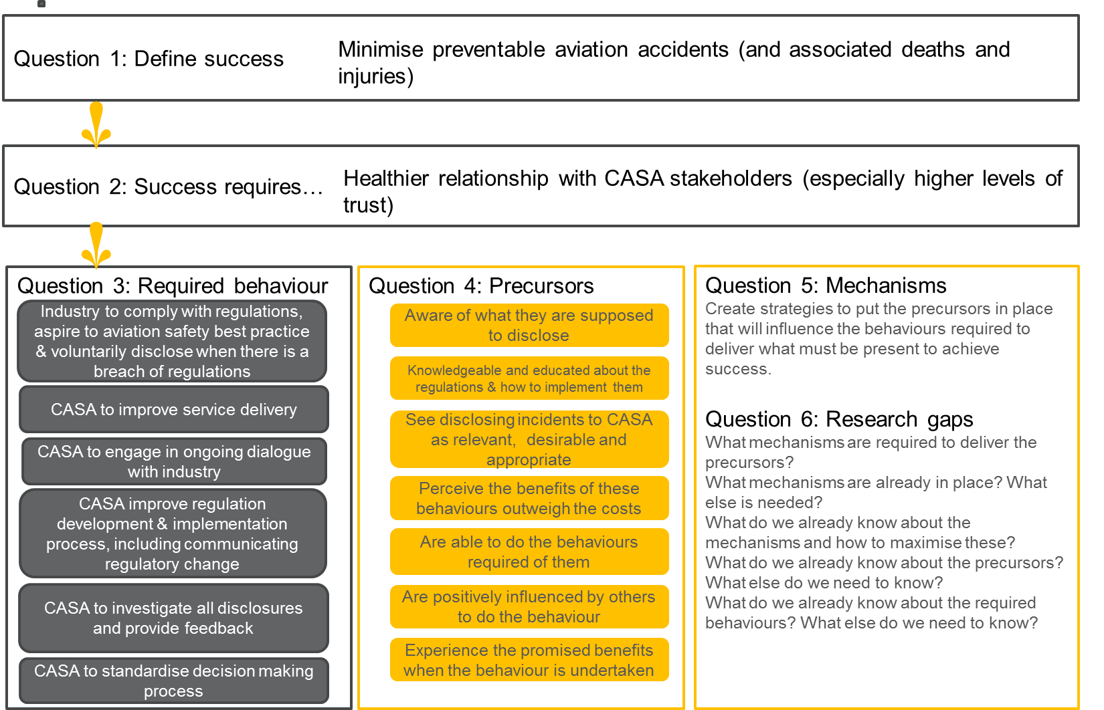

The 2015 survey measured the degree to which both industry and CASA were undertaking the required behaviours (or were perceived to be undertaking the required behaviours) needed to facilitate the healthier relationship needed to achieve CASA’s vision for success. Coming on the back of the initial senate enquiry, it was perhaps not surprising that the results were quite negative overall. However, these findings also provided a benchmark against which initiatives to improve the relationship could be monitored over time.

In August 2016, the CASA’s Director of Aviation Safety/Chief Executive Officer (CEO) approved an [action plan](https://www.casa.gov.au/standard-page/measuring-our-performance-action-plan) to address these inaugural findings. The action plan included initiatives that were already underway before the report was finalised, and also identified new initiatives that are required to improve the Customer’s relationship with the aviation community over time.

### Research objectives

With three years having elapsed since the initial stakeholder survey in 2015, the 2018 study was conducted to assess the impact of the range of change initiatives implemented following the initial survey in 2015. The 2018 research was required to:

* Explore current stakeholder perceptions with regard to CASA’s service provision and relationship with industry and measure changes in perceptions since the 2015 benchmark; and
* Provide guidance on how CASA could continue to improve both service delivery and its relationship with industry stakeholders.

# Methodology in brief

### Overview of research approach

In order to address CASA’s key objectives for the study, both quantitative and qualitative research methodologies were used. The research was conducted in a multi-stage process as outlined below.

* Stage One: Scoping workshop;
* Stage Two: Qualitative research with industry;
* Stage Three: Quantitative fieldwork; and
* Stage Four: Combined qualitative and quantitative analysis and reporting.
  + 1. Stage One: Scoping workshop

The initial scoping workshop was conducted on Wednesday 17th January between members of the Colmar Brunton and CASA project teams. The scoping meeting allowed a deeper knowledge of the objectives of the research, a dissuasion of the initiatives implements by CASA since the 2015 survey was conducted and finalisation of the research design.

* + 1. Stage Two: Qualitative research with industry

In order supplement the feedback obtained through the online survey, a qualitative research phase was undertaken canvassing the views and experiences of n=34 stakeholders across a broad cross section of the aviation sector.

Contact details for specific targeted stakeholders were provided, while general industry participants were randomly drawn from the broader list of aviation stakeholders provided by CASA to undertake the survey. The following table indicates the final breakdown of the n=34 depth interviews by stakeholder group.

Table 1: Completed qualitative interviews by stakeholder groups

|  |  |
| --- | --- |
| **Stakeholder type** | **Number of Depth Interviews** |
| Targeted stakeholders (Qantas, Virgin, TAAAF, AAA, RA Aus, RAPAC, RAAA, AAAA) | 9 |
| General industry participants (AOC holders, GA pilots, Helicopter pilots, RPT pilots, LAMEs, drone operators) | 25 |
| **TOTAL** | **34** |

All depth interviews were conducted between Wednesday 18th April and Tuesday 12th June 2018. In line with standard market research practices, each participant was offered an $80 electronic gift card to reimburse them for their time. Some participants declined this payment due to probity issues within their workplace.

The discussion guide used for these interviews can be found in Appendix A: Qualitative Interview Guide.

* + 1. Stage Three: Quantitative fieldwork

The quantitative questionnaire was largely the same as that used in 2015 in order to allow for comparisons to be made to the 2015 benchmark study. The only changes were additional code frames that were added as a result of responses to the 2015 study and an additional question was added which asked participants about the three most important areas CASA should focus on to improve aviation safety (Question QI.1). As with the 2015 research, the aim of the quantitative survey was to explore the indicators of relationship health with all CASA stakeholders.

While the questionnaire was largely unchanged, the sampling approach did change from a self-select opt in basis in 2015 to a random sampling approach (which was more likely to represent the CASA stakeholder population as a whole) in 2018. With the 2018 study, an initial random sample of 5,000 stakeholders was drawn by CASA from their database. Prior to the sample being provided to Colmar Brunton, CASA sent an introductory email to all stakeholders selected in the random sample, which outlined the purpose of the research, encouraged participation and provided the opportunity to opt-out of the research. Those who elected to opt out of the research were excluded from the sample file provided to Colmar Brunton. An initial email was sent which outlined the purpose of the research and contained a link to complete the survey. During the fieldwork period reminder emails were also sent to encourage further participation in the survey. Based on the completion rate observed with stakeholders in the initial sample file, CASA drew a second random sample of 6,000 stakeholders from their database and a decision was made for the fieldwork period extended. Once again CASA sent an introductory email to all stakeholders selected in this second sample file and those who elected to opt out of the research were excluded from the sample file sent to Colmar Brunton.

The following details the outcomes of the online survey:

* A fieldwork pilot was undertaken Thursday 5th April to Sunday 8th April;
* The main fieldwork was undertaken from Monday 9th April to Tuesday 5th June;
* A total of 11,000 stakeholders were randomly drawn by CASA from their database and invited to participate in the survey;
* Average interview length of 15 minutes; and
* A total of 1,168 surveys were completed.

The final questionnaire can be found in Appendix B: Quantitative Questionnaire.

* + 1. Stage Four: Analysis and reporting

This report presents the all stages of the stakeholder research undertaken in 2018, with the qualitative and quantitative findings presented in separate chapters.

Quantitative findings from the online survey are presented at the overall level. Sub-group analysis and reporting has been undertaken with the 2018 results which examined differences in the data by the following factors:

* Aviation sector primary role;
* Age;
* Gender;
* Location; and
* Length of time in the sector.

The final sample sizes achieved for each of these sub-groups can be seen in the following table.

Table 2: Completed interviews by subgroups used for tests of statistical significance

| **Subgroup** | **Sample achieved** |
| --- | --- |
| Aviation sector primary role | |
| Private flying | 219 |
| Remotely piloted aircraft systems | 160 |
| Licensed aircraft maintenance engineer | 88 |
| Air transport pilot | 79 |
| Recreational pilot/private pilot | 77 |
| Student pilot | 60 |
| Aerial work | 57 |
| Commercial pilot | 57 |
| Flight training including recreational, private and commercial pilot training organisations, and multi-crew training organisation | 52 |
| Regular public transport | 43 |
| Maintenance organisation | 39 |
| Chief pilot | 35 |
| Business aviation | 28 |
| Charter operator | 24 |
| Sport aviation (including self-administered organisations) | 19 |
| Government organisations | 16 |
| Air traffic controller | 15 |
| Aircraft maintenance engineer | 10 |
| Safety manager | 10 |
| Aerodrome services including ground handling, aviation rescue, and fire fighting | 9 |
| Chief engineer | 7 |
| Maintenance training organisation | 6 |
| Consultant & other professional services | 5 |
| Aircraft design/engineering/building | 2 |
| Aviation medicine | 2 |
| Maintenance authority | 1 |
| Cabin crew | 1 |
| Other (Specify) | 47 |
| Age | |
| Under 18 | 7 |
| 18-29 | 97 |
| 30-39 | 191 |
| 40-49 | 226 |
| 50-59 | 321 |
| 60 and over | 283 |
| Prefer not to answer | 43 |
| Gender |  |
| Male | 1,070 |
| Female | 48 |
| I prefer not to answer | 50 |
| Location |  |
| New South Wales | 311 |
| Victoria | 249 |
| Western Australia | 155 |
| Queensland | 266 |
| South Australia | 71 |
| Northern Territory | 37 |
| Australian Capital Territory | 15 |
| Tasmania | 14 |
| I don’t live in Australia | 50 |
| Length of time in sector |  |
| Less than 12 months | 60 |
| 1 - 3 years | 198 |
| 4 - 10 years | 175 |
| 11 - 20 years | 209 |
| 21 - 30 years | 185 |
| 31 - 40 years | 189 |
| More than 40 years | 152 |
| TOTAL SAMPLE | 1,168 |

### Interpreting this report

* + 1. Definitions

The following terms or abbreviations have been utilised throughout this report.

Table 3: Definitions

|  |  |
| --- | --- |
| Term of abbreviation | Definition |
| CASA | Civil Aviation Safety Authority |
| ATSB | Australian Transport Safety Bureau |

* + 1. Charts and tables

Charts included in this report display proportions using a numeric label. In some instances where the proportional responses are small and less than 3%, the numeric label may not be displayed if it is considered it would hinder the ability to read the chart.

* + 1. Percentages and averages

Percentages are generally rounded to whole numbers. Some percentages may not add to 100 percent due to rounding.

Some survey questions asked respondents to give a rating from 0 to 10. The classification used with **satisfaction** ratings was as follows:

* a rating of 0 or 1 is classified as extremely dissatisfied;
* a rating of 2 or 3 is classified as dissatisfied;
* a rating of 4, 5 or 6 is classified as neither satisfied nor dissatisfied;
* a rating of 7 or 8 is classified as satisfied; and
* a rating of 9 or 10 is classified as extremely satisfied.

The classification used with **agreement** ratings is as follows:

* a rating of 0 or 1 is classified as strongly disagree;
* a rating of 2 or 3 is classified as disagree;
* a rating of 4, 5 or 6 is classified as neither agree nor disagree;
* a rating of 7 or 8 is classified as agree; and
* a rating of 9 or 10 is classified as strongly agree.

Mean ratings are rounded to one decimal place. Please note that mean ratings **cannot** be translated into percentages. For example, a mean rating of 7.3 out of 10 cannot be interpreted as meaning 73% of people.

* + 1. Sorting of results

Where appropriate, results in the charts have been sorted from highest mean rating to lowest.

* + 1. Verbatim responses

Verbatim responses to the open-ended question asked of respondents have been reviewed and coded into themes. In addition, responses provided to the partially open ended questions at the code ‘Other (Please specify)’ have also been reviewed and if required coded into themes. The coding model was tailored to the individual questions and designed based on the obtained data to ensure accuracy and validity. Codes have been created when the number of respondents who provided that response is equal to or greater than 1% of the responses at each individual question.

* + 1. Tests of statistical significance

Tests for statistical significance have been conducted on particular subgroups of interest in this report for the 2018 survey results. An exception reporting approach has been undertaken in that if no statistical significance is mentioned, there are none associated with these groups.

Tests have been undertaken at a 95% confidence level (please note significance testing could not be undertaken on sample sizes smaller than n=30). If there is a statistically significant difference between the result for a particular group and the result for the wider population, we can be confident that this difference has not occurred by chance, rather that it reflects a genuine difference among that group compared to the wider population.

* + 1. Changes to sampling approach

In 2015, the original plan was to invite a random sample of CASA stakeholders to undertake the survey using CASA databases to generate the initial sample. Unfortunately, access to CASA’s databases for this purpose was not possible at the time. Rather, the survey was emailed only to those who had opted in to research & stakeholder consultation processes, while all other stakeholders were offered the opportunity to undertake the survey via a generic link published and promoted across a range of CASA’s communication channels.

As noted in the final report from the 2015 study, the opt-in nature of the survey meant that the findings could only be read as indicative of the broader sector, as opposed to being as truly representative of CASA’s broader stakeholder base (as would have been the case if a representative random sample had been selected and invited to participate in the survey).

With the 2018 study, the sampling approach changed to a random sampling strategy as was originally envisioned for the 2015 study. As mentioned previously access to CASA database’s was allowed and an initial random sample of 5,000 stakeholders was drawn. Prior to the sample being provided to Colmar Brunton, CASA sent an introductory email to all stakeholders selected in the random sample, which outlined the purpose of the research, encouraged participation and provided the opportunity to opt-out of the research. Those who elected to opt out of the research were excluded from the sample file provided to Colmar Brunton. An initial email was sent which outlined the purpose of the research and contained a link to complete the survey. During the fieldwork period reminder emails were also sent to encourage further participation in the survey. Based on the completion rate observed with stakeholders in the initial sample file, a decision was made for a second sample file to be provided and the fieldwork period extended. Once again CASA sent an introductory email to all stakeholders selected in this second sample file and those who elected to opt out of the research were excluded from the sample file sent to Colmar Brunton.

Due to the change in sampling approach (i.e. self-select opt in basis to a random sampling approach which is more likely to represent the CASA stakeholder population as a whole), Colmar Brunton has not undertaken significance testing between the 2015 and 2018 survey results. Instead commentary has been included which discusses the observed changes in stakeholder perceptions.

* + 1. Weighting

The results of this survey have not been weighted.

# Qualitative Findings

### Targeted stakeholders

Targeted stakeholders participating in the study were typically more positive in their attitudes towards CASA overall. Many identified that that the appointment of a new Director of Aviation Safety – along with some key changes in the executive leadership team - had facilitated a ‘reset’ of the relationship at the most senior level to a far more collaborative, transparent and constructive one. Whereas previously targeted stakeholders had raised issues but reported finding CASA senior management to be either unresponsive or unwilling to engage on topics of concern, they now felt the organisation had adopted much more of an ‘open door’ policy and a more genuine willingness to hear and consider the arguments they were making on either operational or regulatory matters.

Another key change observed by targeted stakeholders over the past two years is a sense that CASA is better recognising that industry values safety just as much as the regulator does, and that industry knowledge and experience can be more effectively leveraged to deliver better safety outcomes. There was scope of this at two levels – the first being the industry consultation that occurs as part of the regulatory reform process (ensuring proposed approaches will be practically workable upon implementation) and also in how regulations are applied and enforced (including mutually agreed understanding of what constitutes compliance and the consistent application of this across all industry participants).

While changes in CASA’s leadership group have facilitated a degree of cultural change, a number of targeted stakeholders indicated this was yet to be observed at the operational and local level. Not all are optimistic CASA middle managers and operational staff are capable of change and ‘getting on board’ with this, and are looking for the senior leadership group to encourage all staff to adopt a more collaborative and respectful relationship with industry across all levels of the organisation.

### General industry stakeholders

General industry stakeholders were commonly less positive in their assessment of the relationship between industry and CASA – often because perceptions had been formed from interaction some time ago. For many, there had been little direct interaction with the organisation beyond the minimum requirements related to the licencing of their respective aviation activities.

Perhaps the greatest barrier identified to a closer working relationship between CASA and industry was a view that CASA lacks sufficient understanding of the day to day challenges operators face. Operators pointed to the complexity of the regulatory requirements and the perceived misalignment between these and the practicalities of ensuring safe operations. There was a strong desire for greater consistency and certainty in terms of rule interpretation and enforcement by CASA auditors, and beyond this a desire for a much more streamlined and simplified regulatory framework.

Many industry stakeholders felt that CASA staff continue to operate on a ‘their way or the highway’ basis, albeit their most recent interaction was often some time ago. Some of these stakeholders questioned the reason why such a posture was adopted, with some questioning if a narrow and more rigid interpretation of a particular rule was driven by a lack of practical aviation knowledge and a concern about not being able to engage in an informed dialogue around the issue of interest.

However, the vast majority of industry stakeholders are open to greater engagement with CASA staff to facilitate a deeper mutual understanding of respective roles and challenges faced by both parties. There was a desire for more face to face contact with CASA to build trust and understanding on both sides (e.g. getting out onto the hanger floor) – not in an audit capacity – but just to observe aviation businesses at the coal face and talk to people about their work.

A number of stakeholders suggested that CASA’s approach to regulation should be more heavily influenced by sector risk profiles as opposed to the perceived ‘one size fits all’ model. Advocates of such an approach suggested this would allow CASA to target its limited resource base at sectors of the industry that present a more serious risk of non-compliance and/or aviation incident. A number of peak body representatives referenced the extensive work they had done in their sector to develop tailored safety management systems (and take-up of these), noting that such efforts should be reflected in a lowering of the sector’s risk profile to CASA.

The prevailing economic environment and low operator margins were identified by some stakeholders as driving sub-optimum safety outcomes in certain industry sectors. Examples cited by industry stakeholders included pilot fatigue due to poor rostering & length of duty in RPT, and aircraft owners putting undue pressure on LAMEs and pilots at the general aviation & charter level. In a relatively small sector, the power balance between employers and employees was commonly seen as favouring the former as people feel any whistleblowing action could severely impact future employment prospects in the industry.

### Attitudes towards safety

Feedback from stakeholders in the depth interviews indicated safety is paramount for all industry participants, with most feeling this to be managed well (and willingly) in the sector overall.

CASA is seen by most as playing a key role in facilitating safe aviation outcomes, with clear acceptance of the need for a strong and capable regulator overseeing the safety of the sector. However, the key challenge identified consistently across stakeholders remains the perceived gulf between the perceived wordy and inaccessible legislation and how this translates into actual behaviours and/or practices among industry participants (and indeed, how such rules are interpreted and enforced by CASA itself).

Risks of non-compliance are typically seen as more linked to the general aviation sector as opposed to RPT operations, where there are significant resources to develop detailed and dedicated systems to facilitate compliance (albeit safety challenges were recognised as affecting all industry sectors).

Some stakeholders working in smaller settings (non-commercial/rural) noted they find it challenging to manage the administration and paperwork involved in safety regulations (which are commonly perceived as both time and cost intensive). To this end, non-compliance with regulatory obligations is typically considered more of a ‘paperwork’ nature than a practical and/or tangible safety risk.

As with the previous study, stakeholders were asked how likely they would be to self-report a regulatory breach to CASA. Overall, likelihood to self-report non-compliance to CASA is mixed. For the majority, it would need to be a breach of some significance to motivate reporting to CASA. In a small industry, people have fears both for their own career prospects and the ongoing viability of their current employer. Perceptions that CASA would likely be ‘overly heavy handed’, along with concerns of the strict liability nature of some regulatory infringements were both identified as the key barriers to self-reporting breaches – suggesting CASA’s adoption of its ‘just culture’ regulatory philosophy needs to continue to be communicated to industry.

In terms of specific safety concerns, a number of specific issues were identified across the depth interviews:

* Some RPT pilots mentioned what they perceived to be unreasonable roster demands - and the resulting pilot fatigue - as a serious safety issue that CASA may not have full visibility of.
* Some pilots were concerned about nature of the current AvMed assessment process which leads to an unwillingness to disclose metal health challenges for fear of being grounded & losing income. It was suggested there is need for further reform needed in this space to ensure pilots can access the help and support they might need in a timely and effective manner.
* Some pilots and LAMEs – particularly in the GA and Charter space – mentioned being pressured by aircraft owners/AOC holders to reduce costs or push aircraft excessively. In a small industry they reported it can be difficult to push back on these directives both in fear of current employment and also in terms of impact on future employment opportunities.
* More spot checks & unannounced visits/audits desired at the GA & regional aviation end – there is a concern among some stakeholders that CASA is not visible enough which can lead to lax practices with little concern of detection.
* Supervision ratios of LAMEs to other engineering staff, especially in regional areas (e.g. should be 1:2 or 1:3 maximum, not 1:10 or 1:15 which has been observed in some situations).
* Concern about the new LAME training pathway which requires a big upfront investment to the monopoly training provider before a person even gets to experience what being a LAME might be like and whether it suits them – there is concern this will be a longer term safety problem as the supply of qualified LAMEs is reduced.
* Helicopter regulations – there is a need for more guidance on acceptable operations for left hand seat operators (e.g. emergency and rescue operators) – Certificate 4 in Aviation is viewed as insufficient, with a desire for more specialised training and certification for this critical role.

### Industry consultation approaches

Targeted stakeholders commented reasonably positively on the new consultation processes CASA has adopted, including the more selecting consultative committees and the expectation senior industry representatives will engage with their respective constituent groups and bring a collective and considered position to these forums. Importantly, the constitution of tight working groups with clearer terms of reference and tighter timeframes was seen as a far better model of driving critical issues to a point of resolution in a timely manner. There were a number of practical examples given of how this approach had yielded tangible value for both CASA and industry.

A number of targeted stakeholders noted CASA’s ceding ground to industry on some issues has seen an increase in respect for the organisation and has provided optimism for a more collaborative and productive relationship moving forward.

For broader industry, there is certainly a willingness to engage but CASA needs to recognise the time and cost imposts of any engagement process and minimise these where possible. Not all were aware of the more streamlined consultation approaches, suggesting there is a need for committee members to communicate both how broader industry stakeholder interests are being represented to CASA and the ways in which interested parties can contribute to this (e.g. by liaising with their respective peak body and/or committee member) and the benefits this revised approach is delivering for them.

While not all general industry stakeholders were familiar with CASA’s use of online consultation channels, such an approach was generally received quite favourably given the perceived flexibility and minimum impost of these types of channels.

### Regulatory reform process

While there is a considerable degree of ‘regulatory reform fatigue’ among many stakeholder, nearly all agreed on the importance of this work and the need to improve and further streamline the regulatory framework governing aviation activities across all sectors. While some are still concerned at the perceived mismanagement of key recent regulatory reforms, there is a degree of optimism that better industry engagement can help avoid these previous issues and ensure reforms are reasonable and workable for those affected. Of note, however, was the number of stakeholders who commented that the advised timeframe for completing the process was ‘fairly ambitious’ given their experiences to date.

At the broader industry level, many are still advocating for a far simpler regulatory model altogether. These stakeholders commonly point to regulatory models from other jurisdictions (U.S., Europe, New Zealand) as simpler and easier for participants to interpret and comply with. Others suggest the Australian regulations could be significantly improved through a reduction in the multiple layers and further consideration of whether the ‘strict liability’ approach is producing the desired behavioural outcomes.

Some industry stakeholders – particularly those in regional locations – suggested that the key challenge was not in further changes to the regulatory framework, but rather the need for CASA to more effectively police and enforce current regulations through more proactive and unannounced audit activity of aviation operations. It was argued that so long as CASA gave industry participants sufficient warning to ‘get their house in order’, such a move would enhance perceptions of the organisation as both vigilant and willing to take action against those who fail to meet their respective obligations (so long as any detected breaches are interpreted and dealt with in a consistent manner).

Overall, the perceived increasing willingness of CASA to engage and listen to industry to find ‘win/win’ solutions - including reviewing and potentially changing previously strongly advocated CASA positions – has many stakeholders adopting a ‘cautiously optimistic’ stance towards further regulatory reform.

### Need to drive culture change throughout CASA

Across all stakeholder groups there was a desire for CASA to work with industry to facilitate safe outcomes, not tell industry how safety is to be achieved by compliance with regulation or rules in isolation from actual industry practice. While some are seeing signs of this at the senior level, there is concern as to whether this can be driven across the organisation to both middle management and operational levels, where a significant change of culture is required (e.g. less policeman, more education and support).

Stakeholders suggested that a greater appreciation of industry’s willingness to comply at all levels – and adopting a solutions oriented mindset rather than punitive or adversarial approach – will over time engender greater trust and willingness for industry to voluntarily engage with CASA on a consistent basis.

A number of stakeholders noted a view that CASA’s human resources function - and recruitment practices specifically - need to ensure CASA staff have the right attitude towards exercising CASA’s regulatory roles and functions, not just the technical capacity to perform the role. This ‘right attitude’ was identified as a willingness to engage and collaborate with industry to foster compliance, as opposed to a narrow and inflexible interpretation and application of the relevant rules and regulations. Essentially, it involves an appreciation of industry’s willingness to comply, and helping to facilitate compliant outcomes.

Many stakeholders suggested a key driver of the culture change they feel is required would be greater face to face engagement - outside of audit activities - to ensure both CASA and industry can have a better understanding of each parties ‘world view’, challenges and constraints. Some targeted stakeholders took this a step further, advocating for the development of an exchange program that would allow for CASA and industry staff to be placed into each other’s organisation for a 3 to 6 month period.

### Timeliness & responsiveness still a key concern

There remains significant concern that CASA fails to appropriately understand the commercial realities of industry participants – particularly at the GA and Charter Operator level – in terms of CASA work flow processing. A number of stakeholders reported making what they perceived to be straight-forward requests for changes to licencing conditions or operating procedures, only to wait weeks, months - and in some cases years - for a response from CASA. This was viewed as completely inadequate, and sought to further crystallise already negatively held perceptions of the organisation among those impacted.

While resource constraints are acknowledged, there is a view that some in CASA do not understand the time and cost impact these delays have on industry participants. A number of stakeholders identified issues that they had raised with CASA which they presumed had been considered too challenging or difficult to deal with and as such ‘put aside’ for often indefinite amounts of time.

This lack of responsiveness was also observed from professional drone operators. One such operator recounted a story of being asked to quote on a project that would have required access to restricted airspace (filming for the Commonwealth Games around Coolangatta near Gold Coast Airport). When making his enquiry, he was advised CASA would require at least 2 weeks to consider this, and would require payment of $800 to process the request. This stakeholder felt both the time and costs were excessive, and as a result had to turn down the opportunity to quote (which the client had requested by supplied within 1 week). Given the growth in the professional drone operation market, such requests are likely to become increasingly common into the future.

### Drone operators

Obviously one of the major growth areas in CASA’s industry client base has been the significant increase in drone operation for both professional and recreational use. Several drone operators were included across the depth interviews with industry participants.

While most participants were quite complementary on how CASA had interacted with them and supported their safe drone operations, a number of issues were identified that warrant further consideration:

* While recognising CASA’s challenge in regulating this new and growing sector, some believe the current instructions and rules governing drone operations are still to ambiguous and that tighter definitions are required to support pilot decision making (e.g. ‘cant fly over a populous area’…what exactly does this mean?).
* The ‘Can I fly there?’ app CASA has developed to support drone operators is both liked and used – but a comment made by stakeholders was that mapping in the app itself not official, meaning other mapping resources need to be referenced in planning flight operations and seeking approvals or exemptions (if required).
* The ‘No fly zone’ exceptions or clearances– the process for obtaining these is not clearly explained on CASA website. Many had contacted local airfields or airports to seek local permission but felt a more consistent and detailed step-by-step guide would help ensure operators know exactly what is required of them.
* The ‘line of sight’ rule where an operator must be able to see the drone at all times during operation – can be onerous when working in remote locations (e.g. pipeline construction in far west Qld).
* As noted above, some feel requests for airspace permissions are too costly and slow for commercial operators.
* There was a sense that there could be further ongoing outbound information on best practices & regulation or rule changes provided for those drone operators interested to receive this (more so commercial operators).
* Some operators want a greater analysis of risk (e.g. drone failure rate) to appropriately shape operating rules as opposed to the current perceived ‘zero risk’ rule framework (e.g. blanket ban over flying over people).
* One operator who had lost expensive camera equipment to bird strike on multiple occasions suggested there may be scope for CASA to provide some education on bird breeding seasons to minimise bird strike incidence.

### CASA communications

Overall, most stakeholders indicated that they feel well informed and receive regulatory updates from CASA as they occur. Some feel there is not enough information specifically for them (e.g. LAMEs feel seminars are focussed on pilots and AOC holders and would like similar opportunities for them).

In line with previously observed feedback, many stakeholders still indicated a desire for simpler, clearer language and models or examples of behaviour that would facilitate compliance with specific regulations.

In terms of communication format and content, most have a preference for video content, flow charts and diagrams over swathes of written text. Most stakeholders are keen to comply with their regulatory obligations, but want to be able to understand their obligations quickly and easily so as to minimise the time (and cost) impost required.

As noted above, the key missing part of CASA communications and engagement was the strong desire for more face to face interaction for broader industry to build trust and develop a more collaborative and open relationship between CASA and industry.

Finally, some believe media management could be modernised with a more front foot, proactive agenda as opposed to the perceived predominantly reactive model at present.

### Key priorities over next 18-24 months

Stakeholders typically identified the following key priorities they would like CASA to focus on for next 18 – 24 months:

* Finalising the regulatory reform program – there is recognition that finalisation of the regulatory reform program is the most important in terms of providing certainty for both CASA and industry participants. The timeframe for finalisation is seen as challenging and will require close management if this is to be achieved, however initial signs for the new consultation process are positive.
* Once the regulatory reform program in finalised, a program to work on consistency of application of the final regulations - both current and new regulations across all of CASA (including regional offices). Stakeholders expect CASA to work hard to increase the consistency of rulings and decision making, which will require greater collaboration, information sharing and decision review processes across the organisation.
* Development of a cultural change program within CASA so all that all staff, at all levels of the organisation, are on the same page with the leadership as to the nature of the relationship with industry CASA aspires to and the benefits such a relationship will deliver for aviation safety more broadly. A key part of this program will involve CASA staff (at all levels) getting out and meeting with industry participants more often with the intent to foster greater trust and understanding between both parties.

# Quantitative findings

### Sample profile

During the 2018 fieldwork period a total of n=1,168 stakeholders completed the survey, while in 2015 1,217 stakeholders completed the survey. In terms of the demographic profile of the 2018 and 2015 survey respondents the following was observed:

* In terms of age, 2018 survey respondents included a higher proportion who were in the younger age groups and fewer in the older age groups. In 2018, approximately one quarter were aged under 40 (26% 2018 vs 17% 2015), while a further quarter were aged 60 years or over (24% 2018 vs 34% 2015).
* With regards to gender, the distribution among the 2018 and 2015 survey respondents was the same.
* In 2018 there was a slight skew towards respondents who did not own or operate an aircraft of any kind (52% 2018 vs 47% 2015), while in 2015 there was a slight skew towards respondents who own or operate an aircraft of any kind (48% 2018 vs 53% 2015).
* There were more respondents in 2018 who indicated that their current primary role was remotely piloted aircraft systems (14% 2018 vs 1% 2015), licensed aircraft maintenance engineer (8% 2018 vs 4% 2015), student pilot (5% 2018 vs 1% 2015) or chief pilot (3% 2018 vs 0% 2015). There was also fewer respondents in 2018 who indicated that their current primary role was private flying (19% 2018 vs 22% 2015), flight training (4% 2015 vs 12% 2015), maintenance organisation (3% 2018 vs 5% 2015), business aviation (2% 2018 vs 4% 2015), charter operator (2% 2018 vs 4% 2015) and sport aviation (2% 2018 vs 4% 2015).
* With regards to location, there were more respondents in 2018 who lived in Western Australia (13% 2018 vs 11% 2015) or indicated they didn’t live in Australia (4% 2018 vs 2% 2015). There was also fewer respondents who lived in New South Wales (27% 2018 vs 30% 2015) and ACT (1% 2018 vs 3% 2015).
* Following on from age, there was also a greater proportion of respondents who had been in the sector less than 3 years (22% 2018 vs 4% 2015) and fewer who had been in the sector for more than 30 years (29% 2018 vs 43% 2015).

The following figure provides further details of the demographic profile of the 2018 and 2015 survey respondents.

Figure 3: Demographic profile of 2018 and 2015 survey respondents

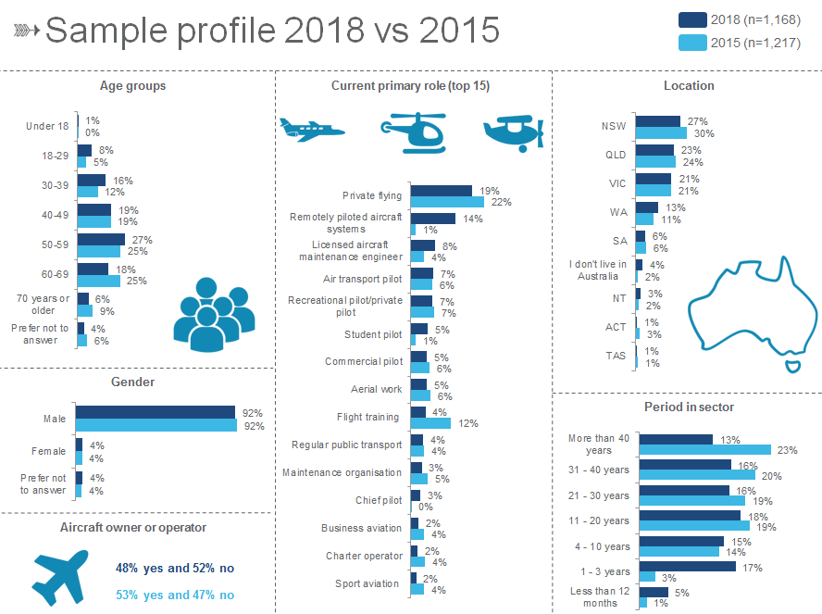

QJ5. Which of the following age groups do you fall into?  
QJ1. Please indicate your gender.  
QJ3. Are you an aircraft owner or operator of any kind?  
QJ2. Which of the following best describes your current primary role in the aviation sector?  
QJ6. Where are you based?  
QJ7. How long have you been operating or involved in the aviation sector for?  
Base: All respondents 2018 (n=1,168); all respondents 2015 (n=1,217)

### Overall satisfaction

* + 1. Satisfaction with relationship with CASA

Survey respondents were asked to rate how satisfied they were with their overall relationship with CASA on a scale of 0-10, where 0 was ‘very dissatisfied’ and 10 was ‘very satisfied’. The mean satisfaction rating observed across the sample in 2018 was 6.2, which is an improvement on the mean satisfaction rating of 4.2 observed in 2015.

In 2018, just over half of all respondents indicated they were either satisfied (30%) or very satisfied (23%) with the relationship they have with CASA. A further 25% were neutral, and one fifth were either dissatisfied (12%) or very dissatisfied (8%) – this proportion is down substantially from that observed in 2015.

Figure 4: Overall satisfaction with relationship with CASA

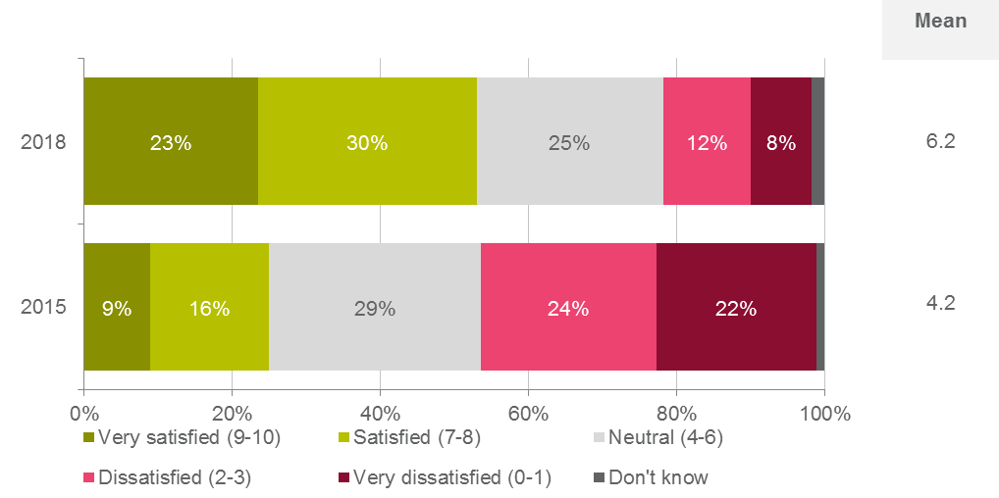

QA1. On a scale of 0 -10 where 0 is ‘very dissatisfied’ and 10 is ‘very satisfied’, how satisfied are you with your relationship with CASA?   
Base: All respondents 2018 (n=1,168); all respondents 2015 (n=1,217)

When examining the mean satisfaction rating, the following statistically significant differences were observed by sub-groups:

* Those aged 18-29 years (mean of 6.9) were more likely to be satisfied with their relationship with CASA with a significantly higher mean rating observed.
* In regards to primary role in the sector, those in remotely piloted aircraft systems (mean of 8.0) and student pilots (mean of 7.4) were more likely to be satisfied with their relationship with CASA with significantly higher mean ratings observed. Conversely, commercial pilots (mean of 5.4), those in regular public transport (mean of 4.9) and air transport pilots (mean of 4.5) were less likely to be satisfied with their relationship with CASA with significantly lower mean ratings observed.
* Those who were relatively new to the sector – i.e. less than 12 months (mean of 8.1) or 1-3 years (mean of 7.7) - were more likely to be satisfied with their relationship with CASA with significantly higher mean ratings observed. Conversely, those who had been in the sector for 11-20 years (mean of 5.6), 31-40 years (mean of 5.7) or more than 40 years (mean of 5.5) were less likely to be satisfied with their relationship with CASA with significantly lower mean ratings observed.
* There were no statistically significant differences by gender or location.
  + 1. Reasons for a low satisfaction rating

Respondents were subsequently asked in an open ended question to provide a reason for their rating. All comments were then coded for further analysis, including identification of key themes and patterns in the rationale given for their overall satisfaction rating.

Of those who gave an overall satisfaction rating of 0-3, the most common reason given for the poor rating in both 2018 and 2015 was unsatisfactory service and support received from CASA (32% an 29% respectively). This included delays in processing licence applications or renewals and difficulties contacting people within the organisation that could assist them.

The second most common response in 2018 was related to medical processes and unsatisfactory AvMed service (13%), with these respondents mentioning overzealous medical processes and the inefficiency of AvMed. This was the eighth most common response in 2015.

The third most common reason for giving a low score in 2018 was the perception that CASA is overly bureaucratic and risk-averse (12%), with a number of these respondents mentioning CASA operates with “too much red tape”. This was the second most common response in 2015.

A number of other reasons were provided, however in 2018 these were mentioned by less than 8% of respondents.

There were no statistically significant differences seen by gender, age, location, primary role in the sector or length of time in the sector.

Figure 5: Reasons for scoring satisfaction with CASA as 0-3

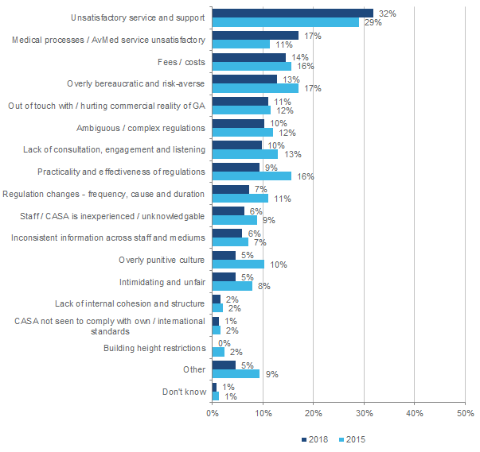

QA2. Why is that?   
Base: Respondents rating 0-3 at QA1 2018 (n=xxx); respondents rating 0-3 at QA1 2015 (n=552)

* + 1. Reasons for a moderate rating

Among those providing an overall satisfaction rating of between 4, 5 or 6 on the 0-10 scale, responses were mixed. Unsatisfactory service and support (36%) was again the most common reason provided for a moderate satisfaction score in 2018.

Similar to the lower-scoring group, medical processes and unsatisfactory AvMed service (13%) and perceptions that CASA was overly bureaucratic and a risk-averse (12%) were other common rationales given for a moderate satisfaction rating.

A number of other reasons were provided, however in 2018 these were mentioned by less than 8% of respondents.

There were no statistically significant differences seen by gender, age, location, primary role in the sector or length of time in the sector.

Figure 6: Reasons for scoring satisfaction with CASA as a 4 - 6

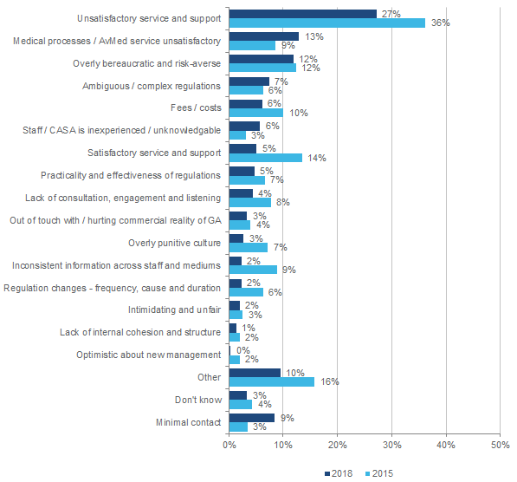

QA2. Why is that?   
Base: Respondents rating 4-6 at QA1 2018 (n=xxx); respondents rating 4-6 at QA1 2015 (n=348)

* + 1. Reasons for a high satisfaction rating

For respondents who gave a rating of 7-10, positive interactions with CASA topped the responses in 2018 with over a quarter (28%) commenting on the speediness and effectiveness of service and support. A further 27% of respondents noted a generally good relationship with or perception of CASA, and another 15% positively mentioned the professionalism and knowledge of staff as their reason for the positive satisfaction rating. These were also the three most common reasons provided in 2015.

There were no statistically significant differences seen by gender, age, location, primary role in the sector or length of time in the sector.

Figure 7: Reasons for scoring satisfaction with relationship with CASA as a 7 - 10

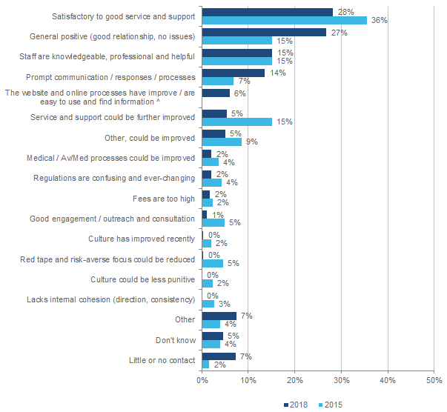

QA2. Why is that?   
Base: Respondents rating 7-10 at QA1 2018 (n=xxx); respondents rating 7-10 at QA1 2015 (n=304)  
^ New code created from verbatim responses provided in 2018.

* + 1. Satisfaction with CASA’s performance

In order to explore what dimensions of the relationship between stakeholders and CASA impact on overall satisfaction, respondents were asked to rate their satisfaction against a number of key performance dimensions. Across the 21 dimensions of performance participants were asked to rate on a scale of 0-10 (with 0 being ‘very dissatisfied’ and 10 being ‘very satisfied’), the highest mean ratings in 2018 were observed for:

* ‘Respects your confidentiality’ (mean of 7.7);
* ‘Operates with safety as its primary focus’ (mean of 6.8); and
* ‘Shares information and knowledge willingly’, ‘Provides competent and capable staff’ and ‘Is efficient in its dealings with you’ (all with means of 6.3).

Four of these five performance dimensions also recorded the highest mean ratings in 2015 – the one exception was ‘Is efficient in its dealings with you’ (2015 mean of 4.0, ranked seventh).

Conversely, those performance dimensions which scored the lowest mean ratings among the 21 dimensions presented were:

* ‘Strives to minimise administrative costs and charges’ (mean of 4.3);
* ‘Is innovative and open to new ideas’ (mean of 4.7);
* ‘Is openly accountable for its actions’ (mean of 5.0); and
* ‘Balances consistency and flexibility’ (mean of 5.2).

All four of these performance dimensions also recorded the lowest mean ratings in 2015.

Importantly, since 2015, the mean ratings for all 21 dimensions have increased.

Figure 8: Satisfaction with individual performance measures

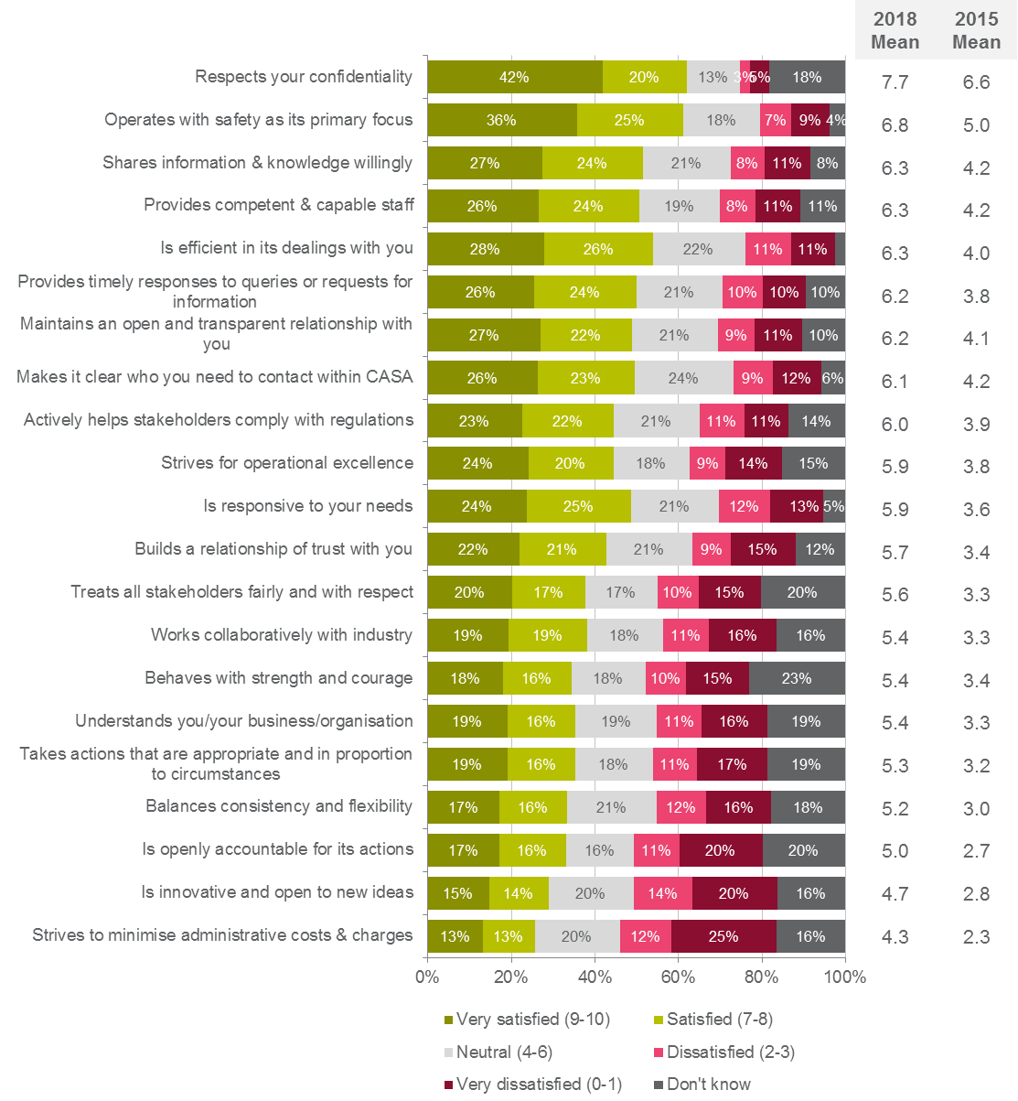

QA3. Please rate how satisfied you are with the following aspects of CASA’s performance on a scale of 0 to 10, where 0 is ‘very dissatisfied’ and 10 is ‘very satisfied’.   
Base: All respondents 2018 (n=1,168); all respondents 2015 (n=1,217)

When examining the mean satisfaction ratings across these performance dimensions, the following statistically significant differences were observed by sub groups:

* Females were more likely to be satisfied with the following aspects of CASA”s performance: ‘Operates with safety as its primary focus’ (mean of 8.1),’Shares information and knowledge willingly’ (mean of 7.7), ‘Is efficient in its dealings with you’ (mean of 7.5), ‘Strives for operational excellence’ (mean of 7.4), ‘Provides competent and capable staff’ (mean of 7.4), ‘Works collaboratively with industry’ (mean of 7.0), ‘Builds a relationship of trust with you’ (mean of 7.0), ‘Treats all stakeholders fairly and with respect’ (mean of 6.9), ‘Is responsive to your needs’ (mean of 6.9), ‘Behaves with strength and courage’ (mean of 6.8), ‘Balances consistency and flexibility’ (mean of 6.7), ‘Understands you/your business/organisation’ (mean of 6.6), ‘Is openly accountable for its actions’ (mean of 6.4), and ‘Is innovative and open to new ideas’ (mean of 6.1).
* Across ages, the following significant differences were observed:
  + Respondents aged 18-29 were more likely to be satisfied with each of the statements, with the exception of ‘Maintains an open and transparent relationship with you’ (mean of 6.8).
  + Those aged 30-39 were less likely to be satisfied with ‘Strives for operational excellence’ (mean of 5.3).
  + Those aged 50-59 were more likely to be satisfied with ‘Shares information and knowledge willingly’ (mean of 6.7), and ‘Strives to minimise administrative costs and charges’ (mean of 4.8).
  + Those aged 70 years or older were less likely to be satisfied with ‘Treats all stakeholders fairly and with respect’ (mean of 4.5), ‘Is innovative and open to new ideas’ (mean of 3.7), and ‘Strives to minimise administrative costs and charges’ (mean of 3.4).
* Queensland respondents were less likely to be satisfied with ‘Operates with safety as its primary focus’ (mean of 6.3)
* Respondents who do not live in Australia were more likely to be satisfied with ‘Operates with safety as its primary focus’ (mean of7.5), ‘Shares information and knowledge willingly’ (mean of 7.2), ‘Actively helps stakeholders comply with regulations’ (mean of 7.0), ‘Works collaboratively with industry’ (mean of 6.8), ‘Builds a relationship of trust with you’ (mean of 6.7), ‘Is openly accountable for its actions’ (mean of 6.4), ‘Is innovative and open to new ideas’ (mean of 6.0), and ‘Strives to minimise administrative costs and charges’ (mean of 5.7).
* In terms of length of time in the sector, a number of significant differences were observed which included:
  + Those who have been in the aviation for sector for less than 12 months or for 1-3 years were more likely to be satisfied with each of the statements. Furthermore, those who have been in the sector for 4-10 years were more likely to be satisfied with ‘Respects your confidentiality’ (mean of 8.3), and ‘Treats all stakeholders fairly and with respect’ (mean of 6.2).
  + Those who have been in the aviation sector for 11-20 years or for more than 40 years were less likely to agree with each of the statements, excluding ‘Respects your confidentiality’ (means of 7.3 and 7.1 respectively).
  + Those who have been in the aviation sector for 21-30 years were less likely to be satisfied with ‘Respects your confidentiality’ (mean of 7.2), ‘Operates with safety as its primary focus’ (mean of 6.1), ‘Provides competent and capable staff’ (mean of 5.7), ‘Is efficient in its dealings with you’ (mean of 5.7), ‘Maintains an open and transparent relationship with you’ (mean of 5.6), ‘Is responsive to your needs’ (mean of 5.3), ‘Is openly accountable for its actions’ (mean of 4.4), and ‘Strives to minimise administrative costs and charges’ (mean of 3.7).
  + Those who have been in the aviation sector for 31-40 years were less likely to be satisfied with each of the statements (means ranging from 4.0 to 6.1), excluding the following three statements: ‘Respects your confidentiality’ (mean of 7.2), ‘Maintains an open and transparent relationship with you’ (mean of 5.8), and ‘Strives to minimise administrative costs and charges’ (mean of 3.8).
* With regards to their primary role in the aviation sector, a number of significant differences were observed:
  + Those doing aerial work were less likely to be satisfied with ‘Actively helps stakeholders comply with regulations’ (mean of 4.6), ‘Treats all stakeholders fairly and with respect’ (mean of 4.3), and ‘Works collaboratively with industry’ (mean of 4.2).
  + Those doing private flying were less likely to be satisfied with ‘Understands you/your business/organisation’ (mean of 4.8), ‘Balances consistency and flexibility’ (mean of 4.7), ‘Strives to minimise administrative costs and charges’ (mean of 3.7).
  + Those involved with regular public transport were less likely to be satisfied with each of the statements (means ranging from 2.9 to 5.2), with the exceptions of ‘Respects your confidentiality’ (mean of 7.0), ‘Provides timely responses to queries or requests for information’ (mean of 5.1), ‘Is responsive to your needs’ (mean of 5.0), ‘Understands you/your business/organisation’ (mean of 4.6).
  + Those involved with flight training were less likely to be satisfied with ‘Provides competent and capable staff’ (mean of 5.2), ‘Is efficient in its dealings with you’ (mean of 5.2), ‘Provides timely responses to queries or requests for information’ (mean of 4.9), ‘Understands you / your business / organisation’ (mean of 4.2).
  + Commercial pilots were less likely to be satisfied with ‘Operates with safety as its primary focus’ (mean of 5.6), ‘Provides competent and capable staff’ (mean of 5.2), ‘Shares information and knowledge willingly’ (mean of 4.9), ‘Strives for operational excellence’ (mean of 4.8), ‘Actively helps stakeholders comply with regulations’ (mean of 4.5), ‘Maintains an open and transparent relationship with you’ (mean of 4.5), ‘Treats all stakeholders fairly and with respect’ (mean of 4.4.), ‘Takes actions that are appropriate and in proportion to circumstances’ (mean of 4.1) , ‘Builds a relationship of trust with you’ (mean of 4.1), ‘Understand you / your business / organisation’ (mean of 3.9), ‘Works collaboratively with industry’ (mean of 3.9), ‘Is openly accountable for its actions’ (mean of 3.7), ‘Is innovative and open to new ideas’ (mean of 3.4), ‘Strives to minimise administrative costs and charges’ (mean of 3.1).
  + Air transport pilots were less likely to be satisfied with each of the statements (means ranging from 2.6 to 6.7).
  + Those involved with remotely piloted aircraft systems were more likely to be satisfied with each statement (means ranging from 7.1 to 9.0).
  + Student pilots were more likely to be satisfied with each statement (means ranging from 6.2 to 8.6), with the exclusion of ‘Strives to minimise administrative costs and charges’ (mean of 5.3).
  + Recreational pilots/private pilots were more likely to be satisfied with ‘Respects your confidentiality’ (mean of 8.4), ‘Provides competent and capable staff’ (mean of 7.2), ‘Shares information and knowledge willingly’ (mean of 7.1), ‘Strives for operational excellence’ (mean of 6.9), ‘Understands you / your business / organisation’ (mean of 6.4).

### Compliance with aviation safety regulations

* + 1. Ease of compliance

Respondents were asked to indicate how easy or difficult it was to comply with their aviation safety regulations on a scale of 0 to 10, where 0 was ‘very difficult’ and 10 was ‘very easy’. The mean rating observed in 2018 was 5.9, which was higher than the mean rating of 4.2 observed in 2015.

In 2018, half of all respondents felt compliance was either very easy (22%) or easy (28%) with the relationship they have with CASA. A further 24% were neutral, and approximately one quarter felt compliance was either difficult (13%) or very difficult (11%).

Figure 9: Ease of complying with aviation safety regulations

c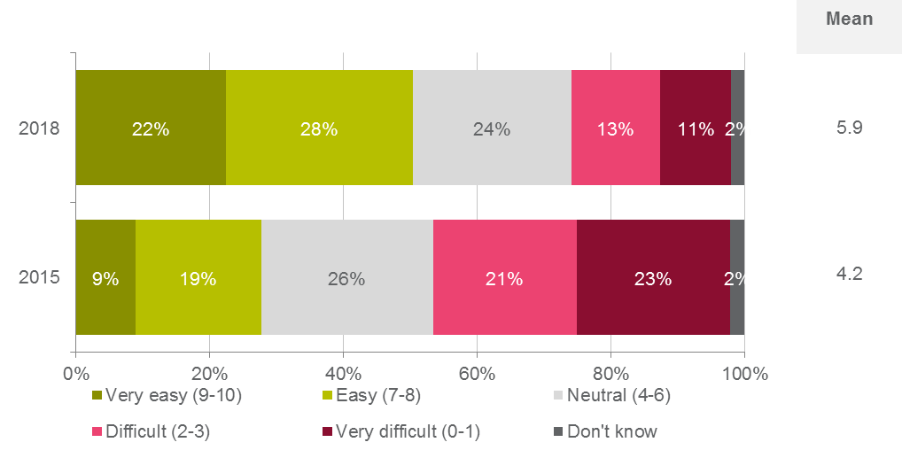

QB1. On a scale of 0 to 10, where 0 is ‘very difficult’ and 10 is ‘very easy’, how easy or difficult is it for you to fully comply with all aviation safety regulations relevant to your role or activities?   
Base: All respondents 2018 (n=1,168); all respondents 2015 (n=1,217)

When examining the mean compliance rating, the following statistically significant differences were observed by sub-groups:

* Females (mean of 7.3) were more likely to rate compliance with air safety regulations as easy with a significantly higher mean rating observed.
* Those aged 18-29 years (mean of 7.2) were more likely to rate compliance with air safety regulations as easy with a significantly higher mean rating observed.
* In regards to primary role in the sector, those in remotely piloted aircraft systems (mean of 7.3) and student pilots (mean of 7.0) were more likely to rate compliance with air safety regulations as easy with significantly higher mean ratings observed. Conversely, those in regular public transport (mean of 4.6), commercial pilots (mean of 4.8) and air transport pilots (mean of 4.9) were less likely to rate compliance with air safety regulations as easy with significantly lower mean ratings observed.
* Those who were relatively new to the sector – i.e. less than 12 months (mean of 7.8) or 1-3 years (mean of 7.3) - were more likely to rate compliance with air safety regulations as easy with significantly higher mean ratings observed. Conversely, those who had been in the sector for 11-20 years (mean of 5.5), 21-30 years (mean of 5.3), 31-40 years (mean of 5.3) or more than 40 years (mean of 5.3) were less likely to rate compliance with air safety regulations as easy with significantly lower mean ratings observed.
* There were no statistically significant differences by location.
  + 1. Confidence in ability to comply

Respondents were then asked to rate their confidence in their ability to comply with aviation safety regulations governing their activities on a scale of 0 to 10, where 0 was ‘not at all confident’ and 10 was ‘very confident’. The mean rating observed in 2018 was 7.4, which was higher than the mean rating of 5.8 observed in 2015.

In 2018, approximately three quarters of all respondents indicated that they were either confident (28%) or very confident (43%) in their ability to comply with all aviation safety regulations relevant to their role. A further 16% were neutral on the matter, and approximately one in ten indicated they were not confident (6%) or not at all confident (5%).

Figure 10: Confidence in ability to comply with safety regulations

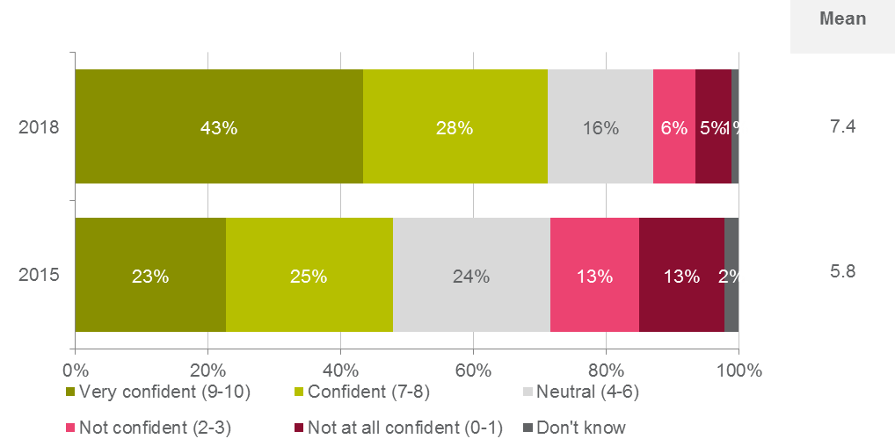  
QB2. On a scale of 0 to 10, where 0 is ‘not at all confident’ and 10 is ‘very confident’, how confident are you in your ability to comply with all aviation safety regulations relevant to your role? Base: All respondents 2018 (n=1,168); all respondents 2015 (n=1,217)

When examining the mean confidence rating, the following statistically significant differences were observed by sub-groups:

* Those aged 18-29 (mean of 8.3) years were more likely to be confident in their ability to comply with all aviation safety regulations relevant to their role with a significantly higher mean rating observed.
* In regards to primary role in the sector, those in remotely piloted aircraft systems (mean of 8.8) were more likely to be confident in their ability to comply with all aviation safety regulations relevant to their role with a significantly higher mean rating observed. Conversely, air transport pilots (mean of 6.4) were less likely to be confident in their ability to comply with all aviation safety regulations relevant to their role with significantly lower mean ratings observed.
* Those who were relatively new to the sector – i.e. less than 12 months (mean of 8.7) or 1-3 years (mean of 8.5) - were more likely to be confident in their ability to comply with all aviation safety regulations relevant to their role with a significantly higher mean rating observed. Conversely, those who had been in the sector for more than 40 years (mean of 6.8) were less likely to be confident in their ability to comply with all aviation safety regulations relevant to their role with a significantly lower mean rating observed.
* There were no statistically significant differences by gender or state.  
  + 1. Attitudes towards compliance

To further explore stakeholder perceptions of complying with their aviation safety regulations, a battery of statements were developed with respondents asked to indicate their level of agreement with each statement on a 0-10 scale (0 being ‘strongly disagree’, and 10 being ‘strongly agree’).

The findings showed moderate to neutral levels of agreement with most statements in 2018, with the mean ratings for all seven statements increasing since 2015. The highest mean rating in 2018 was observed with the statement ‘Regulations play a key role in ensuring I operate safely’ at 7.2, followed by ‘I have a sound understanding of all the regulations governing my activities’ at 6.8. These two statements also recorded the highest mean ratings in 2015.

The two statements that were observed to have the lowest mean ratings in 2018 were ‘CASA explains the regulations and how they affect industry stakeholders in a clear and succinct manner’ at 5.2 and ‘Regulations covering my activities are easy to understand’ at 5.4. The first statement recorded the lowest mean rating in 2015, while the second statement recorded the third lowest mean rating in 2015.

Figure 11: Agreement with compliance statements

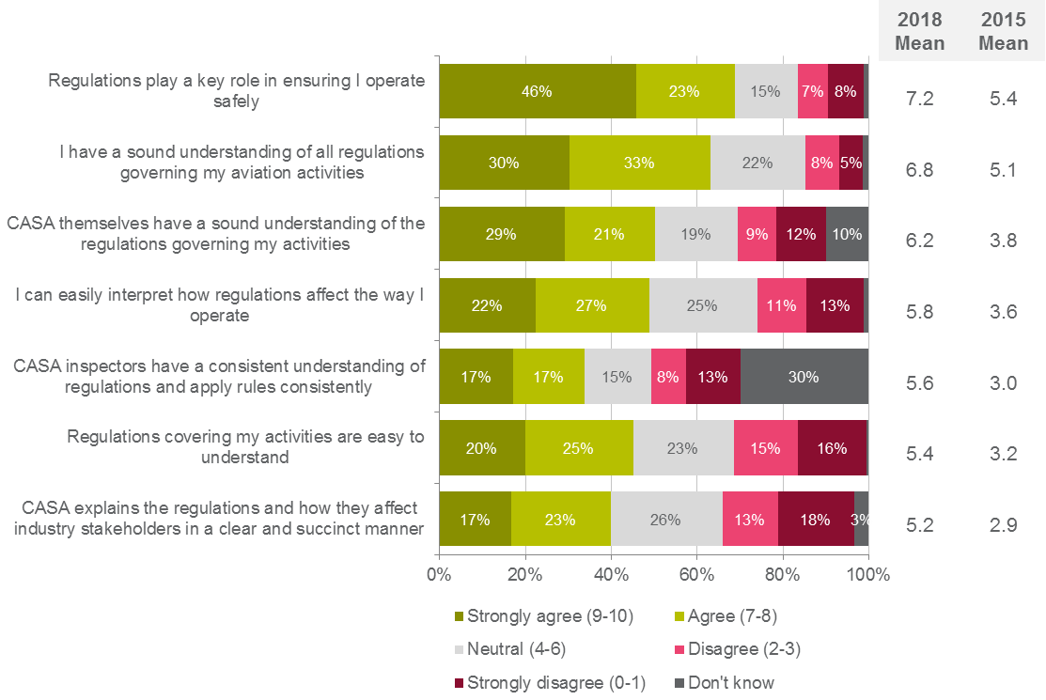

QB3. On a scale of 0 to 10, where 0 is ‘strongly disagree’ and 10 is ‘strongly agree’, please indicate your level of agreement with the following statements.   
Base: All respondents 2018 (n=1,168); all respondents 2015 (n=1,217)

When examining the mean satisfaction ratings across these compliance statements, the following statistically significant differences were observed by sub groups:

* Females were more likely to be satisfied that ‘CASA themselves have a sound understanding of the regulations governing my aviation activities’ (mean of 7.3), ‘I can easily interpret how regulations affect the way I operate’ (mean of 6.9), ‘CASA inspectors have a consistent understanding of regulations and apply rules consistently’ (mean of 6.9), ‘Regulations covering my activities are easy to understand’ (mean of 6.5) and ‘CASA explains the regulations and how they affect industry stakeholders in a clear and succulent manner’ (mean of 6.5) with significantly higher mean ratings observed.
* Respondents aged 18-29 were more likely to be satisfied with all seven compliance statements with significantly higher mean ratings observed for each one.
* Respondents who indicated they lived outside of Australia were more likely to be satisfied that 'Regulations play a key role in ensuring I operate safely’ (mean of 8.0), ‘CASA themselves have a sound understanding of the regulations governing my aviation activities’ (mean of 7.3), ‘Regulations covering my activities are easy to understand’ (mean of 6.4) and ‘CASA explains the regulations and how they affect industry stakeholders in a clear and succulent manner’ (mean of 6.2) with significantly higher mean ratings observed.
* In terms of primary role in the sector, a number of significant differences were observed which included:
  + Those with remotely pilot aircraft systems were more likely to be satisfied with all seven compliance statements with significantly higher mean ratings observed for each one.
  + Students were more likely to be satisfied that ‘Regulations covering my activities are easy to understand’ (mean of 8.3), ‘CASA themselves have a sound understanding of the regulations governing my aviation activities’ (mean of 7.6), ‘CASA inspectors have a consistent understanding of regulations and apply rules consistently’ (mean of 7.2), 'Regulations play a key role in ensuring I operate safely’ (mean of 6.3) and ‘CASA explains the regulations and how they affect industry stakeholders in a clear and succulent manner’ (mean of 6.3) with significantly higher mean ratings observed.
  + Recreational pilots and private pilots were more likely to be satisfied that ‘CASA themselves have a sound understanding of the regulations governing my aviation activities’ (mean of 7.4) and ‘CASA inspectors have a consistent understanding of regulations and apply rules consistently’ (mean of 7.0) with significantly higher mean ratings observed.
  + Those in regular public transport, flight training organisations, commercial pilots and air transport pilots were less likely to be satisfied that that ‘Regulations covering my activities are easy to understand’ (means of 3.8 to 4.4), ‘CASA explains the regulations and how they affect industry stakeholders in a clear and succulent manner’ (means of 3.4 to 4.0) and ‘CASA themselves have a sound understanding of the regulations governing my aviation activities’ (means 4.3 to 5.0) with significantly lower mean ratings observed.
  + Further those in regular public transport, flight training organisations and air transport pilots were also less likely to be satisfied that ‘I can easily interpret how regulations affect the way I operate’ (means of 4.1 to 4.7) and ‘CASA inspectors have a consistent understanding of regulations and apply rules consistently’ (means of 3.8 to 4.2) with significantly lower mean ratings observed.
  + In addition air transports pilots were also less likely to be satisfied that 'Regulations play a key role in ensuring I operate safely’ (mean of 6.3) with a significantly lower mean rating observed.
  + Those in aerial work were less likely to be satisfied that ‘CASA themselves have a sound understanding of the regulations governing my aviation activities’ (mean of 4.9) with a significantly higher mean rating observed.
  + Those in private flying were less likely to be satisfied that ‘I have a sound understanding of all the regulations governing my activities’ (mean of 6.4) with a significantly higher mean rating observed.
* Those who were relatively new to the sector – i.e. less than 12 months (mean of 8.7) or 1-3 years (mean of 8.5) - were more likely to be satisfied with all seven compliance statements with significantly higher mean ratings observed for each one. Conversely, those who had been in the sector for longer – i.e. 11-20 years, 21-30 years, 31-40 years or more than 40 years – were less likely to be satisfied with all seven compliance statements with significantly lower mean ratings generally observed for each one.
* Further respondents who had been in the sector for 4-10 years were more likely to be satisfied that ‘Regulations covering my activities are easy to understand’ (mean of 5.9) with a significantly higher mean rating observed.

### Aviation safety best practice

* + 1. Time spent demonstrating best practice

As per the agreed Programme Logic model developed at the start of the project in 2015, one of the key behaviours CASA sought of stakeholders was for them to both aspire to and operate in accordance with known best practice in terms of aviation safety practices. To this end, stakeholders were asked the amount of time they felt they conducted their aviation activities in line with industry best practice on a 0-10 scale, where 0 represented ‘never’ and 10 represented ‘at all times’. The mean rating observed in 2018 was 9.0 which was higher than the mean rating of 8.6 observed in 2015.

In 2018, the vast majority of respondents indicated they demonstrated best practice in their aviation safety activities either always (71%) or most of the time (23%). Only 4% indicated approximately half of the time and just 1% indicated sometimes or never.

Figure 12: How frequently are activities in line with best practice

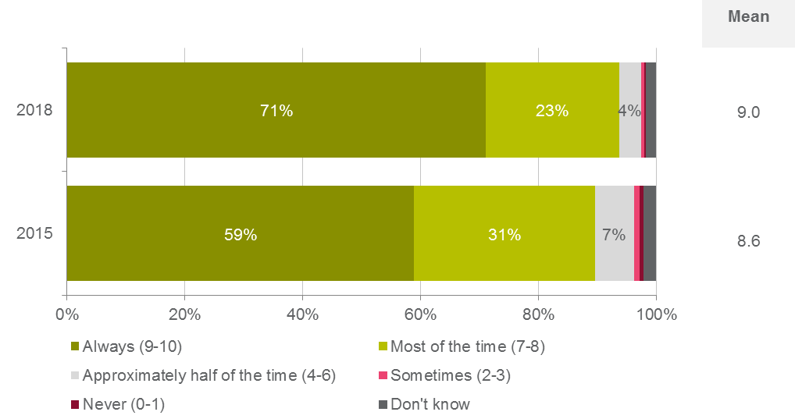

QC1. On a scale of 0 to 10, where 0 is ‘never’ and 10 is ‘always’, please indicate how much of the time you believe you are demonstrating best practice in your aviation safety activities.   
Base: All respondents 2018 (n=1,168); all respondents 2015 (n=1,217)

When examining the mean rating, the following statistically significant differences were observed by sub-groups:

* Those who had been in the sector for 1-3 years (mean of 9.3) were more likely to have demonstrated best practice in their aviation safety activities with a significantly higher mean rating observed.
* There were no statistically significant differences by age, gender, location or primary role in the sector.
  + 1. Best practice behaviours and attitudes

To further explore stakeholder perceptions of aviation safety best practice, a battery of statements were developed with respondents asked to indicate their level of agreement with each statement on a 0-10 scale (0 being ‘strongly disagree’, and 10 being ‘strongly agree’).

In 2018, respondents had the highest mean level of agreement with the statement ‘I actively seek opportunities to operate as safely as possible’ (mean of 9.3), followed by ‘I operate in excess of CASA’s minimum safety requirements’ (mean of 8.2). These two statements also recorded the highest mean ratings in 2015 and the 2018 findings once again aligned strongly with the qualitative findings that suggested the vast majority of aviation stakeholders take their safety obligations very seriously.

The two statements that were observed to have the lowest mean ratings in 2018 were ‘CASA recognises and promotes safety best practice from other countries’ at 5.4 and ‘CASA recognises and values industry knowledge and experience’ at 5.6. These two statements also recorded the lowest mean ratings in 2015.

Figure 13: Agreement with statements on aviation safety best practice

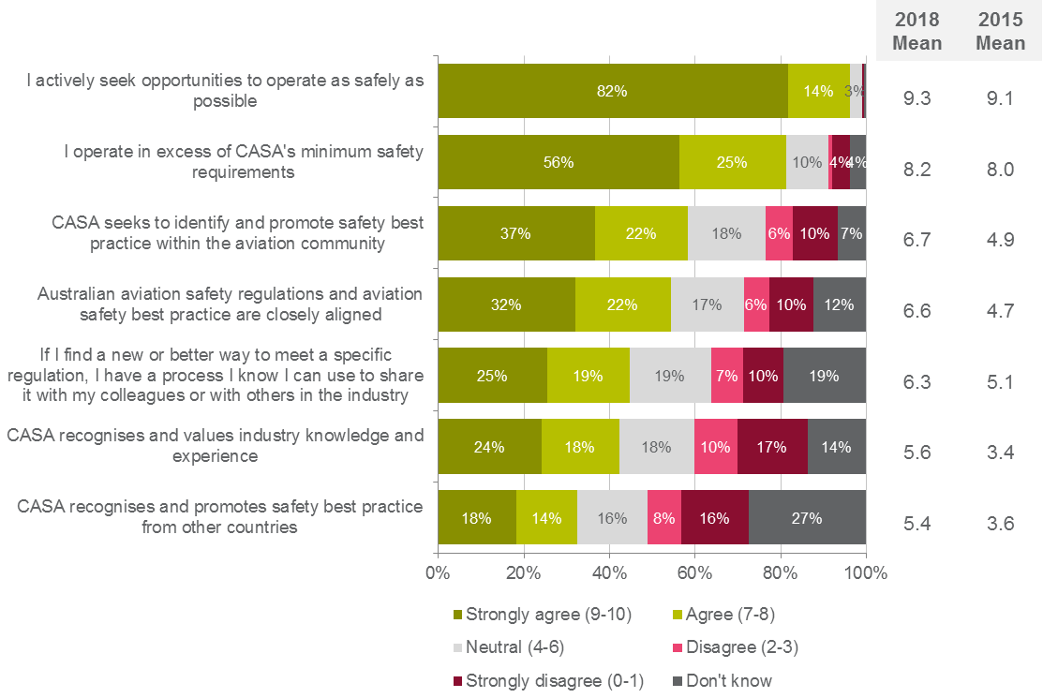

QC2. On a scale of 0 to 10, where 0 is ‘strongly disagree’ and 10 is ‘strongly agree’, please indicate how much you agree with each of the following statements.   
Base: All respondents 2018 (n of 1,168); all respondents 2015 (n=1,217)

When examining the mean agreement ratings across these aviation safety best practice statements, the following statistically significant differences were observed by sub groups:

* Females and those aged 18-29 were more likely to agree with ‘Australian aviation safety regulations and aviation safety best practice are closely aligned’ (means of 8.1 and 7.7 respectively), ‘CASA seeks to identify and promote safety best practice within the aviation community’ (means of 7.7 and 7.6 respectively), ‘CASA recognises and values industry knowledge and experience’ (means of 7.6 and 7.1 respectively), ‘CASA recognises and promotes safety best practice from other countries’ (means of 7.3 and 7.1 respectively).
* Queensland residents were less likely to agree with ‘CASA seeks to identify and promote safety best practice within the aviation community’ (mean of 6.2).
* Those who do not live in Australia were more likely to agree with ‘Australian aviation safety regulations and aviation safety best practice are closely aligned’ (mean of 7.6), ‘CASA seeks to identify and promote safety best practice within the aviation community’ (mean of 7.7), ‘CASA recognises and values industry knowledge and experience’ (mean of 6.8).
* In terms of length of time in the sector, the following significant differences were observed:
  + Those who have been in the sector for less than 12 months or for 1-3 years were more likely to agree with ‘Australian aviation safety regulations and aviation safety best practice are closely aligned’ (means of 9.0 and 8.4 respectively), ‘CASA seeks to identify and promote safety best practice within the aviation community’ (means of 8.9 and 8.4 respectively), ‘CASA recognises and values industry knowledge and experience’ (means of 8.7 and 7.8 respectively), ‘CASA recognises and promotes safety best practice from other countries’ (means of 9.0 and 7.3 respectively), and additionally those in the industry for 1-3 years were also more likely to agree with ‘If I find a new or better way to meet a specific regulation, I have a process I know I can use to share it with my colleagues or with others in the industry’ (mean of 7.2).
  + Those who have been in the sector for 11-20 years were less likely to agree with ‘CASA seeks to identify and promote safety best practice within the aviation community’ (mean of 6.2), and ‘CASA recognises and values industry knowledge and experience’ (mean of 5.0).
  + Those who have been in the aviation sector for 21-30 years were less likely to agree with ‘Australian aviation safety regulations and aviation safety best practice are closely aligned’ (mean of 6.1) and ‘CASA recognises and promotes safety best practice from other countries’ (mean of 4.6).
  + Those who have been in the aviation sector for 31-40 years or for more than 40 years were less likely to agree with ‘Australian aviation safety regulations and aviation safety best practice are closely aligned’ (means of 5.6 and 5.8 respectively), ‘CASA seeks to identify and promote safety best practice within the aviation community’ (means of 5.8 and 6.0 respectively), ‘CASA recognises and values industry knowledge and experience’ (means of 4.7 and 4.4 respectively), and additionally, those in the industry for 31-40 years were also less likely to agree with ‘CASA recognises and promotes safety best practice from other countries’ (mean of 4.5).
  + In terms of primary role in the sector, a number of significant differences were observed which included:
  + Commercial pilots were less likely to agree with ‘CASA seeks to identify and promote safety best practice within the aviation community’ (mean of 5.6), and ‘CASA recognises and values industry knowledge and experience’ (mean of 4.2).
  + Recreational pilots / private pilots were more likely to agree with ‘Australian aviation safety regulations and aviation safety requirements’ (mean of 7.4) and ‘CASA seeks to identify and promote safety best practice within the aviation community’ (mean of 7.6).
  + Chief pilots were more likely to agree with ‘I operate in excess of CASA’s minimum safety requirements’ (mean of 9.1).
  + Those involved with remotely piloted aircraft systems and student pilots were more likely to agree with ‘Australian aviation safety regulations and aviation safety best practice are closely aligned’ (means of 8.7 and 8.3 respectively), ‘CASA seeks to identify and promote safety best practice within the aviation community’ (means of 8.6 and 8.2 respectively), ‘CASA recognises and values industry knowledge and experience’ (means of 8.0 and 7.9 respectively), ‘CASA recognises and promotes safety best practice from other countries’ (means of 7.7 and 7.9 respectively).
  + Those involved with regular public transport and air transport pilots were less likely to agree with ‘Australian aviation safety regulations and aviation safety best practice are closely aligned’ (means of 4.6 and 4.9 respectively), ‘CASA seeks to identify and promote safety best practice within the aviation community’ (means of 4.9 and 4.5 respectively), ‘CASA recognises and values industry knowledge and experience’ (means of 3.7 and 3.5 respectively), ‘CASA recognises and promotes safety best practice from other countries’ (means of 3.3 and 3.1 respectively).

### CASA’s service delivery

* + 1. Satisfaction with service delivery

All participants were asked to rate CASA’s service delivery on a scale of 0 to 10, where 0 represented ‘very dissatisfied’ and 10 represented ‘very satisfied’. In 2018 the mean overall satisfaction rating for CASA service delivery was 6.2, which was higher than the mean rating of 3.8 observed in 2015. This question was asked of all respondents, independent of whether they had actually had a service interaction with CASA recently.

In 2018, over half of all respondents were either satisfied (29%) or very satisfied (25%) with CASA’s service delivery. Approximately a quarter (23%) were neutral on the matter and just one if five were dissatisfied (9%) or very dissatisfied (11%).

Figure 14: Satisfaction with CASA service delivery

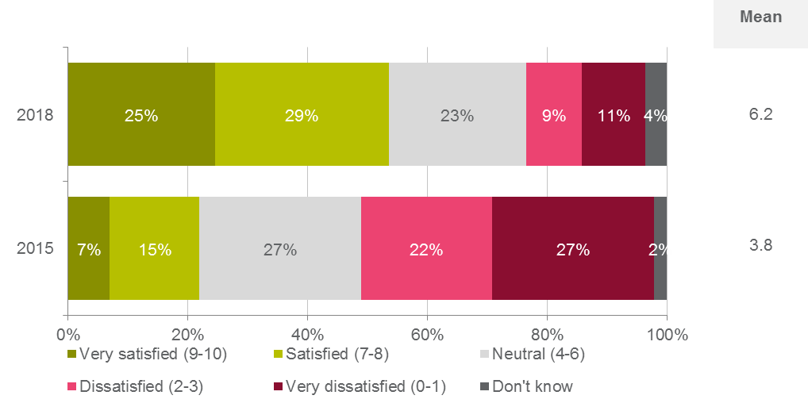

QD1. On a scale of 0-10 where 0 is ‘very dissatisfied’ and 10 is ‘very satisfied’, how satisfied are you with CASA’s service delivery?   
Base: All respondents 2018 (n=1,168); all respondents 2015 (n=1,217)

When examining the mean satisfaction rating, the following statistically significant differences were observed by sub-groups:

* Females (mean of 7.1) were more likely to be satisfied with CASA’s service delivery with a significantly higher mean rating observed.
* Those aged 18-29 years (mean of 7.2) were more likely to be satisfied with CASA’s service delivery with a significantly higher mean rating observed. Conversely, those aged 30-39 years (mean of 5.7) were less likely to be satisfied with CASA’s service delivery.
* Respondents who indicated they lived outside of Australia (mean of 7.3) were more likely to be satisfied with CASA’s service delivery with a significantly higher means rating observed.
* In regards to primary role in the sector, those in remotely piloted aircraft systems (mean of 7.8) and student pilots (mean of 7.3) were more likely to be satisfied with CASA’s service delivery with significantly higher mean ratings observed. Conversely, air transport pilots (mean of 4.3) and those in regular public transport (mean of 4.7) were less likely to be satisfied with CASA’s service delivery with significantly lower mean ratings observed.
* Those who were relatively new to the sector – i.e. less than 12 months (mean of 8.4) or 1-3 years (mean of 7.7) – were more likely to be satisfied with CASA’s service delivery with significantly higher mean ratings observed. Conversely, those who had been in the sector for 11-20 years (mean of 5.5), 31-40 years (mean of 5.6) or more than 40 years (mean of 5.6) were less likely to be satisfied with CASA’s service delivery with significantly lower mean ratings observed.  
  + 1. Contact with CASA in the past 12 months

In 2018, approximately three quarters of respondents indicated that they had been in contact with CASA staff at least once in the past 12 months prior to the survey being conducted. This is lower than the proportion of 85% observed in 2015. Of those that required at least some contact with CASA staff in the past 12 months, the average number of contacts reported per respondent was 6.6, down from 9.9 in 2018.

Figure 15: Direct contact with CASA staff over past 12 months

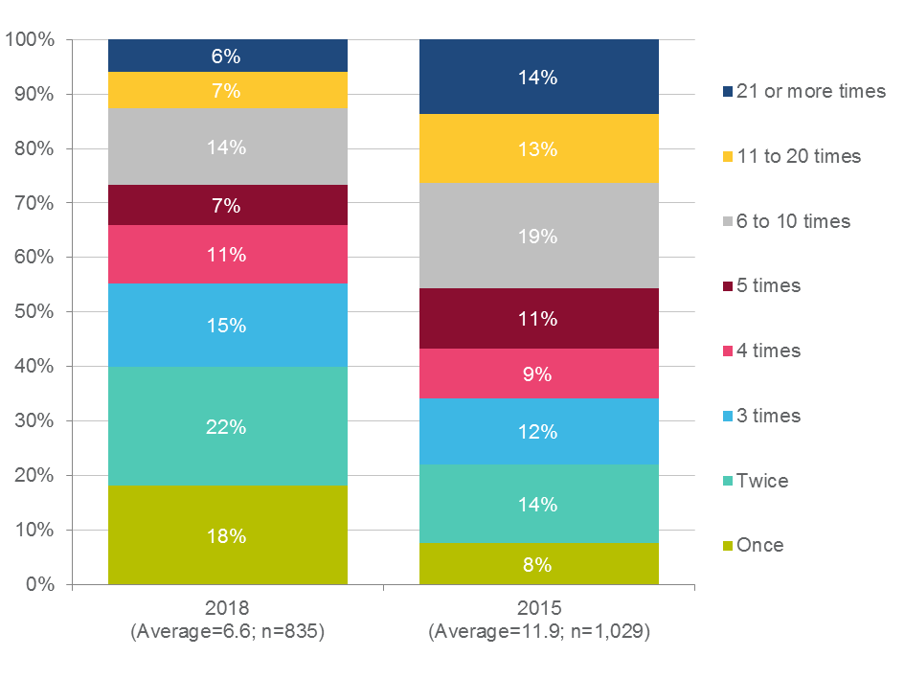

QD2. How many times have you had direct contact with CASA staff over the past 12 months?   
Base: All respondents (n=1,217); Respondents who had contact in the past 12 months (n=1,029).

When examining the proportion of respondent who had contact with CASA staff at least once in the past 12 months, the following statistically significant differences were observed by sub-groups:

* Those who had been in the sector for 1-3 years (62%) were significantly less likely to have been in contact with CASA in the past 12 months.
* There were no statistically significant differences by age, gender, location or primary role in the sector.

When looking at differences by the average number of contacts made, the following statistically significantly differences were observed by sub-groups:

* Those aged 18-29 years (average of 4.1) made significantly less contact.
* Respondents who indicated they lived outside of Australia (average of 2.3) also made significantly less contact.
* In regards to primary role in the sector, recreational pilots/private pilots (average of 2.7), student pilots (average of 3.0), licensed aircraft maintenance engineers (average of 3.0), commercial pilots (average of 3.4), those in private flying (average of 3.4) and remotely piloted aircraft systems (average of 4.6) made significantly less contact. Conversely, those in flight training including recreational, private and commercial pilot training organisations and multi crew training organisations (average of 11.9) and chief pilots (average of 18.8) made significantly more contact.
* Those who were relatively new to the sector – i.e. less than 12 months (average of 2.9) or 1-3 years (average of 3.7) – made significantly less contact. Conversely, those who had been in the sector for 31-40 years (average of 9.6) made significantly more contact.
* There were no statistically significant differences by gender.  
  + 1. Forms of contact with CASA

Respondents were asked what their most recent interaction with CASA staff was in relation to. In 2018 ‘applying for aviation medical’ (27%) was the most common response, followed by ‘apply for/renew flight crew license’ (21%) and ‘to seek clarification or further information on a regulation’ (17%). These were also the top three most common responses provided in 2015, however the order of the three interaction types did vary slightly with ‘apply for/renew flight crew license’ the most common response.

Figure 16: Reason for most recent contact with CASA staff

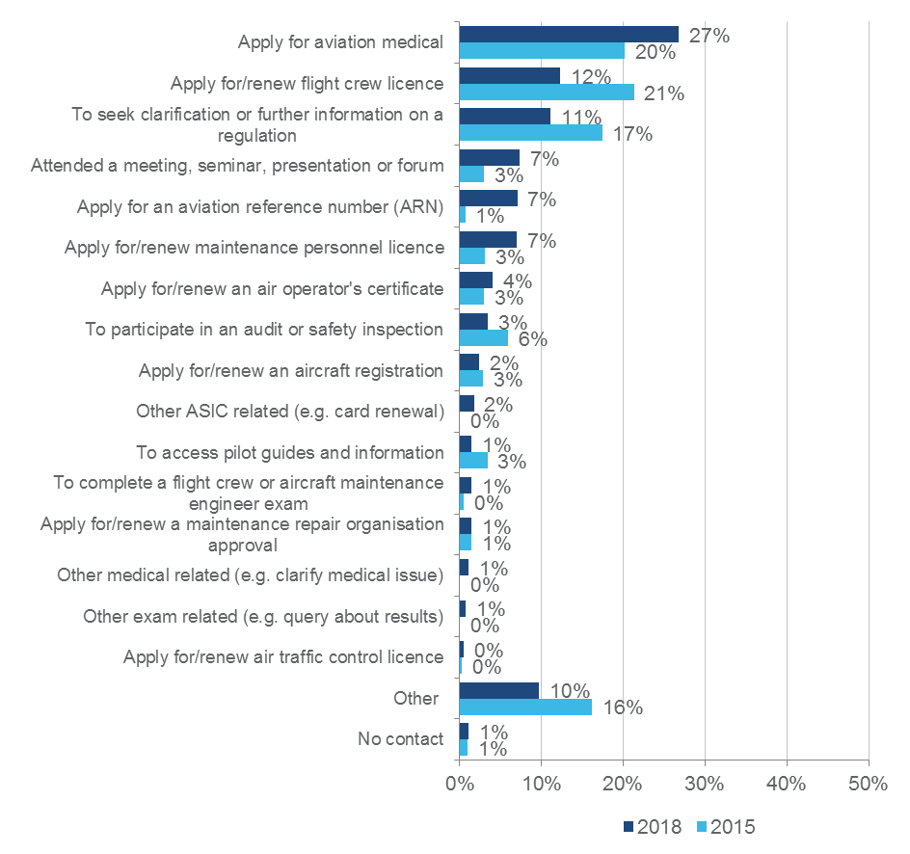

QD3. What was your most recent direct contact with CASA staff in relation to?   
Base: All respondents 2018 (n=1,168); all respondents 2015 (n=1,217)

When examining the reasons for the most recent interaction with CASA, the following significant differences were observed by sub-groups:

* Those aged 60 years or older were significantly more likely to have most recently contacted CASA to ‘apply for aviation medial’ (35%) or have ‘attended a meeting, seminar, presentation or forum’ (12%). Conversely, those aged 40-49 years were significantly less likely to have most recently contacted CASA to ‘apply for aviation medial’ (18%).
* Regarding length of time in the sector, those who had been in the sector for 1-3 years were significantly more likely to have most recently contacted CASA to ‘apply for an aviation reference number’ (22%) and significantly less likely to have most recently contacted CASA to ‘apply for aviation medical’ (18%). Conversely, respondents who had been in the sector for more than 40 years were significantly more likely to have most recently contacted CASA to ‘apply for aviation medical’ (38%).
* In terms of primary role in the sector, a number of significant differences were observed which included:
  + - Student pilots, those in private flying and air transport pilots were significantly more likely to have contacted CASA to ‘apply for an aviation medical’ (57%, 45% and 44% respectively);
    - Those with remotely piloted aircraft were significantly more likely to have contacted CASA to ‘apply for an aviation reference number’ (37%) or ‘to seek clarification or further information on a regulation’ (19%); and
    - Licensed aircraft maintenance engineers were significantly more likely to have contacted CASA to ‘apply for/renew maintenance personnel licence (56%).
* There were no statistically significant differences by gender or location.   
  + 1. Satisfaction with CASA contact

Survey respondents were asked how satisfied they were with their most recent interaction with CASA staff across a range of service attributes, with each attribute ranked on a 0-10 satisfaction scale.

In 2018 the highest mean ratings were observed for the statements ‘CASA staff were helpful’ (mean of 7.5) and ‘CASA staff understood your issue’ (mean of 7.4). These two statements also recorded the highest mean ratings in 2015.

The two statements that were observed to have the lowest mean ratings in 2018 were ‘Your transaction was completed with only reasonable costs incurred by you’ (mean of 6.6) and ‘CASA staff knew the history of your issue’ (mean of 7.1). This reflects the contribution of timeliness and responsiveness as observed earlier as key drivers of overall relationship satisfaction. The first statement recorded the lowest mean rating in 2015, while the second statement recorded the third highest mean rating in 2015.

Figure 17: Satisfaction with most recent contact with CASA

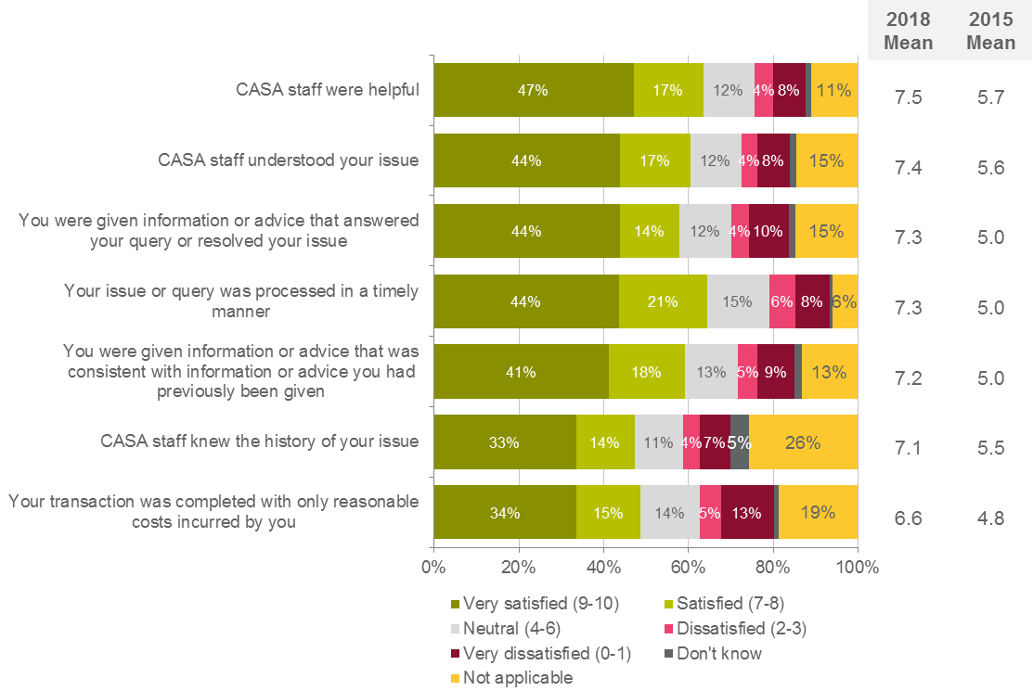

QD4. During your most recent interaction with CASA staff, how satisfied were you that…   
Base: All respondents 2018 (n=1,168); all respondents 2015 (n=1,217)

When examining the mean satisfaction ratings across these compliance statements, the following statistically significant differences were observed by sub groups:

* Those aged 18-29 were more likely to be satisfied with ‘CASA staff understood your issue’ (mean of 8.4), ‘You were given information or advice that answered your query or resolved your issue’ (mean of 8.2), ‘CASA staff knew the history of your issue’ (mean of 8.2), ‘CASA staff were helpful’ (mean of 8.2), ‘You were given information or advice that was consistent with information or advice you had previously been given’ (mean of 8.0).
* In terms of length of time in the sector, a number of significant differences were observed which included:
  + Those who have been in the industry for less than 12 months or for 1-3 years, or their primary role involves remotely piloted aircraft systems, were more likely to be satisfied with each of the statements.
  + Those who have been in the sector for 21-30 years were less likely to be satisfied ‘CASA staff were helpful’ (mean of 6.8), and those who have been in the sector for 11-20 years were less likely to be satisfied with ‘Your issue or query was processed in a timely manner’ (mean of 6.6).
  + Those who have been in the sector for 31-40 years were less likely to be satisfied with ‘CASA staff understood your issue’ (mean of 6.6), ‘You were given information or advice that answered your query or resolved your issue’ (mean of 6.4), ‘CASA staff knew the history of your issue’ (mean of 6.4), ‘CASA staff were helpful’ (mean of 6.8), ‘You were given information or advice that was consistent with information or advice you had previously been given’ (mean of 6.4).
* In terms of primary role in the sector, a number of significant differences were observed which included:
  + Those who are involved with regular public transport and commercial pilots were less likely to be satisfied with ‘CASA staff were helpful’ (means of 6.0 and 6.5 respectively), furthermore, commercial pilots were also less likely to be satisfied with ‘Your transaction was completed with only reasonable costs incurred by you’ (mean of 4.9).
  + Air transport pilots were less likely to be satisfied with each of the statements (means ranging from 5.0 to 5.6).
  + Student pilots were more likely to be satisfied with ‘CASA stuff understood your issue’ (mean of 8.4), ‘You were given information or advice that answered your query or resolved your issue’ (mean of 8.5), ‘CASA staff were helpful’ (mean of 8.5).
  + Recreational pilots / private pilots were more likely to be satisfied with ‘You were given information or advice that answered your query or resolved your issue’ (mean of 8.4), ‘You were given information or advice that was consistent with information or advice you had previously been given’ (mean of 8.1), and ‘Your transaction was completed with only reasonable costs incurred by you’ (mean of 7.7).
    1. Expectation for service delivery timeframes

Stakeholders were presented with a number of service interactions and asked what an acceptable timeframe would be for CASA to resolve or finalise the issue.

As with the 2015 findings, the majority of respondents in 2018 expected most transactions or interactions with CASA to be resolved or finalised within a 2 week period, albeit it was evident in the findings that stakeholders did appreciate that more detailed interactions or transactions would require longer for CASA to process and finalise. However, the upper limit of time for nearly all transaction and interaction types was up to one month – very few respondents were accepting of longer time periods (with the notable exception being application for/renewal of an air operator’s certificate and application for/renewal of a maintenance repair organisation approval).

Figure 18: Acceptable timeframes for specific CASA interactions – Key tasks

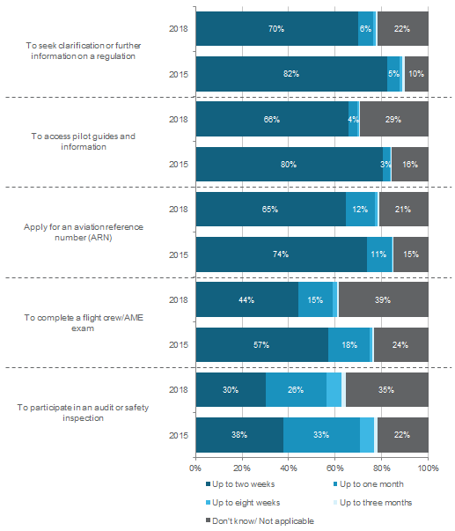

QD5. For each of the following possible interactions with CASA, please indicate what would be an acceptable timeframe for CASA to take to resolve or finalise your issue.  
Base: All respondents 2018 (n=1,168); all respondents 2015 (n=1,217)

Figure 19: Acceptable timeframes for specific CASA interactions - Applications

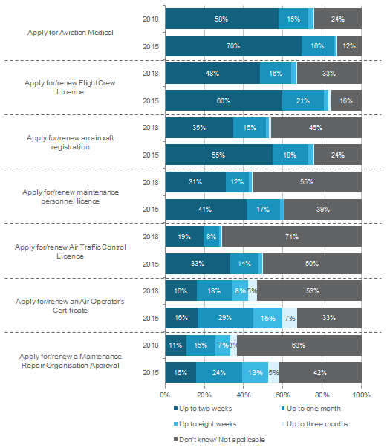

QD5. For each of the following possible interactions with CASA, please indicate what would be an acceptable timeframe for CASA to take to resolve or finalise your issue.  
Base: All respondents 2018 (n=1,168); all respondents 2015 (n=1,217)

### Development and reform of aviation safety regulations

Another key behaviour that was identified as supporting an improved relationship between CASA and industry stakeholders was CASA’s development of aviation safety regulations. Survey respondents were asked to rate their level of satisfaction with the ways CASA develops aviation safety regulations on a scale of 0 to 10, where 0 was ‘very dissatisfied’ and 10 was ‘very satisfied’. In 2018 the mean satisfaction rating for the ways CASA develops aviation safety regulations was 5.5, which was higher than the mean rating of 3.0 observed in 2015.

In 2018, two fifths of respondents were either satisfied (21%) or very satisfied (19%) with the ways CASA develops aviation safety regulations. A further fifth (20%) were neutral on the matter and a further quarter were dissatisfied (11%) or very dissatisfied (15%).

Figure 20: Satisfaction with CASA's development of aviation safety regulations

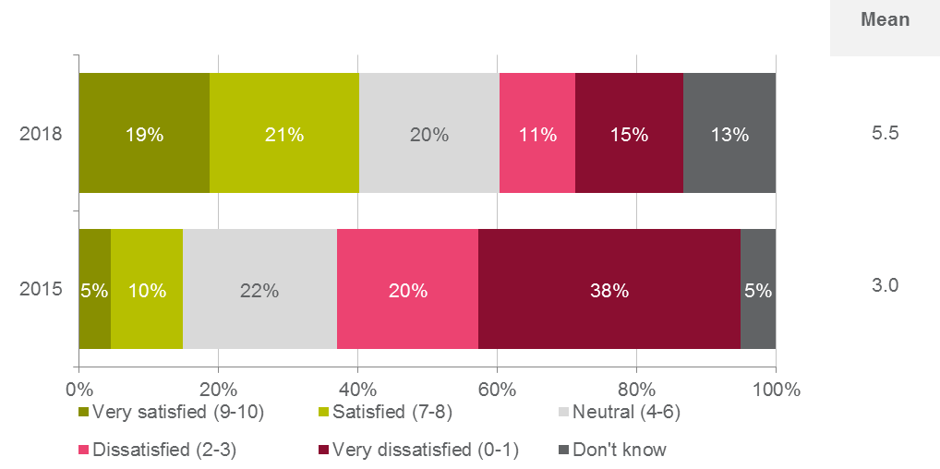

QE1. On a scale of 0-10 where 0 is ‘very dissatisfied’ and 10 is ‘very satisfied’, how satisfied are you with the ways CASA develops aviation safety regulations? Base: All respondents 2018 (n=1,168); all respondents 2015 (n=1,217)

When examining the mean satisfaction rating, the following statistically significant differences were observed by sub-groups:

* Females (mean of 6.7) were more likely to be satisfied with the ways CASA develops aviation safety regulations with a significantly higher mean rating observed.
* Those aged 18-29 years (mean of 6.8) were more likely to be satisfied with the ways CASA develops aviation safety regulations with a significantly higher mean rating observed.
* Respondents who indicated they lived outside of Australia (mean of 6.6) were more likely to be satisfied with the ways CASA develops aviation safety regulations with a significantly higher means rating observed.
* In regards to primary role in the sector, those in remotely piloted aircraft systems (mean of 7.7), student pilots (mean of 7.4) and recreational pilots/private pilots (mean of 6.6) were more likely to be satisfied with the ways CASA develops aviation safety regulations with significantly higher mean ratings observed. Conversely, air transport pilots (mean of 2.7), those in regular public transport (mean of 3.8) and commercial pilots (mean of 4.2) were less likely to be satisfied with the ways CASA develops aviation safety regulations with significantly lower mean ratings observed.
* Those who were relatively new to the sector – i.e. less than 12 months (mean of 8.7) or 1-3 years (mean of 7.5) – were more likely to be satisfied with the ways CASA develops aviation safety regulations with significantly higher mean ratings observed. Conversely, those who had been in the sector for 11-20 years (mean of 4.8), 21-30 years (mean of 4.8), 31-40 years (mean of 4.2) or more than 40 years (mean of 4.6) were less likely to be satisfied with the ways CASA develops aviation safety regulations with significantly lower mean ratings observed.
  + 1. Attitudes towards regulation development and implementation

To further explore stakeholder perceptions of CASA’s regulation development role, a battery of statements were developed with respondents asked to indicate their level of agreement with each statement on a 0-10 scale (0 being ‘strongly disagree’, and 10 being ‘strongly agree’).

As with the 2015 results, respondents in 2018 agreed that their input to regulation and reform would be useful to CASA with this statement once again observing the highest and same mean rating as observed in 2015 (mean of 7.1). The responses to all other statements, while shifting upward slightly, were still negative and highlight an area of CASA’s performance that warrants further improvement. Specifically, the lowest mean ratings in 2018 were observed for the following three statements:

* ‘CASA always consults with the most appropriate people in industry when developing and reforming aviation safety regulations’ (mean of 4.7);
* ‘Current aviation safety regulations represent the most current leaning and innovation in industry’ (mean of 5.0); and
* ‘CASA does a good job of translating my legal obligations into practical guidance’ (mean of 5.2).

Figure 21: Agreement with CASA regulation performance statements

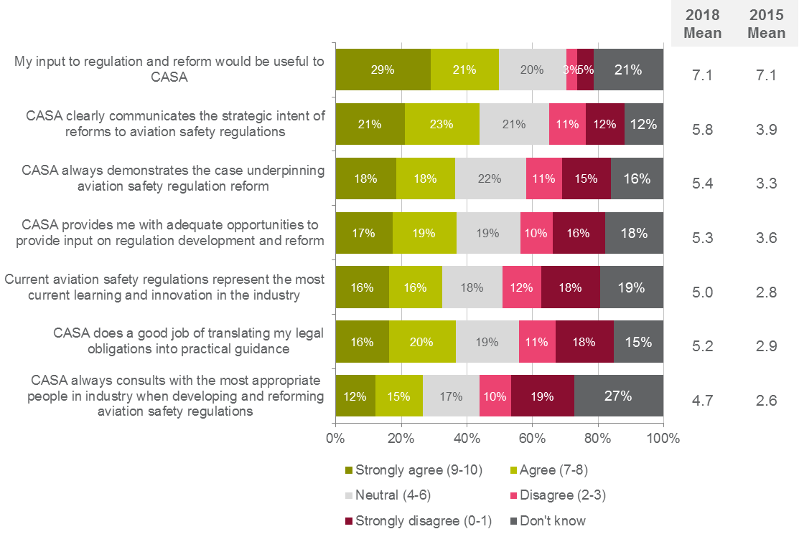

QE2. On a scale of 0 to 10, where 0 is ‘strongly disagree’ and 10 is ‘strongly agree’, please indicate how much you agree with each of the following statements.   
Base: All respondents 2018 (n=1,168); all respondents 2015 (n=1,217)

When examining the mean satisfaction ratings across these compliance statements, the following statistically significant differences were observed by sub groups:

* Females and 18-29 year olds were more likely to agree with ‘CASA always demonstrates the case underpinning aviation safety regulation reform’ (means of 6.7 and 6.8 respectively), ‘CASA always consults with the most appropriate people in industry when developing and reforming aviation safety regulations’ (means of 6.3 and 6.5 respectively), ‘Current aviation safety regulations represent the most current learning and innovation in the industry’ (means of 6.7 and 6.5 respectively), ‘CASA does a good job of translating my legal obligations into practical guidance’ (means of 6.4 and 6.2 respectively), additionally,18-29 year olds were also more likely to agree with ‘CASA clearly communicates the strategic intent of reforms to aviation safety regulations’ (mean of 6.8).
* Those who do not live in Australia were more likely to agree with ‘CASA clearly communicates the strategic intent of reforms to aviation safety regulations’ (mean of 7.0).
* In terms of length of time in the sector, a number of significant differences were observed which included:
  + Those who have been in the sector for less than 12 months and for 1-3 years were more likely to agree with ‘CASA clearly communicates the strategic intent of reforms to aviation safety regulations’ (means of 8.5 and 7.6 respectively), ‘CASA always demonstrates the case underpinning aviation safety regulation reform’ (means of 8.4 and 7.5 respectively), ‘CASA always consults with the most appropriate people in industry when developing and reforming aviation safety regulations’ (means of 8.1 and 7.2 respectively), ‘Current aviation safety regulations represent the most current learning and innovation in the industry’ (means of 8.6 and 7.2 respectively), ‘CASA does a good job of translating my legal obligations into practical guidance’ (means of 8.0 and 7.2 respectively), and ‘CASA provides me with adequate opportunities to provide input on regulation development and reform’ (means of 7.7 and 7.0 respectively).
  + Those who have been in the sector for 11-20 years were less likely to agree with ‘CASA clearly communicates the strategic intent of reforms to aviation safety regulations’ (mean of 5.2), ‘CASA always demonstrates the case underpinning aviation safety regulation reform’ (mean of 4.7), ‘CASA always consults with the most appropriate people in industry when developing and reforming aviation safety regulations’ (mean of 4.1), ‘Current aviation safety regulations represent the most current learning and innovation in the industry’ (mean of 4.3), ‘CASA does a good job of translating my legal obligations into practical guidance’ (mean of 4.6).
  + Those who have been in the sector for 21-30 years were less likely to agree with ‘Current aviation safety regulations represent the most current learning and innovation in the industry’ (mean of 4.4).
  + Those who have been in the sector for less than 31-40 years and for more than 40 years were less likely to agree with ‘CASA clearly communicates the strategic intent of reforms to aviation safety regulations’ (means of 5.0 and 5.0 respectively), ‘CASA always demonstrates the case underpinning aviation safety regulation reform’ (means of 4.7 and 4.4 respectively), ‘CASA always consults with the most appropriate people in industry when developing and reforming aviation safety regulations’ (means of 3.8 and 3.6 respectively), ‘Current aviation safety regulations represent the most current learning and innovation in the industry’ (means of 3.9 and 4.2 respectively), ‘CASA does a good job of translating my legal obligations into practical guidance’ (means of 4.2 and 4.3 respectively), and ‘CASA provides me with adequate opportunities to provide input on regulation development and reform’ (means of 4.7 and 4.6 respectively).
* In terms of primary role in the sector, a number of significant differences were observed which included:
  + Those involved with regular public transport or air transport pilots were less likely to agree with each of the statements, excluding ‘My input to regulation and reform would be useful to CASA’ (means of 6.6 and 6.9 respectively).
  + Those involved with private flying were less likely to agree with ‘My input to regulation and reform would be useful to CASA’ (mean of 6.3).
  + Those involved with flight training were less likely to agree with ‘Current aviation safety regulations represent the most current learning and innovation in the industry’ (mean of 3.8).
  + Commercial pilots were less likely to agree with ‘CASA clearly communicates the strategic intent of reforms to aviation safety regulations’ (mean of 4.9), ‘CASA always consults with the most appropriate people in industry when developing and reforming aviation safety regulations’ (mean of 3.3), ‘Current aviation safety regulations represent the most current learning and innovation in the industry’ (mean of 3.7), and ‘CASA does a good job of translating my legal obligations into practical guidance’ (mean of 3.8).
  + Those involved with maintenance organisation were less likely to agree with ‘CASA always demonstrates the case underpinning aviation safety regulation reform’ (mean of 4.2), ‘CASA always consults with the most appropriate people in industry when developing and reforming aviation safety regulations’ (mean of 3.4), ‘Current aviation safety regulations represent the most current learning and innovation in the industry’ (mean of 3.5).
  + Those involved with remotely piloted aircraft systems were more likely to agree with each of the statements (means ranging from 6.9 to 7.9).
  + Student pilots were more likely to agree with each of the statements (means ranging from 7.4 to 7.8), excluding ‘My input to regulation and reform would be useful to CASA’ (mean of 7.0).
  + Recreational pilots / private pilots were more likely to agree with ‘CASA clearly communicates the strategic intent of reforms to aviation safety regulations’ (mean of 6.9), ‘CASA always demonstrates the case underpinning aviation safety regulation reform’ (mean of 6.5), ‘CASA always consults with the most appropriate people in industry when developing and reforming aviation safety regulations’ (mean of 5.8), and ‘CASA does a good job of translating my legal obligations into practical guidelines’ (mean of 6.4).
    1. Participation in consultation

Survey respondents were asked if they had participated in any consultation on regulation development or reform over the past three years. Less than one fifth (16%) of respondents in 2018 indicated that they had participated, compared to exactly half (50%) of all respondents in 2015.

Figure 22: Participation in regulation reform or development consultation

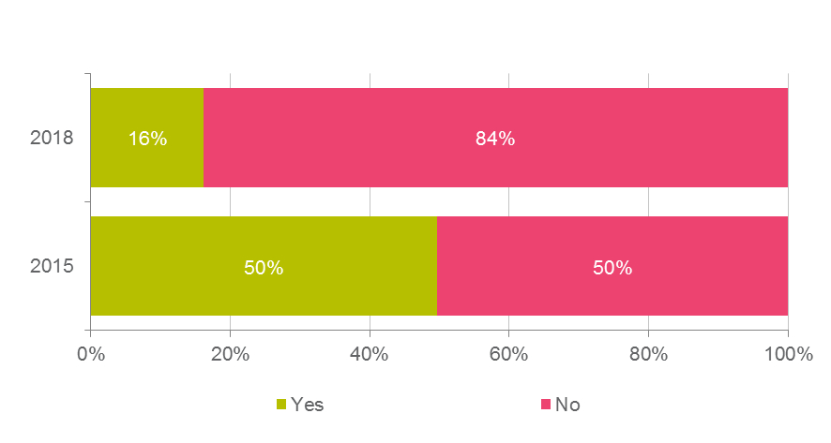

QE3. Have you participated in any consultation on regulation development or reform - including a face- to-face consultation session or safety session, or submitting written feedback – over the past three years?   
Base: All respondents 2018 (n=1,168); all respondents 2015 (n=1,217)

When examining participation in consultation and regulation development or reform, the following significant differences were observed by sub-groups:

* In terms of primary role in the sector, student pilots (98%) were significantly more likely to have not participated in consultation and regulation development or reform.
* There were no statistically significant differences by gender, age, location or period of time in the aviation sector.

Participants who indicated that they had not participated in any consultation on regulation development or reforms in the past year were then asked the main reason why they had not participated. In 2018, the most common reason was ‘wasn’t made aware I could’ (42%), followed by ‘too busy/no time’ (16%) and ‘won’t make a difference/waste of time’ (16%). These were also the top three most common responses provided in 2015, however the order of the three interaction types did vary slightly with reasons two and three swapping in order.

Figure 23: Reasons for lack of participation in consultation

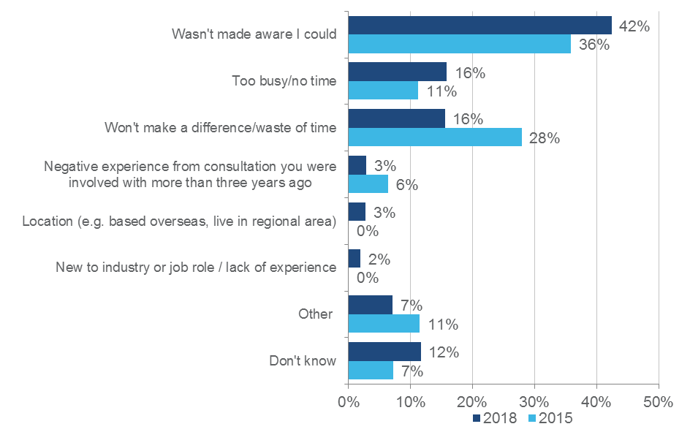

QE4. What is the main reason you have not participated in CASA led consultation over the past three years?   
Base: Respondents who have not participated in consultation over the past three years 2018 (n=xxx); respondents who have not participated in consultation over the past three years 2015 (n=613)

When examining the reasons for not participating in CASA led consultation, the following significant differences were observed by sub-groups:

* Regarding length of time in the sector, respondents who had been in the sector for 1-3 years were significantly more likely to have indicated that they had not participated because they ‘weren’t made aware I could’ (62%). Conversely, respondents who had been in the sector were significantly less likely to have provided this reason (28%) and significantly more likely to have indicated that they have not participated because it ‘won’t make a difference / waste of time’ (26%).
* Respondents with remotely piloted aircraft were also significantly more likely to have indicated that they had not participated because they ‘weren’t made aware I could’ (56%).
* There were no statistically significant differences by gender, age or location.
  + 1. Factors that would encourage participation

Participants were presented with a range of factors and asked how important each of these would be in terms of encouraging them to participate in either face to face or written consultation with CASA (on a scale of 0 to 10, with 0 being ‘very unimportant’ and 10 being ‘very important’).

In 2018 the highest mean ratings were observed for the factors ‘the topic of the consultation of relevant or interesting to me’ (mean of 8.1), ‘Feeling like my contribution would be used to make real change’ (mean of 7.6) and ‘Receiving feedback on how my contribution was used’ (mean of 7.6). These three statements also recorded the highest mean ratings in 2015, however the mean rating provided for not only these three statements but all of the statements were slightly lower in 2018.

The two statements that were observed to have the lowest mean ratings in 2018 were ‘The invitation to participate came to me personally’ (mean of 6.7) and ‘There is an opportunity to meet people from CASA whom I would like to meet’ (mean of 6.6). The first statement recorded the lowest mean rating in 2015, while the second statement recorded the third lowest mean rating in 2015.

Figure 24: Importance of factors to encourage consultation participation

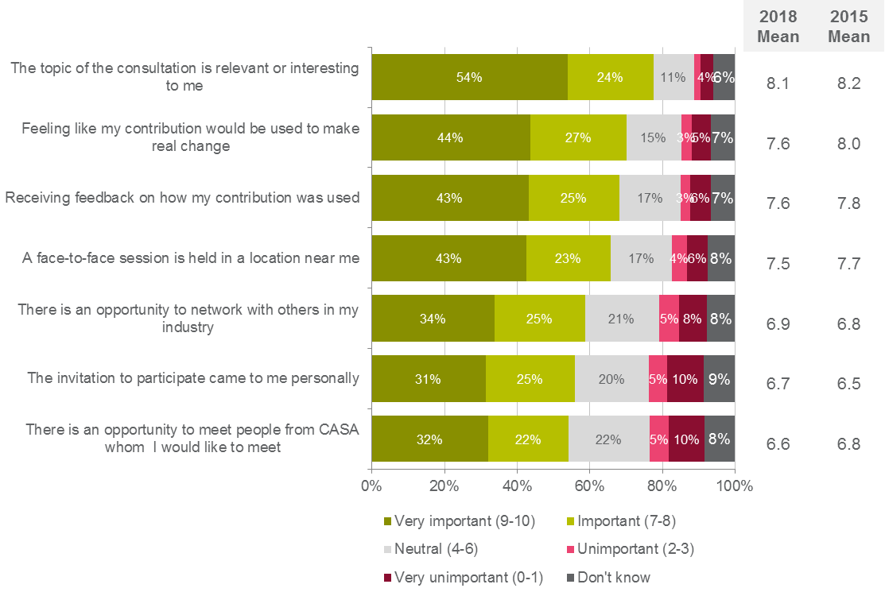

QE5. On a scale from 0 to 10, where 0 is ‘very unimportant’ and 10 is ‘very important’, how important would each of the following factors be in terms of encouraging you to participate in face-to-face or written consultation with CASA?   
Base: All respondents 2018 (n=1,168); all respondents 2015 (n=1,217)

When examining the mean importance ratings across these factors to encourage consultation participation, the following statistically significant differences were observed by sub groups:

* Respondents aged 18-29 were more likely to assign a greater level of importance to ‘There is an opportunity to network with others in my industry’ (mean of 7.7) with a significantly higher mean rating observed.
* In terms of primary role in the sector, a number of significant differences were observed which included:
  + Those in flight training organisation and those with remotely piloted aircraft were more likely to assign greater levels of importance to ‘There is an opportunity to network with others in my industry’ (means of 8.0 and 7.6 respectively). In addition, those with remotely piloted aircraft were also more likely to assign a greater level of importance to ‘There is an opportunity to meet people from CASA whom I would like to meet’ (mean of 7.5) with a significantly higher mean rating observed.
  + Air transport pilots were less likely to a greater level of importance to ‘There is an opportunity to network with others in my industry’ (mean of 5.6) with a significantly lower mean rating observed.
  + Licensed aircraft maintenance engineers were less likely to a greater level of importance to ‘There is an opportunity to meet people from CASA whom I would like to meet’ (mean of 5.5) with significantly a lower mean rating observed.
* In terms of length of time in the sector, a number of significant differences were observed which included:
  + Those who had been in the sector for 1 - 3 years were more likely to assign greater levels of importance to ‘There is an opportunity to network with others in my industry’ (mean of 7.9), ‘There is an opportunity to meet people from CASA whom I would like to meet’ (mean of 7.4) and ‘The invitation to participate came to me personally’ (mean of 7.4) with significantly higher mean ratings observed.
  + Those who had been in the sector 21 - 30 years or 31 - 40 years were less likely to assign a greater level of importance to ‘There is an opportunity to network with others in my industry’ (means of 6.2 and 6.3 respectively) with significantly lower mean ratings observed.
* There were no statistically significant differences by gender or location.

### Consistency of decision making

* + 1. Satisfaction with consistency of CASA’s decision making

Another key behaviour that was identified as supporting an improved relationship between CASA and industry stakeholders was to increase the perceived consistency of CASA’s decision making (at least in situations where cases present as being similar in nature). Survey respondents were asked to rate their level of satisfaction with the consistency of CASA decision making on a scale of 0 to 10, where 0 was ‘very dissatisfied’ and 10 was ‘very satisfied’. In 2018 the mean satisfaction rating for the consistency of CASA’s decision making was 5.4, which was higher than the mean rating of 3.2 observed in 2015.

In 2018, over a third of respondents were either satisfied (21%) or very satisfied (15%) with the consistency of CASA’s decision making. A quarter (24%) were neutral on the matter and a further quarter were dissatisfied (10%) or very dissatisfied (14%).

Figure 25: Satisfaction with consistency of CASA decision making

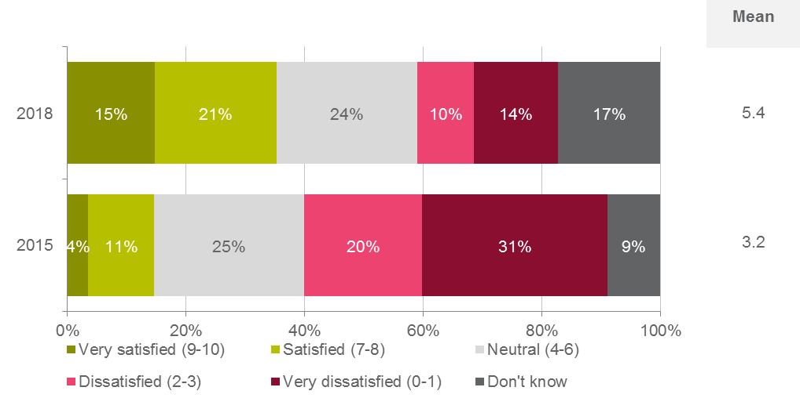

QF1. On a scale of 0 to10 where 0 is ‘very dissatisfied’ and 10 is ‘very satisfied’, how satisfied are you with the consistency of CASA’s decision making?   
Base: All respondents 2018 (n=1,168); all respondents 2015 (n=1,217)

When examining the mean satisfaction rating, the following statistically significant differences were observed by sub-groups:

* Females (mean of 6.5) were more likely to be satisfied with the consistency of CASA’s decision making with a significantly higher mean rating observed.
* Those aged 18-29 years (mean of 6.7) were more likely to be satisfied with the consistency of CASA’s decision making with a significantly higher mean rating observed.
* Respondents who indicated they lived outside of Australia (mean of 6.5) were more likely to be satisfied with the consistency of CASA’s decision making with a significantly higher mean rating observed.
* In regards to primary role in the sector, those with remotely piloted aircraft systems (mean of 7.5), student pilots (mean of 7.5) and recreational pilots / private pilots (mean of 6.3) were more likely to be satisfied with the consistency of CASA’s decision making with significantly higher mean ratings observed. Conversely, commercial pilots (mean of 4.2), those in regular public transport (mean of 3.8) and air transport pilots (mean of 3.4) were less likely to be satisfied with the consistency of CASA’s decision making with significantly lower mean ratings observed.
* Those who were relatively new to the sector – i.e. less than 12 months (mean of 8.4) or 1-3 years (mean of 7.4) – were more likely to be satisfied with the consistency of CASA’s decision making with significantly higher mean ratings observed. Conversely, those who had been in the sector for 11-20 years (mean of 4.8), 21-30 years (mean of 4.7), 31-40 years (mean of 4.6) or more than 40 years (mean of 4.4) were less likely to be satisfied with the consistency of CASA’s decision making with significantly lower mean ratings observed.
* There were no statistically significant differences by location.   
  + 1. Attitudes towards CASA’s decision making

To further explore stakeholder perceptions of CASA’s decision making, a battery of statements were developed and respondents were asked to indicate their level of agreement with each statement on a 0-10 scale (0 being ‘strongly disagree’, and 10 being ‘strongly agree’).

While the mean ratings observed for 2018, have shifted in a positive direction since 2015, moderate mean ratings were still observed for each of the four statements:

* ‘CASA are consistent in the decisions that are made’ (mean of 5.2);
* ‘CASA staff are consistent in how they make decisions’ (mean of 5.2);
* ‘They understand why CASA makes the decisions it does’ (mean of 4.8); and
* ‘CASA makes decisions which reflect an understanding of my aviation activities and/or business’ (mean of 4.8).

Figure 26: Agree with CASA decision consistency statements

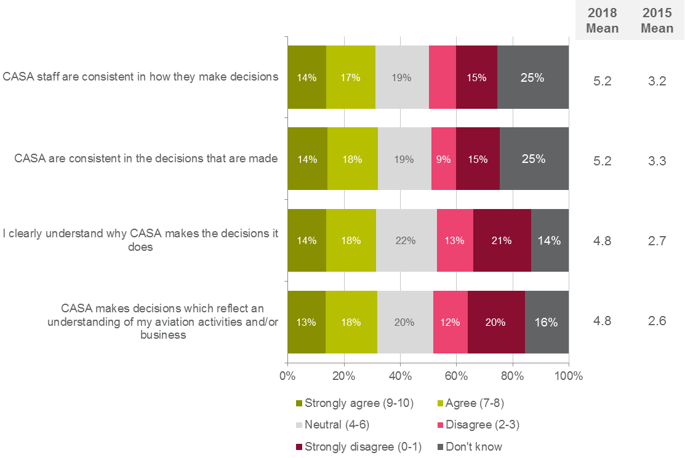

QF2. On a scale of 0 to 10, where 0 is ‘strongly disagree’ and 10 is ‘strongly agree’, please indicate how much you agree with each of the following statements.   
Base: All respondents 2018 (n=1,168); all respondents 2015 (n=1,217)

When examining the mean agreement ratings across these CASA decision consistency statements, the following statistically significant differences were observed by sub groups:

* Females and respondents aged 18-29 were more likely to agree with all four statements with significantly higher mean ratings observed for each one
* Those aged 70 years or older were less likely to agree that ‘CASA makes decisions which reflect an understanding of my aviation activities and/or business’ (mean of 3.8) and ‘I clearly understand why CASA makes the decisions it does’ (mean of 3.6) with significantly lower mean ratings observed.
* In terms of primary role in the sector, a number of significant differences were observed which included:
  + Student pilots and those with remotely piloted aircraft systems were more likely to agree with all four statements with significantly higher mean ratings observed for each one.
  + Recreational pilots / private pilots were more likely to agree with three of the four statements with significantly higher mean ratings observed. The one exception was the statement ‘I clearly understand why CASA makes the decisions it does ’were no significant difference in the mean rating was observed.
  + Air transport pilots and those in regular public transport were less likely to agree with all four statements with significantly lower mean ratings observed for each one.
  + Commercial pilots were less likely to agree with three of the four statements with significantly lower mean ratings observed. The one exception was the statement ‘I clearly understand why CASA makes the decisions it does’ ’were no significant difference in the mean rating was observed.
  + Those in aerial work were less likely to agree that ‘CASA are consistent in the decisions that are made’.
* Those who were relatively new to the sector – i.e. less than 12 months or 1-3 years - were more likely to agree with all four statements with significantly higher mean ratings observed for each one. Conversely, those who had been in the sector for longer – i.e. 11-20 years, 21-30 years, 31-40 years or more than 40 years – were less likely agree with all four statements with significantly lower mean ratings observed for each one.
* There were no statistically significant differences by location.

### Safety reporting

* + 1. Likelihood of making a voluntary safety report

The final behaviour that was identified as driving an improvement in levels of trust between CASA and its stakeholders (which in turn should support a reduction in preventable aviation accidents and incidents) was for stakeholders to voluntarily disclose instances where regulations have been either inadvertently or deliberately breached.

To explore this, survey respondents were asked how likely they would be to make a voluntary safety report to CASA in situations of material non-compliance with safety regulations on a scale of 0 to 10, where 0 was ‘very unlikely’ and 10 was ‘very likely’. Encouragingly in 2018, some 37% of respondents said they would be very likely to report such an incident to CASA, with a further 23% indicating they would be likely to do so. At the other end of the spectrum, 10% of respondents indicated that they would be very unlikely to make a voluntary safety report, and a further 6% said this would be unlikely.

In 2018 the mean likelihood rating to report such an incident to CASA was 6.9, which was higher than the mean rating of 6.0 observed in 2015.

Figure 27: Likelihood of reporting situations of material non-compliance to CASA

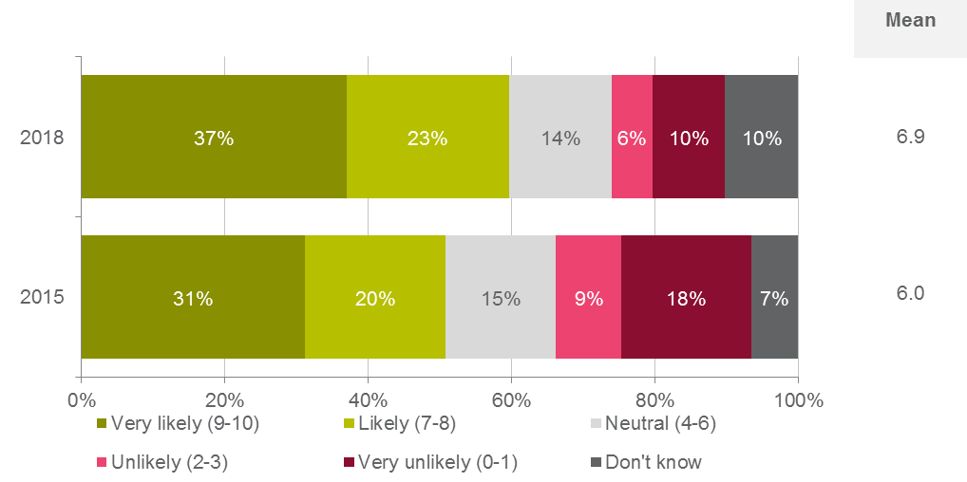

QG1. On a scale of 0-10 where 0 is ‘very unlikely’ and 10 is ‘very likely’, how likely would you be to make a voluntary safety report (e.g. alert CASA voluntarily in the case of non-compliance with your regulatory obligations) in situations of material non-compliance with safety regulations?   
Base: All respondents 2018 (n=1,168); all respondents 2015 (n=1,217)

When examining the mean likelihood rating, the following statistically significant differences were observed by sub-groups:

* In regards to primary role in the sector, student pilots (mean of 8.1) and those with remotely piloted aircraft systems (mean of 7.6) were more likely to make a voluntary safety report to CASA with significantly higher mean ratings observed.
* Those who had been in the sector for 1-3 years (mean of 7.6) more likely to make a voluntary safety report to CASA with a significantly higher mean rating observed.
* There were no statistically significant differences by gender, age or location.   
  + 1. Safety reports made in the last two years

Fewer respondents in 2018 reported having made a report to either ATSB and/or CASA in the two years prior to the survey. In 2018, 15% had made a safety report to ATSB (compared to 28% in 2015), while 11% had made a safety report to CASA (compared to 16% in 2015) over the same period (noting that some had made safety reports to both organisations).

Figure 28: Incidence of safety reports made to CASA and/or ATSB in past two years

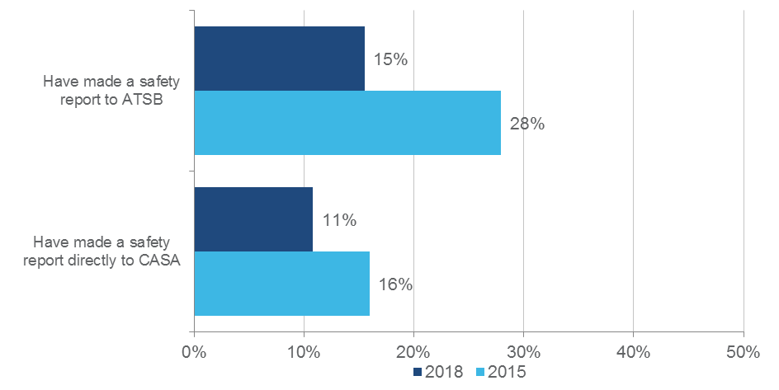

QG2. Have you made any of the following safety reports in the past two years?   
Base: All respondents 2018 (n=1,168); all respondents 2015 (n=1,217)

When examining the incidence of safety reporting, the following significant differences were observed by sub-groups:

* Those aged 18-29 years (98%) were significantly more likely to have not made a safety report directly to CASA (98%).
* Those in private flying were significantly more likely to have not made a safety report to ATSB or directly to CASA (93% and 96% respectively).
* Further, respondents with remotely piloted aircraft (99%), student pilots (97%), recreational pilots / private pilots (96%) and licensed aircraft maintenance engineers (98%) were significantly more likely to not have made a safety report to the ATSB, Conversely, those in flight training organisations (67%) and air transport pilots (61%) were significantly less likely to have not reported a safety report to ATSB.
* Those who had been in the sector 31-40 years (23%) were significantly more likely to have a safety report to the ATSB. Conversely respondent who had been in the sector less than 12 months (98%) or 1-3 years (97%) were significantly more likely to have not made a safety report to the ATSB.
* Further, respondents who had been in the sector 21-30 years (16%) were significantly more likely to have made a safety report directly to CASA, while those who had been in the sector 1-3 years (97%) were significantly more likely to have not made a safety report directly to CASA.
* There were no statistically significant differences by gender or location.

Those that had made a safety report to CASA within the past two years were asked how satisfied they were with CASA’s response on a scale of 0 to 10, with 0 being ‘very dissatisfied’ and 10 being ‘very satisfied’. Of the respondents who had made a report to CASA, in 2018 23% were satisfied and a further 24% were very satisfied with the response they received. Conversely, 22% indicated they were very dissatisfied and a further 6% indicated they were dissatisfied with the outcome.

In 2018 the mean satisfaction rating for the CASA’s response to safety reports was 5.5, which was slightly higher than the mean rating of 5.3 observed in 2015.

When examining the mean satisfaction rating, there were no statistically significant differences seen by gender, age, location, primary role in the sector or length of time in the sector.

Figure 29: Satisfaction with CASA's response to safety report made

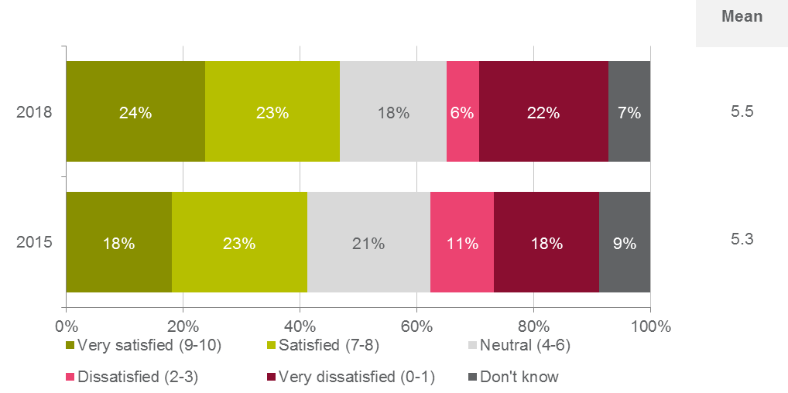

QG3. On a scale of 0-10 where 0 is ‘very dissatisfied’ and 10 is ‘very satisfied’, how satisfied were you with the response to your safety report made to CASA?   
Base: Respondents who made a safety report to CASA in the past two years (n=194). There were no statistically significant differences by gender or state.

* + 1. Agreement with safety report statements

To further explore stakeholder attitudes towards making voluntary reports to CASA, a battery of statements were developed and respondents were asked to indicate their level of agreement with each statement on a 0-10 scale (0 being ‘strongly disagree’, and 10 being ‘strongly agree’).

The findings to these statements suggest that respondents were still both generally (but not universally) aware of who they need to make safety reports to and how to do this. There was also recognition among most respondents in both 2018 and 2015 that ‘Making safety reports to CASA helps improve the knowledge of everyone in the industry’ (means of 7.6 and 6.4 respectively). There was also a lower mean rating once again observed with the statement ‘The level of CASA’s response to any non-compliance always reflects the severity of the problem’, however in 2018 some 37% of respondents answered ‘don’t know’ to this statement.

Figure 30: Agreement with safety report statements

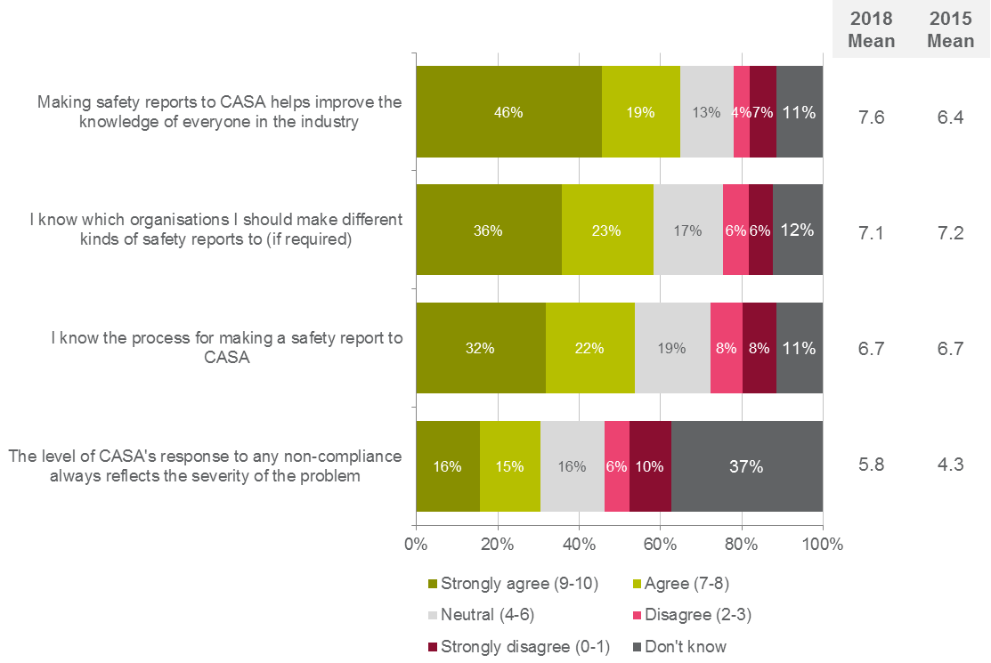

QG4. On a scale of 0 to 10, where 0 is ‘strongly disagree’ and 10 is ‘strongly agree’, please indicate how much you agree with each of the following statements.   
Base: All respondents 2018 (n=1,168); all respondents 2015 (n=1,217)

When examining the mean agreement ratings across these safety report statements, the following statistically significant differences were observed by sub groups:

* Respondents aged 18-29 were more likely to agree that ‘The level of CASA's response to any non-compliance always reflects the severity of the problem’ (mean of 7.1) with a significantly higher mean rating observed. Further respondents aged 70 years or older were more likely to agree that ‘I know the process for making a safety report to CASA’ (mean of 7.6) with a significantly higher mean rating observed.
* Respondents who indicated they lived outside of Australia were more likely to agree that ‘Making safety reports to CASA helps improve the knowledge of everyone in the industry’ (mean of 8.7) with a significantly higher mean rating observed.
* In terms of primary role in the sector, a number of significant differences were observed which included:
  + Chief pilots, those in flight training organisations and commercial pilots were more likely to agree that ‘I know which organisations I should make different kinds of safety reports to (if required)’ (means of 8.6, 8.5 and 8.2 respectively) with significantly higher mean ratings observed. In addition, chief pilots were also more likely to agree that ‘I know the process for making a safety report to CASA’ (mean of 8.5) with a significantly higher mean rating observed.
  + Student pilots and those with remotely piloted aircraft systems were more likely to agree that ‘Making safety reports to CASA helps improve the knowledge of everyone in the industry’ (means of 9.2 and 8.7 respectively) with significantly higher mean ratings observed. In addition, those with remotely piloted aircraft systems were more likely to agree that ‘The level of CASA's response to any non-compliance always reflects the severity of the problem’ (mean of 7.2) with a significantly higher mean rating observed.
  + Those in private flying were less likely to agree that I know which organisations I should make different kinds of safety reports to (if required)’ (mean of 6.2) and that ‘I know the process for making a safety report to CASA’ (mean of 5.9) with significantly lower mean ratings observed.
  + Air transport pilots and those in regular public transport were less likely to agree that ‘Making safety reports to CASA helps improve the knowledge of everyone in the industry’ (means of 6.2 and 5.7 respectively) with a significantly lower mean rating observed. In addition, air transport pilots were also less likely to agree that that ‘The level of CASA's response to any non-compliance always reflects the severity of the problem’ (mean of 3.8) with a significantly lower mean rating observed.
* In terms of length of time in the sector, a number of significant differences were observed which included:
  + Those who were relatively new to the sector – i.e. less than 12 months or 1-3 years - were more likely to agree that ‘Making safety reports to CASA helps improve the knowledge of everyone in the industry’ (means of 9.9 and 8.7 respectively) and ‘The level of CASA's response to any non-compliance always reflects the severity of the problem’ (means of 7.6 and 7.3 respectively) with significantly higher mean ratings observed. In addition those that had been in the sector for 1 - 3 years were less likely to agree that ‘I know the process for making a safety report to CASA’ (mean of 6.4) and ‘I know which organisations I should make different kinds of safety reports to (if required)’ (mean of 5.9) with significantly lower mean ratings observed.
  + Those that had been in the sector for 11-20 years were more likely to agree that ‘I know which organisations I should make different kinds of safety reports to (if required)’ (mean of 7.6), while those who had been in the sector more than 40 years were more likely to agree that ‘I know the process for making a safety report to CASA’ (mean of 7.4) with significantly higher mean ratings observed.
  + Those who had been in the sector for 31-40 years were less likely to agree that ‘The level of CASA's response to any non-compliance always reflects the severity of the problem’ (mean of 4.9) and ‘Making safety reports to CASA helps improve the knowledge of everyone in the industry’ (mean of 6.8) with significantly lower mean ratings observed.
* There were no statistically significant differences by gender.

### Dialogue with industry

* + 1. Satisfaction with CASA’s ongoing dialogue with industry

In developing the program logic model for the project in 2015, it was identified that a behaviour required to improve the health of the relationship with industry stakeholders was for CASA to engage in ongoing dialogue with industry.

To provide a measure of how well CASA performs in this regard, survey respondents were asked to indicate how satisfied they were with CASA’s ongoing dialogue with industry on a 0 to 10 scale, where 0 represented ‘very dissatisfied’ and 10 represented ‘very satisfied’. In 2018 an overall mean of 5.6 was observed for this question, which was higher than the mean rating of 3.7 observed in 2015.

In 2018, approximately two fifths of respondents were either satisfied (25%) or very satisfied (12%) with CASA’s ongoing dialogue with industry. A quarter (24%) were neutral on the matter and a further quarter were either dissatisfied (10%) or very dissatisfied (12%).

Figure 31: Satisfaction with CASA's ongoing dialogue with industry

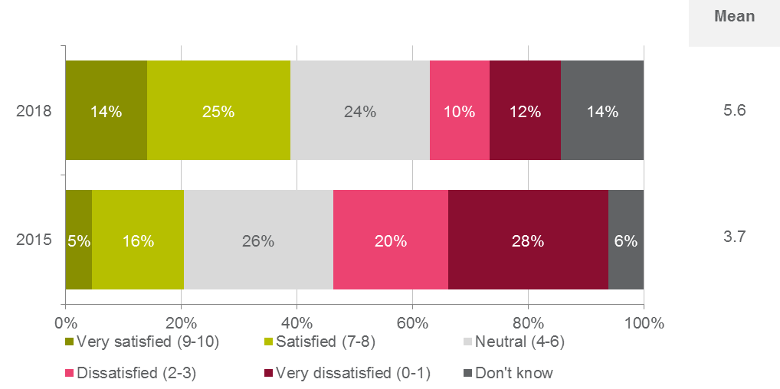

QH1. On a scale of 0-10 where 0 is ‘very dissatisfied’ and 10 is ‘very satisfied’, how satisfied are you with CASA’s ongoing dialogue with industry?   
Base: All respondents 2018 (n=1,168); all respondents 2015 (n=1,217)

When examining the mean satisfaction rating, the following statistically significant differences were observed by sub-groups:

* Females (mean of 6.8) were more likely to be satisfied with CASA’s ongoing dialogue with industry with a significantly higher mean rating observed.
* Those aged 18-29 years (mean of 6.5) were more likely to be satisfied with CASA’s ongoing dialogue with industry with a significantly higher mean rating observed.
* In regards to primary role in the sector, those with remotely piloted aircraft systems (mean of 7.4) and student pilots (mean of 7.2) and were more likely to be satisfied with CASA’s ongoing dialogue with industry with significantly higher mean ratings observed. Conversely, those in regular public transport (mean of 3.8) and air transport pilots (mean of 3.6) were less likely to be satisfied with CASA’s ongoing dialogue with industry with significantly lower mean ratings observed.
* Those who were relatively new to the sector – i.e. less than 12 months (mean of 7.7) or 1-3 years (mean of 7.2) – were more likely to be satisfied with CASA’s ongoing dialogue with industry with significantly higher mean ratings observed. Conversely, those who had been in the sector for 11-20 years (mean of 5.1), 31-40 years (mean of 4.6) or more than 40 years (mean of 4.9) were less likely to be satisfied with CASA’s ongoing dialogue with industry with significantly lower mean ratings observed.
* There were no statistically significant differences by location.   
  + 1. Attitudes toward CASA’s dialogue with industry

To further explore stakeholder attitudes towards CASA’s ongoing dialogue with industry, a battery of statements were developed and respondents were asked to indicate their level of agreement with each statement on a 0-10 scale (0 being ‘strongly disagree’, and 10 being ‘strongly agree’).

In 2018 the highest mean ratings were observed for the statements ‘CASA is vital in ensuring aviation safety in Australia’ (mean of 7.8) and ‘I have a professional and courteous relationship with CASA staff’ (mean of 7.4). These two statements also recorded the highest mean ratings in 2015.

The two statements that were observed to have the lowest mean ratings in 2018 were ‘CASA takes the time to get to know people in the industry’ (mean of 5.1) and ‘CASA values input from industry’ (mean of 5.3). These two statements also recorded the lowest mean ratings in 2015.

Figure 32: Agreement with statements on industry dialogue

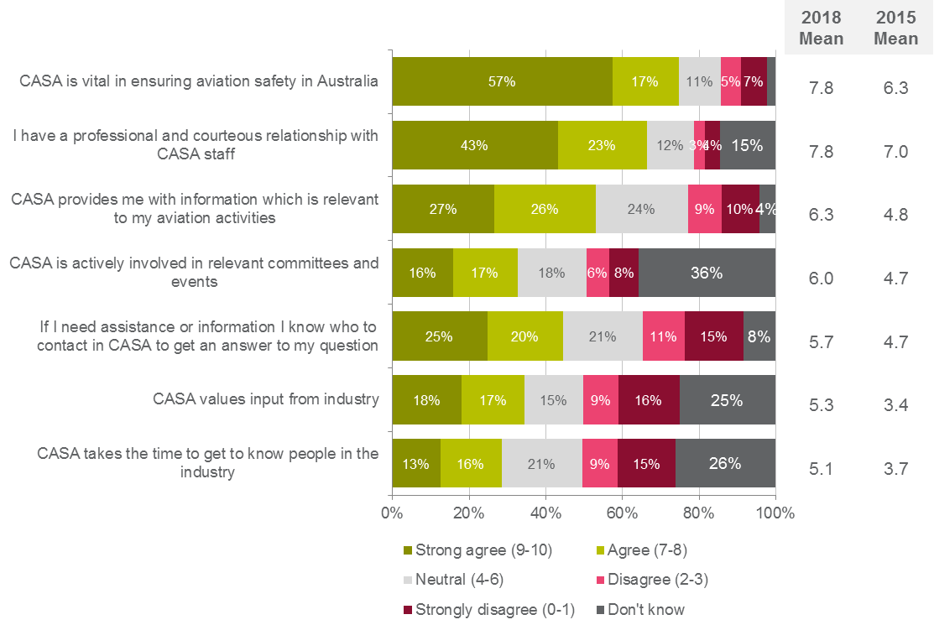

QH2. On a scale of 0-10, how much would you agree that…   
Base: All respondents 2018 (n=1,168); all respondents 2015 (n=1,217)

When examining the mean agreement ratings across statements on industry dialogue, the following statistically significant differences were observed by sub groups:

* Females were more likely to agree that ‘CASA is vital in ensuring aviation safety in Australia’ (mean of 8.7), ‘CASA provides me with information which is relevant to my aviation activities’ (mean of 7.3), ‘CASA is actively involved in relevant committees and events’ (mean of 7.2) and ‘CASA values input from industry’ (mean of 7.2) with significantly higher mean ratings observed.
* Respondents aged 18-29 were more likely to agree that ‘CASA is vital in ensuring aviation safety in Australia’ (mean of 8.5) and ‘CASA values input from industry’ (mean of 6.7) with significantly higher mean ratings observed.
* In terms of primary role in the sector, a number of significant differences were observed which included:
  + Those with remotely piloted aircraft systems were more likely to agree with all seven statements with significantly higher mean ratings observed for each one.
  + Student pilots and recreational pilots / private pilots were more likely to agree that ‘CASA is actively involved in relevant committees and events’ (means of 7.9 and 7.2 respectively), ‘CASA provides me with information which is relevant to my aviation activities’ (means of 7.7 and 7.3 respectively) and ‘CASA takes the time to get to know people in the industry’ (means of 7.0 and 6.5 respectively) with significantly higher mean ratings observed.
  + In addition, student pilots were also more likely to agree that ‘CASA is vital in ensuring aviation safety in Australia’ (mean of 9.0) and ‘CASA values input from industry’ (mean of 7.7) with significantly higher mean ratings observed.
  + Air transport pilots were less likely to agree with all seven statements with significantly lower mean ratings observed for each one.
  + Those in regular public transport were less likely to agree that ‘CASA takes the time to get to know people in the industry’ (mean of 3.3), ‘CASA values input from industry’ (mean of 3.6), ‘CASA is actively involved in relevant committees and events’ (mean of 4.0) and ‘CASA provides me with information which is relevant to my aviation activities’ (mean of 4.7) with significantly lower mean ratings observed.
* In terms of length of time in the sector, a number of significant differences were observed which included:
  + Those who were relatively new to the sector – i.e. less than 12 months or 1-3 years - were more likely to agree with six of the seven statements with significantly higher mean ratings generally observed for each one. The one exception was the statement ‘I have a professional and courteous relationship with CASA staff’ were no significant difference in the mean rating was observed.
  + Those that had been in the sector for 11-20 years were less likely to agree that ‘CASA is vital in ensuring aviation safety in Australia’ (mean of 7.7) with a significantly lower mean rating observed.
  + Those who had been in the sector for 11-20 years, 21-30 years or 31-40 years were less likely to agree that ‘CASA provides me with information which is relevant to my aviation activities’ (mean of 5.6 to 5.8) with significantly lower mean ratings observed.
  + Further those that had been in the sector for 21-30 years, 31-40 years and more than 40 years were less likely to agree that ‘CASA values input from industry’ (means of 4.4 to 4.7) with significantly lower mean ratings observed.
  + In addition those that had been in the sector for 31-40 years or more than 40 years were less likely to agree that ‘CASA takes the time to get to know people in the industry’ (means of 4.5 and 4.2 respectively) with significantly lower mean ratings observed.
* There were no statistically significant differences by location.

### CASA’s auditing roles and responsibilities

* + 1. Satisfaction with how CASA performs its audit and compliance functions

Another key area of CASA’s relationship with industry stakeholders that needed to be explored through the study was perceptions of how CASA undertakes its audit and compliance activities. To provide a measure of how well CASA performs in this regard, survey respondents were asked to indicate how satisfied they were with the way CASA performs its audit and compliance activities on a 0 to 10 scale, where 0 represented ‘very dissatisfied’ and 10 represented ‘very satisfied’. In 2018 an overall mean of 6.3 was observed for this question, which was higher than the mean rating of 4.8 observed in 2015.

In 2018, approximately a third of respondents were either satisfied (18%) or very satisfied (16%) with the way CASA performs its audit and compliance activities. Approximately one in ten respondents were either dissatisfied (4%) or very dissatisfied (7%), while 41% indicated they didn’t know (most likely reflecting their lack of direct experience with CASA audit or compliance activity).

Figure 33: Satisfaction with CASA audit and compliance activity

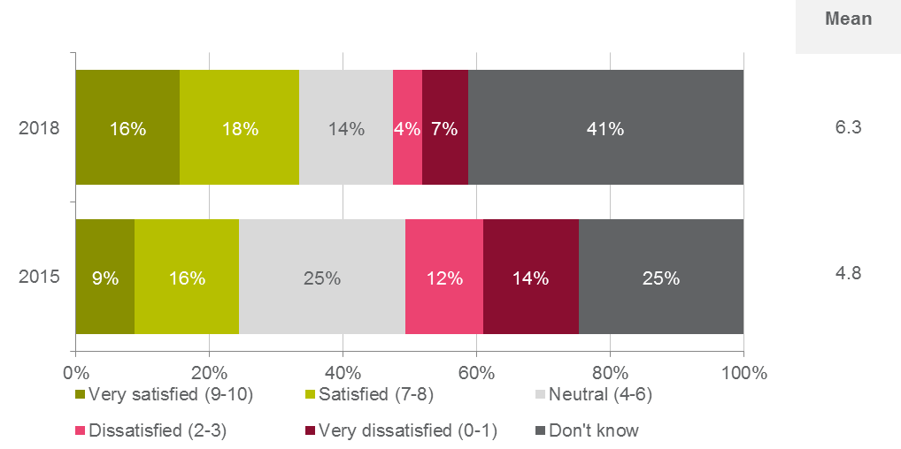

QI1. On a scale of 0 -10 where 0 is ‘very dissatisfied’ and 10 is ‘very satisfied’, how satisfied are you with the way CASA performs its audit and compliance activities (e.g. ramp checks, etc.)?   
Base: All respondents 2018 (n=1,168); all respondents 2015 (n=1,217)

When examining the mean satisfaction rating, the following statistically significant differences were observed by sub-groups:

* Those aged 18-29 years (mean of 7.3) were more likely to be satisfied with CASA’s audit and compliance activity with a significantly higher mean rating observed.
* In regards to primary role in the sector, those with remotely piloted aircraft systems (mean of 7.9) and student pilots (mean of 7.7) were more likely to be satisfied with CASA’s audit and compliance activity with significantly higher mean ratings observed. Conversely, those in regular public transport (mean of 4.8) and air transport pilots (mean of 5.2) were less likely to be satisfied with CASA’s audit and compliance activity with significantly lower mean ratings observed.
* Those who were relatively new to the sector – i.e. less than 12 months (mean of 8.1) or 1-3 years (mean of 7.6) – were more likely to be satisfied with CASA’s audit and compliance activity with significantly higher mean ratings observed.
* There were no statistically significant differences by gender or location.   
  + 1. CASA audit in the last two years

Approximately a third (36%) of the respondents surveyed in 2018 indicated that they or their organisation had been subject to CASA audit activity in the two years prior to the survey. This was less than the 47% of respondents who indicated in the 2015 survey that they or their organisation had been subject to audit activity.

Figure 34: Subject to CASA audit in past two years

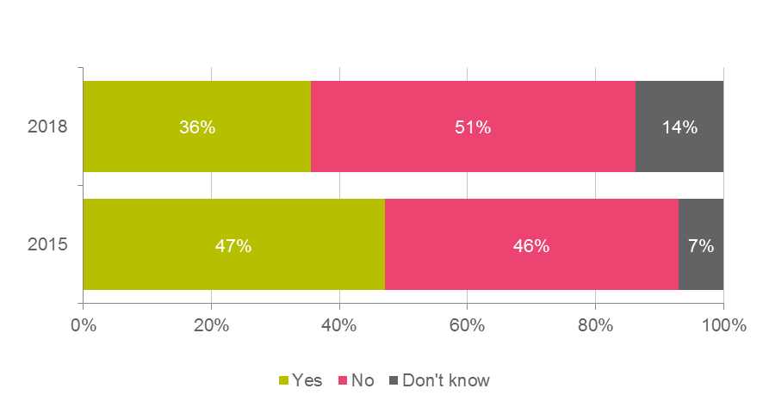

QI2. Have you or your organisation been subject to any CASA audit activity over the past two years?   
Base: All respondents 2018 (n=1,168); all respondents 2015 (n=1,217)

When examining those who had been subject to CASA audit activity in the two years prior to the survey, the following significant differences were observed by sub-groups:

* Respondents in Western Australia (46%) were significantly more likely to have reported that they or their organisation had been subject to CASA audit activity, while those in New South Wales (30%) were significantly less likely.
* Maintenance organisations (90%), those in regular public transport (70%), licensed aircraft maintenance engineers (66%), flight training organisations (65%) and air transport pilots (58%) were significantly more likely to have reported that they or their organisation had been subject to CASA audit activity.
* Those who had been in the sector for some time – i.e. 11-20 years (44%), 21-30 years (45%) and 31-40 years (53%) – were significantly more likely to have reported that they or their organisation had been subject to CASA audit activity.
* There were no statistically significant differences by gender or age.
  + 1. Attitudes towards CASA’s auditing role

To further explore attitudes towards CASA’s auditing role and how perform this, a battery of statements were developed and respondents were asked to indicate their level of agreement with each statement on a 0-10 scale (0 being ‘strongly disagree’, and 10 being ‘strongly agree’).

Encouragingly, average mean ratings were once again higher for this battery of statements than other aspects of CASA’s role observed across the survey as follows:

* ‘CASA’s auditing role is critical to the safety of aviation in Australia’ (mean of 7.8);
* ‘CASA staff undertake audit activities in a professional manner’ (mean of 7.5);
* ‘CASA staff are fair and reasonable in dealing with those subject to audit’ (mean of 6.9); and
* ‘Audits are undertaken in a constructive manner to improve safety’ (mean of 6.6).

Figure 35: Agreement with statements on CASA audit activities

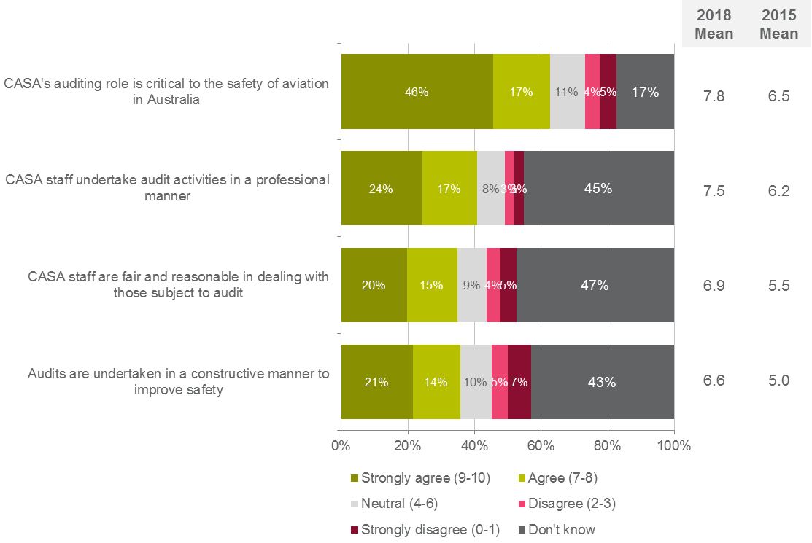

QI3. On a scale of 0 to 10, where 0 is ‘strongly disagree’ and 10 is ‘strongly agree’, please indicate how much you agree with each of the following statements.   
Base: All respondents 2018 (n=1,168); all respondents 2015 (n=1,217)

When examining the mean agreement ratings across the statements on CASA audit activities, the following statistically significant differences were observed by sub groups:

* Females were more likely to agree that ‘Audits are undertaken in a constructive manner to improve safety’ (mean of 8.6) with a significantly higher mean rating observed.
* Respondents aged 18-29 were more likely to agree that ‘CASA’s auditing role is critical to the safety of aviation in Australia’ (mean of 8.5), ‘Audits are undertaken in a constructive manner to improve safety’ (mean of 8.1) and ‘CASA staff are fair and reasonable in dealing with those subject to audit’ (mean of 8.1) with significantly higher mean ratings observed.
* In terms of primary role in the sector, a number of significant differences were observed which included:
  + Those with remotely piloted aircraft systems were more likely to agree with all four statements with significantly higher means observed for each one.
  + Student pilots were more likely to agree that ‘CASA’s auditing role is critical to the safety of aviation in Australia’ (mean of 9.1) with a significantly higher mean observed.
  + Recreational pilots / private pilots were more likely to agree that ‘Audits are undertaken in a constructive manner to improve safety’ (mean of 7.9) with a significantly higher mean observed.
  + Those in private flying were less likely to agree that and ‘CASA staff are fair and reasonable in dealing with those subject to audit’ (mean of 5.8) with a significantly lower mean rating observed
* Those who were relatively new to the sector – i.e. less than 12 months (mean of 8.7) or 1-3 years (mean of 8.5) - were more likely to agree with all four statements with significantly higher mean ratings generally observed for each one.
* Those who had been in the sector for more than 40 years were less likely to agree that ‘Audits are undertaken in a constructive manner to improve safety’ (mean of 5.8) with a significantly lower mean rating observed.
* There were no statistically significant differences by location.

### Areas to improve aviation safety

In 2018 a new question was added to the survey which asked respondents to provide up to three most important areas CASA should focus on to improve aviation safety. The most important area was to make regulations simpler, clearer or more practical at 19%. This was followed by increasing industry and stakeholder knowledge and interaction through consultation (13%) and focus on training (10%).

All other responses were provided by 10% or fewer respondents.

Figure 36: Areas to improve aviation safety – new question in 2018

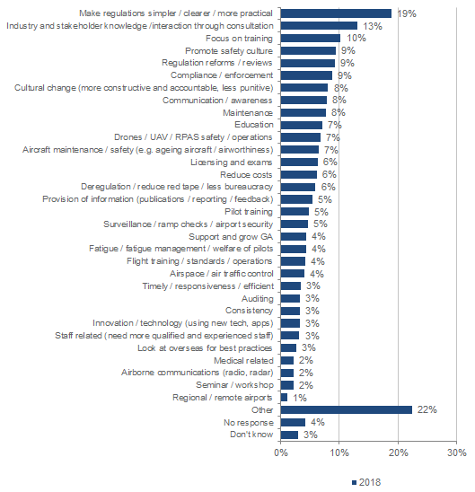QI3. What are the three most important areas CASA should focus on to improve aviation safety?   
Base: All respondents 2018 (n=1,168)

The following significant differences were observed by sub-groups:

* The response ‘Drones / UAV / RPAS safety or operations’ not surprisingly was significantly more likely to have been mentioned by those who operate a remotely piloted aircraft system (34%) or those who had been in the sector for 1 - 3 years (21%).
* There were no statistically significant differences by gender, age, location or primary role in the sector.

# Appendix A: Qualitative Interview Guide

**Interview Guide – General**

**1. PREAMBLE (5 MINS)**

* Introduce interviewer and Colmar Brunton an independently owned market research company
* Explain purpose of market research and role of interviewer
* Mention there are never any right or wrong answers. Honest opinions that count
* Explain that the research is being conducted on behalf of the Civil Aviation Safety Authority (CASA)
* Explain role of audio-recording and that will only be used for research purposes and their privacy/confidentiality is guaranteed
* Discussion will run for about one hour
* Please mute mobile phones
* Any questions?

**2. BACKGROUND (5 MINS)**

* Let’s talk about aviation – what is your role in the Sector?
* How long have you been in that role?

**3. ATTITUDES TO AVIATION SAFETY (15 MINS)**

* What does the term “aviation safety” mean to you?
* Is this being managed well by the industry?
* Is it easy or difficult to ensure the safety of your aviation activities? How come?
* What helps us or supports us to operate in a safe manner?
* What barriers are there to operating in a safe manner?
* Most aviation stakeholders will agree that safety is paramount in aviation activities. In your experience, does this translate into appropriate behaviours? How come?
* Compliance activity (such as audit) shows that a small number of operators fail to comply with their regulatory obligations – why do you think this is the case? [PROBE – Ignorance, confusion, cost pressures].
  + Do you have empathy for this group? How come?
* Do you think most people comply willingly with their safety obligations, or more so in fear of audit?
  + How come?
* Are you aware of any instances where you or someone else has not complied with their safety obligations?
  + Why did that happen?
  + What did you/they do about it?
* Have you ever had an interaction with CASA about some non-compliance with regulatory obligations?
  + (IF YES) How did they become aware of the non-compliance?
  + What did you expect would happen?
  + What did you think would be a fair outcome?
  + What happened? Were you satisfied with what happened?
  + (IF NO) Would you report any non-compliance to CASA? Why/why not?
  + What do you think would happen if you reported non-compliance to CASA?
  + What would have to change to encourage you to report non-compliance more often?

**4. CASA’S ROLE (10 MINS)**

* What role does CASA play in terms of promoting and ensuring aviation safety?
  + How well do they perform this role? How come?
* What terms would you use to describe how CASA communicates with stakeholders such as yourselves? How come?
  + What does CASA do well in terms of communication?
  + Specifically, what aspects of their communication with stakeholders do they need to improve?
* How can CASA encourage stakeholders to voluntarily comply with their obligations – that is, see the value in operating in accordance with safety requirements as opposed to doing these to avoid penalties?

**5. RELATIONSHIP WITH CASA (20 MINS)**

* In the past 12 months, what interactions have you had with CASA? Have you sent emails, applied for a licence, made calls, attended seminars etc.?
* Tell me about your most recent interaction with CASA?
  + Did they contact you or did you contact them?
  + What was the purpose of the interaction?
* How satisfied were you that your issue was resolved?
  + What things helped it to be resolved?
  + What things got in the way?
  + What could have changed to have made the experience more positive for you?
* What would the ideal relationship with CASA look like for you? What factors would it need to include?
* I’d like you to imagine for a moment that it’s 10 years into the future, and CASA has taken all of your ideas on board, and you now have the ideal relationship with CASA.
  + What things happened to change this relationship?
  + Who made those changes?
  + What would that mean for your business?
  + What would that mean for aviation safety in Australia?

**6. WRAP UP (5 MINS)**

**CLOSING**

That’s the end of the session. Thanks so much for your time, it has been greatly appreciated!

1. Ask for any final comments?
2. Inform participants that the research is being conducted on behalf of CASA.
3. State that as this is market research, it is carried out in compliance with the Privacy Act / information provided will only be used for research purposes.
4. Remind them that you are from Colmar Brunton Research. Advise if any queries, call Colmar Brunton Research on (02) 6249 8566.
5. Confirm email address for incentive to be sent to.

# Appendix B: Quantitative Questionnaire

SECTION A: SURVEY INTRODUCTION

The Civil Aviation Safety Authority (CASA) is keen to improve service delivery and its relationship with the aviation community and needs your help to find out more about what industry is thinking.

We have engaged Colmar Brunton - an independent research organisation that conducts projects on behalf of the Government and other organisations – to undertake this survey on our behalf. Your contact details and any responses you give in this survey will remain confidential to Colmar Brunton. Your responses will not be personally linked to you or your organisation as they will be combined with all other responses and used only for research purposes.

The survey will take no longer than 15 minutes to complete, and this is your opportunity to influence how CASA interacts with all industry stakeholders into the future.

When completing the survey, please do not use the forward and back buttons in your browser.

Please click on “next” to enter the survey.

SECTION B: INDIVIDUAL PROJECT REQUIREMENTS

PART A. – OVERALL SATISFACTION WITH RELATIONSHIP

QA1 On a scale of 0 -10 where 0 is “very dissatisfied” and 10 is “very satisfied”, how satisfied are you with your relationship with CASA?

|  |  |  |  |  |  |  |  |  |  |  |  |
| --- | --- | --- | --- | --- | --- | --- | --- | --- | --- | --- | --- |
| Very dissatisfied |  |  |  |  |  |  |  |  |  | Very satisfied | Don’t know |
| 0 | 1 | 2 | 3 | 4 | 5 | 6 | 7 | 8 | 9 | 10 | 97 |

QA2 Why is that?

|  |
| --- |
|  |

QA3. Please rate how satisfied you are with the following aspects of CASA’s performance on a scale of 0 to 10, where 0 is very dissatisfied and 10 is very satisfied.

|  |  |  |  |
| --- | --- | --- | --- |
| CODE |  | Rating 0-10 | Don’t know |
| 1 | Operates with safety as its primary focus | 0-10 | 97 |
| 2 | Is efficient in its dealings with you | 0-10 | 97 |
| 3 | Actively helps stakeholders comply with regulations | 0-10 | 97 |
| 4 | Is responsive to your needs | 0-10 | 97 |
| 5 | Provides timely responses to queries or requests for information | 0-10 | 97 |
| 6 | Maintains an open and transparent relationship with you | 0-10 | 97 |
| 7 | Is innovative and open to new ideas | 0-10 | 97 |
| 8 | Shares information & knowledge willingly | 0-10 | 97 |
| 9 | Provides competent & capable staff | 0-10 | 97 |
| 10 | Understands you/your business/organisation | 0-10 | 97 |
| 11 | Respects your confidentiality | 0-10 | 97 |
| 12 | Works collaboratively with industry | 0-10 | 97 |
| 13 | Strives for operational excellence | 0-10 | 97 |
| 14 | Makes it clear who you need to contact within CASA | 0-10 | 97 |
| 15 | Builds a relationship of trust with you | 0-10 | 97 |
| 16 | Is openly accountable for its actions | 0-10 | 97 |
| 17 | Treats all stakeholders fairly and with respect | 0-10 | 97 |
| 18 | Strives to minimise administrative costs & charges | 0-10 | 97 |
| 19 | Takes actions that are appropriate and in proportion to circumstances | 0-10 | 97 |
| 20 | Balances consistency and flexibility | 0-10 | 97 |
| 21 | Behaves with strength and courage | 0-10 | 97 |

PART B – COMPLIANCE WITH AVIATION SAFETY REGULATIONS

QB1. On a scale of 0 to 10, where 0 is ‘very difficult’ and 10 is ‘very easy’, how easy or difficult is it for you to fully comply with all aviation safety regulations relevant to your role or activities?

|  |  |  |  |  |  |  |  |  |  |  |  |
| --- | --- | --- | --- | --- | --- | --- | --- | --- | --- | --- | --- |
| Very difficult |  |  |  |  |  |  |  |  |  | Very easy | Don’t know |
| 0 | 1 | 2 | 3 | 4 | 5 | 6 | 7 | 8 | 9 | 10 | 97 |

QB2. On a scale of 0 to 10, where 0 is ‘not at all confident’ and 10 is ‘very confident’, how confident are you in your ability to comply with all aviation safety regulations relevant to your role?

|  |  |  |  |  |  |  |  |  |  |  |  |
| --- | --- | --- | --- | --- | --- | --- | --- | --- | --- | --- | --- |
| Not at all confident |  |  |  |  |  |  |  |  |  | Very confident | Don’t know |
| 0 | 1 | 2 | 3 | 4 | 5 | 6 | 7 | 8 | 9 | 10 | 97 |

QB3. Please indicate your level of agreement with the following statements.

|  |  |  |  |
| --- | --- | --- | --- |
| CODE |  | Rating 0-10 | Don’t know |
| 1 | Regulations covering my activities are easy to understand | 0-10 | 97 |
| 2 | CASA explains the regulations and how they affect industry stakeholders in a clear and succinct manner | 0-10 | 97 |
| 3 | I have a sound understanding of all regulations governing my aviation activities | 0-10 | 97 |
| 4 | CASA themselves have a sound understanding of the regulations governing my activities | 0-10 | 97 |
| 5 | I can easily interpret how regulations affect the way I operate | 0-10 | 97 |
| 6 | CASA inspectors have a consistent understanding of regulations and apply rules consistently | 0-10 | 97 |
| 7 | Regulations play a key role in ensuring I operate safely | 0-10 | 97 |

PART C – BEST PRACTICE

QC1. On a scale of 0 to 10, where 0 is “never” and 10 is “always”, please indicate how much of the time you believe you are demonstrating best practice in your aviation safety activities.

|  |  |  |  |  |  |  |  |  |  |  |  |
| --- | --- | --- | --- | --- | --- | --- | --- | --- | --- | --- | --- |
| Never |  |  |  |  |  |  |  |  |  | Always | Don’t know |
| 0 | 1 | 2 | 3 | 4 | 5 | 6 | 7 | 8 | 9 | 10 | 97 |

QC2. On a scale of 0 to 10, where 0 is “strongly disagree” and 10 is “strongly agree”, please indicate how much you agree with each of the following statements.

|  |  |  |  |
| --- | --- | --- | --- |
| CODE |  | Rating 0-10 | Don’t know |
| 1 | I operate in excess of CASA’s minimum safety requirements | 0-10 | 97 |
| 2 | I actively seek opportunities to operate as safely as possible | 0-10 | 97 |
| 3 | Australian aviation safety regulations and aviation safety best practice are closely aligned | 0-10 | 97 |
| 4 | If I find a new or better way to meet a specific regulation, I have a process I know I can use to share it with my colleagues or with others in the industry | 0-10 | 97 |
| 5 | CASA seeks to identify and promote safety best practice within the aviation community | 0-10 | 97 |
| 6 | CASA recognises and values industry knowledge, experience | 0-10 | 97 |
| 7 | CASA recognises and promotes safety best practice from other countries | 0-10 | 97 |

PART D – SERVICE DELIVERY

QD1. On a scale of 0-10 where 0 is “very dissatisfied” and 10 is “very satisfied”, how satisfied are you with CASA’s service delivery?

|  |  |  |  |  |  |  |  |  |  |  |  |
| --- | --- | --- | --- | --- | --- | --- | --- | --- | --- | --- | --- |
| Very dissatisfied |  |  |  |  |  |  |  |  |  | Very satisfied | Don’t know |
| 0 | 1 | 2 | 3 | 4 | 5 | 6 | 7 | 8 | 9 | 10 | 97 |

QD2. How many times have you had direct contact with CASA staff over the past 12 months?

|  |  |
| --- | --- |
| Enter number of times: |  |
| None/no contact | 99999 |

QD3. What was your most recent direct contact with CASA staff in relation to? (SR)

|  |  |
| --- | --- |
| CODE |  |
| 1 | Apply for/renew maintenance personnel licence |
| 2 | Apply for/renew air traffic control licence |
| 3 | Apply for/renew flight crew licence |
| 4 | Apply for aviation medical |
| 5 | Apply for/renew an air operator’s certificate |
| 6 | Apply for/renew a maintenance repair organisation approval |
| 7 | Apply for/renew an aircraft registration |
| 8 | To seek clarification or further information on a regulation |
| 9 | Apply for an aviation reference number (ARN) |
| 10 | To access pilot guides and information |
| 11 | To participate in an audit or safety inspection |
| 12 | To complete a flight crew or aircraft maintenance engineer exam |
| 13 | Attended a meeting, seminar, presentation or forum |
| 96 | Other (Specify) |

QD4. During your most recent interaction with CASA staff, how satisfied were you that…

|  |  |  |  |  |
| --- | --- | --- | --- | --- |
| CODE |  | Rating 0-10 | Don’t know | Not applicable |
| 1 | Your issue or query was processed in a timely manner | 0-10 | 97 | 98 |
| 2 | You were given information or advice that was consistent with information or advice you had previously been given | 0-10 | 97 | 98 |
| 3 | CASA staff understood your issue | 0-10 | 97 | 98 |
| 4 | CASA staff knew the history of your issue | 0-10 | 97 | 98 |
| 5 | Your transaction was completed with only reasonable costs incurred by you | 0-10 | 97 | 98 |
| 6 | CASA staff were helpful | 0-10 | 97 | 98 |
| 7 | You were given information or advice that answered your query or resolved your issue | 0-10 | 97 | 98 |

D5. For each of the following possible interactions with CASA, please indicate what would be an acceptable timeframe for CASA to take to resolve or finalise your issue.

|  |  |  |  |  |  |  |  |
| --- | --- | --- | --- | --- | --- | --- | --- |
| CODE |  | Up to two weeks | Up to one month | Up to eight weeks | Up to three months | Don’t know | Not applicable |
| 1 | Apply for/renew maintenance personnel licence | 1 | 2 | 3 | 4 | 97 | 98 |
| 2 | Apply for/renew Air Traffic Control Licence | 1 | 2 | 3 | 4 | 97 | 98 |
| 3 | Apply for/renew Flight Crew Licence | 1 | 2 | 3 | 4 | 97 | 98 |
| 4 | Apply for Aviation Medical | 1 | 2 | 3 | 4 | 97 | 98 |
| 5 | Apply for/renew an Air Operator’s Certificate | 1 | 2 | 3 | 4 | 97 | 98 |
| 6 | Apply for/renew a Maintenance Repair Organisation Approval | 1 | 2 | 3 | 4 | 97 | 98 |
| 7 | Apply for/renew an aircraft registration | 1 | 2 | 3 | 4 | 97 | 98 |
| 8 | To seek clarification or further information on a regulation | 1 | 2 | 3 | 4 | 97 | 98 |
| 9 | Apply for an aviation reference number (ARN) | 1 | 2 | 3 | 4 | 97 | 98 |
| 10 | To access pilot guides and information | 1 | 2 | 3 | 4 | 97 | 98 |
| 11 | To participate in an audit or safety inspection | 1 | 2 | 3 | 4 | 97 | 98 |
| 12 | To complete a flight crew/AME exam | 1 | 2 | 3 | 4 | 97 | 98 |

PART E – DEVELOPMENT AND REFORM OF AVIATION SAFETY REGULATIONS

QE1. On a scale of 0-10 where 0 is “very dissatisfied” and 10 is “very satisfied”, how satisfied are you with the ways CASA develops aviation safety regulations?

|  |  |  |  |  |  |  |  |  |  |  |  |
| --- | --- | --- | --- | --- | --- | --- | --- | --- | --- | --- | --- |
| Very dissatisfied |  |  |  |  |  |  |  |  |  | Very satisfied | Don’t know |
| 0 | 1 | 2 | 3 | 4 | 5 | 6 | 7 | 8 | 9 | 10 | 97 |

QE2. On a scale of 0 to 10, where 0 is “strongly disagree” and 10 is “strongly agree”, please indicate how much you agree with each of the following statements.

|  |  |  |  |
| --- | --- | --- | --- |
| CODE |  | Rating 0-10 | Don’t know |
| 1 | CASA clearly communicates the strategic intent of reforms to aviation safety regulations | 0-10 | 98 |
| 2 | CASA always demonstrates the case underpinning aviation safety regulation reform | 0-10 | 98 |
| 3 | CASA always consults with the most appropriate people in industry when developing and reforming aviation safety regulations | 0-10 | 98 |
| 4 | Current aviation safety regulations represent the most current learning and innovation in the industry | 0-10 | 98 |
| 5 | CASA does a good job of translating my legal obligations into practical guidance | 0-10 | 98 |
| 6 | CASA provides me with adequate opportunities to provide input on regulation development and reform | 0-10 | 98 |
| 7 | My input to regulation and reform would be useful to CASA | 0-10 | 98 |

QE3. Have you participated in any consultation on regulation development or reform - including a face- to-face consultation session or safety session, or submitting written feedback – over the past three years?

|  |  |  |
| --- | --- | --- |
| CODE |  |  |
| 1 | Yes | 1 |
| 2 | No | 2 |

IF QE3=2, CONTINUE TO QE4 BELOW. OTHERWISE SKIP TO QE5 BELOW.

QE4. What is the main reason you have not participated in CASA led consultation over the past three years?

|  |  |
| --- | --- |
| CODE |  |
| 1 | Wasn’t made aware I could |
| 2 | Too busy/no time |
| 3 | Won’t make a difference/waste of time |
| 4 | Negative experience from consultation you were involved with more than three years ago |
| 96 | Other (SPECIFY) |
| 97 | Don’t know |

QE5. On a scale from 0 to 10, where 0 is “very unimportant” and 10 is “very important ”, how important would each of the following factors be in terms of encouraging you to participate in face-to-face or written consultation with CASA?

|  |  |  |  |
| --- | --- | --- | --- |
| CODE |  | Rating 0-10 | Don’t know |
| 1 | A face-to-face session is held in a location near me | 0-10 | 98 |
| 2 | The invitation to participate came to me personally | 0-10 | 98 |
| 3 | The topic of the consultation is relevant or interesting to me | 0-10 | 98 |
| 4 | There is an opportunity to meet people from CASA whom I would like to meet | 0-10 | 98 |
| 5 | There is an opportunity to network with others in my industry | 0-10 | 98 |
| 6 | Feeling like my contribution would be used to make real change | 0-10 | 98 |
| 7 | Receiving feedback on how my contribution was used | 0-10 | 98 |

PART F – CONSISTENCY OF DECISION MAKING

QF1. On a scale of 0 to10 where 0 is “very dissatisfied” and 10 is “very satisfied”, how satisfied are you with the consistency of CASA’s decision making?

|  |  |  |  |  |  |  |  |  |  |  |  |
| --- | --- | --- | --- | --- | --- | --- | --- | --- | --- | --- | --- |
| Very dissatisfied |  |  |  |  |  |  |  |  |  | Very satisfied | Don’t know |
| 0 | 1 | 2 | 3 | 4 | 5 | 6 | 7 | 8 | 9 | 10 | 97 |

QF2. On a scale of 0 to 10, where 0 is “strongly disagree” and 10 is “strongly agree”, please indicate how much you agree with each of the following statements.

|  |  |  |  |
| --- | --- | --- | --- |
| CODE |  | Rating 0-10 | Don’t know |
| 1 | CASA staff are consistent in how they make decisions | 0-10 | 98 |
| 3 | CASA are consistent in the decisions that are made | 0-10 | 98 |
| 4 | I clearly understand why CASA makes the decisions it does | 0-10 | 98 |
| 5 | CASA makes decisions which reflect an understanding of my aviation activities and/or business | 0-10 | 98 |

PART G – SAFETY REPORTING

QG1. On a scale of 0 -10 where 0 is “very unlikely” and 10 is “very likely”, how likely would you be to make a voluntary safety report (e.g. alert CASA voluntarily in the case of non-compliance with your regulatory obligations) in situations of material non-compliance with safety regulations?

|  |  |  |  |  |  |  |  |  |  |  |  |
| --- | --- | --- | --- | --- | --- | --- | --- | --- | --- | --- | --- |
| Very unlikely |  |  |  |  |  |  |  |  |  | Very likely | Don’t know |
| 0 | 1 | 2 | 3 | 4 | 5 | 6 | 7 | 8 | 9 | 10 | 97 |

QG2. Have you made any of the following safety reports in the past two years?

|  |  |  |  |
| --- | --- | --- | --- |
| CODE |  | Yes | No |
| 1 | A safety report to ATSB | 1 | 0 |
| 2 | A safety report directly to CASA | 1 | 0 |

**IF QG2 2=YES, CONTINUE TO QG3 BELOW. OTHERWISE SKIP TO QG4 BELOW.**

QG3. (FOR SAFETY REPORTS TO CASA ONLY) On a scale of 0-10 where 0 is “very dissatisfied” and 10 is “very satisfied”, how satisfied were you with the response to your safety report made to CASA?

|  |  |  |  |  |  |  |  |  |  |  |  |
| --- | --- | --- | --- | --- | --- | --- | --- | --- | --- | --- | --- |
| Very dissatisfied |  |  |  |  |  |  |  |  |  | Very satisfied | Don’t know |
| 0 | 1 | 2 | 3 | 4 | 5 | 6 | 7 | 8 | 9 | 10 | 97 |

QG4. On a scale of 0 to 10, where 0 is “strongly disagree” and 10 is “strongly agree”, please indicate how much you agree with each of the following statements.

|  |  |  |  |
| --- | --- | --- | --- |
| CODE | Issue | Rating 0-10 – label 0 as strongly disagree and 10 is strongly agree | Don’t know |
| 1 | I know which organisations I should make different kinds of safety reports to (if required) | 0-10 | 97 |
| 2 | I know the process for making a safety report to CASA | 0-10 | 97 |
| 3 | The level of CASA’s response to any non-compliance always reflects the severity of the problem | 0-10 | 97 |
| 4 | Making safety reports to CASA helps improve the knowledge of everyone in the industry | 0-10 | 97 |

PART H– DIALOGUE WITH INDUSTRY

QH1. On a scale of 0-10 where 0 is “very dissatisfied” and 10 is “very satisfied”, how satisfied are you with CASA’s ongoing dialogue with industry?

|  |  |  |  |  |  |  |  |  |  |  |  |
| --- | --- | --- | --- | --- | --- | --- | --- | --- | --- | --- | --- |
| Very dissatisfied |  |  |  |  |  |  |  |  |  | Very satisfied | Don’t know |
| 0 | 1 | 2 | 3 | 4 | 5 | 6 | 7 | 8 | 9 | 10 | 97 |

QH2. On a scale of 0-10, how much would you agree that…

|  |  |  |  |
| --- | --- | --- | --- |
| CODE | Issue | Rating 0-10 – label 0 as strongly disagree and 10 is strong agree | Don’t know |
| 1 | CASA is vital in ensuring aviation safety in Australia | 0-10 | 97 |
| 2 | CASA takes the time to get to know people in the industry | 0-10 | 97 |
| 3 | CASA is actively involved in relevant committees and events | 0-10 | 97 |
| 4 | CASA provides me with information which is relevant to my aviation activities | 0-10 | 97 |
| 5 | CASA values input from industry | 0-10 | 97 |
| 6 | If I need assistance or information I know who to contact in CASA to get an answer to my question | 0-10 | 97 |
| 7 | I have a professional and courteous relationship with CASA staff | 0-10 | 97 |

PART I – CASA’s Audit Roles & Responsibilities

QI1. On a scale of 0 -10 where 0 is “very dissatisfied” and 10 is “very satisfied”, how satisfied are you with the way CASA performs its audit and compliance activities (e.g. ramp checks, etc.)?

|  |  |  |  |  |  |  |  |  |  |  |  |
| --- | --- | --- | --- | --- | --- | --- | --- | --- | --- | --- | --- |
| Very dissatisfied |  |  |  |  |  |  |  |  |  | Very satisfied | Don’t know |
| 0 | 1 | 2 | 3 | 4 | 5 | 6 | 7 | 8 | 9 | 10 | 97 |

QI2. Have you or your organisation been subject to any CASA audit activity over the past two years?

|  |  |
| --- | --- |
| CODE |  |
| 1 | Yes |
| 2 | No |
| 3 | Don’t know |

QI3. On a scale of 0 to 10, where 0 is “strongly disagree” and 10 is “strongly agree”, please indicate how much you agree with each of the following statements.

|  |  |  |  |
| --- | --- | --- | --- |
| CODE | Issue | Rating 0-10 – label 0 as strongly disagree and 10 is strongly agree | Don’t know |
| 1 | CASA staff undertake audit activities in a professional manner | 0-10 | 97 |
| 2 | CASA staff are fair and reasonable in dealing with those subject to audit | 0-10 | 97 |
| 3 | Audits are undertaken in a constructive manner to improve safety | 0-10 | 97 |
| 4 | CASA’s auditing role is critical to the safety of aviation in Australia | 0-10 | 97 |

PART I.1 – IMPROVEMENT AREAS

QI1.1. What are the 3 most important areas CASA should focus on to improve aviation safety?

|  |  |
| --- | --- |
| 01 | [INSERT] |
| 02 | [INSERT] |
| 03 | [INSERT] |

Part J - DEMOGRAPHICS

Now just a few questions to help us analyse our results…

ASK ALL:

QJ1 GENDER

QJ1. Please indicate your gender. Please select one. (SR)

|  |  |
| --- | --- |
| Code |  |
| 1 | Male |
| 2 | Female |
| 96 | I prefer not to answer |

QJ2. Which of the following best describes your current primary role in the aviation sector? Please select one. (SR)

|  |  |
| --- | --- |
| Code |  |
| 1 | Aerial work |
| 2 | Charter operator |
| 3 | Private flying |
| 4 | Business aviation |
| 5 | Regular passenger transport |
| 6 | Sport aviation (including self-administered organisations) |
| 7 | Remotely piloted aircraft systems |
| 8 | Flight training including recreational, private and commercial pilot training organisations, and multi-crew training organisations |
| 9 | Student pilot |
| 10 | Recreational pilot/private pilot |
| 11 | Commercial pilot |
| 12 | Air transport pilot |
| 13 | Maintenance authority |
| 14 | Cabin crew |
| 15 | Air traffic controller |
| 16 | Aircraft design/engineering/building |
| 17 | Maintenance organisation |
| 18 | Maintenance training organisation |
| 19 | Licensed aircraft maintenance engineer |
| 20 | Aircraft maintenance engineer |
| 21 | Aerodrome services including ground handling, aviation rescue, and fire fighting |
| 22 | Aviation medicine |
| 23 | Consultant & other professional services |
| 24 | Chief engineer |
| 25 | Chief pilot |
| 26 | Government organisations |
| 27 | Safety manager |
| 96 | Other (SPECIFY) |

QJ3. Are you an aircraft owner or operator of any kind?

|  |  |
| --- | --- |
| Yes | 1 |
| No | 2 |

IF QJ3 =1, GO TO QJ4 BELOW. OTHERWISE SKIP TO QJ5 BELOW.

QJ4. Please indicate if you are licensed to operate any of the following aircraft types. (MR)

|  |  |
| --- | --- |
| CODE |  |
| 1 | Fixed wing – jet |
| 2 | Fixed wing – twin engine |
| 3 | Fixed wing – turbo prop |
| 4 | Fixed wing – single engine |
| 5 | Fixed wing - piston |
| 6 | Fixed wing - light sports aircraft |
| 7 | Rotary – turbine (heavy) |
| 8 | Rotary – light helicopter |
| 9 | Hot air balloon |
| 10 | Glider |
| 11 | Gyrocopter/trike |
| 12 | Hang glider |
| 13 | Warbird |
| 14 | Remotely piloted aircraft/drones |
| 97 | Other (SPECIFY) |

QJ5. Which of the following age groups do you fall into? Please select one. (SR)

|  |  |
| --- | --- |
| Code |  |
| 1 | Under 18 |
| 2 | 18-24 |
| 3 | 25-29 |
| 4 | 30-34 |
| 5 | 35-39 |
| 6 | 40-44 |
| 7 | 45-49 |
| 8 | 50-54 |
| 9 | 55-59 |
| 10 | 60-64 |
| 11 | 65-69 |
| 12 | 70 years or older |
| 13 | I prefer not to answer |

QJ6. Where are you based? Please select one. (SR)

|  |  |
| --- | --- |
| Code |  |
| 1 | Sydney |
| 2 | New South Wales (other than Sydney) |
| 3 | Melbourne |
| 4 | Victoria (other than Melbourne) |
| 5 | Brisbane |
| 6 | Queensland (other than Brisbane) |
| 7 | Adelaide |
| 8 | South Australia (other than Adelaide) |
| 9 | Perth |
| 10 | Western Australia (other than Perth) |
| 11 | Australian Capital Territory |
| 12 | Northern Territory |
| 13 | Tasmania |
| 14 | I don’t live in Australia |

QJ7. How long have you been operating or involved in the aviation sector for? (SR)

|  |  |
| --- | --- |
| Code |  |
| 1 | Less than 12 months |
| 2 | 1 – 3 years |
| 3 | 4 – 10 years |
| 4 | 11 – 20 years |
| 5 | 21 – 30 years |
| 6 | 31 – 40 years |
| 7 | More than 40 years |

QJ8. As part of CASA’s efforts to further improve their communications with stakeholders, they are likely to want to engage with industry participants in the near future for additional research on a range of topics. Would you be willing to be contacted to participate in any future research activity undertaken? Even if you agree, participation would be voluntary and you would be under no obligation to participate even if contacted again in future if this didn’t suit your circumstance at the time.

Are you willing to be recontacted and be invited to participate in future research projects undertaken by CASA?

|  |  |  |
| --- | --- | --- |
| Code |  | Instructions |
| 1 | Yes | CONTINUE |
| 2 | No | GO TO CLOSING SCRIPT |

QJ9. Thank you for your willingness to potentially engage in us with future research projects. Please record your name and contact details below in order for us to contact you if such opportunities arise. This information will be separated from your responses to the survey to ensure your confidentiality.

|  |  |
| --- | --- |
| Name |  |
| Best phone contact no. (incl. area code if landline) |  |
| Email address |  |

SECTION C: MANDATORY QMS REQUIREMENTS

CONCLUSION

Thank you, you have completed the survey.

As this is market research, it is carried out in compliance with the Privacy Act and the information you provide will be used only for research purposes. The research project is being conducted on behalf of the Civil Aviation Safety Authority.

For questions about the Market Research Industry as a whole, you can visit the Market and Social Research Society's website <https://www.amsrs.com.au/>.

Thank you for sharing your views.

Please click “SUBMIT” to send your responses.

1. The 2018 study was conducted via a random sample of CASA stakeholders drawn from CASA’s stakeholder database, whereas the 2015 survey was conducted as a self-select survey.